**DESIGN DFA TO PERFORM ODD NUMBER OF A**

AIM:

.DESIGN DFA TO PERFORM ODD NUMBER OF A

OUTPUT:

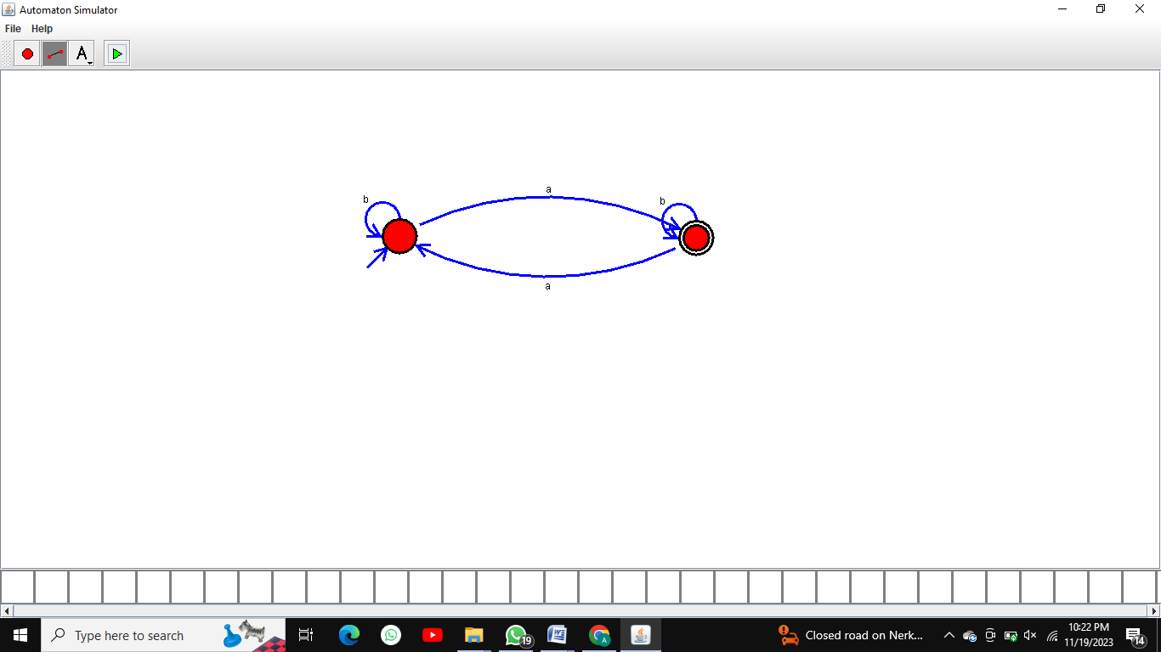

RESULT:  
 THUS THE DESIGNED DFA IS WORKED SUCCESSFULLY