**DESIGN DFA SIMULATOR THAT ACCEPT STRING THAT SHOULD BE END WITH AB**

AIM:

DESIGN DFA SIMULATOR THAT ACCEPT STRING THAT SHOULD BE END WITH AB

OUTPUT:

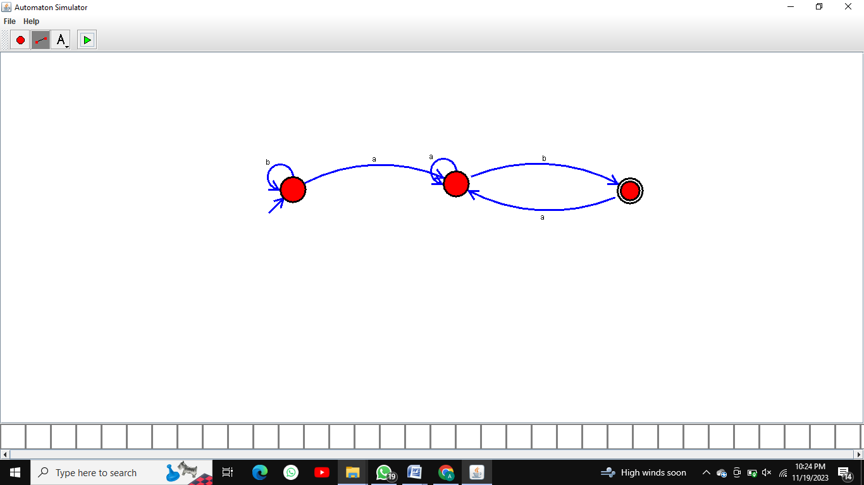

RESULT:  
 THUS THE DESIGNED DFA IS WORKED SUCCESSFULLY