**DESIGN DFA PROBLEM THAT HAVING OVER THE SIMULATOR HAVING AB STRING**

AIM:

DESIGN DFA PROBLEM THAT HAVING OVER THE SIMULATOR HAVING AB STRING

OUTPUT;

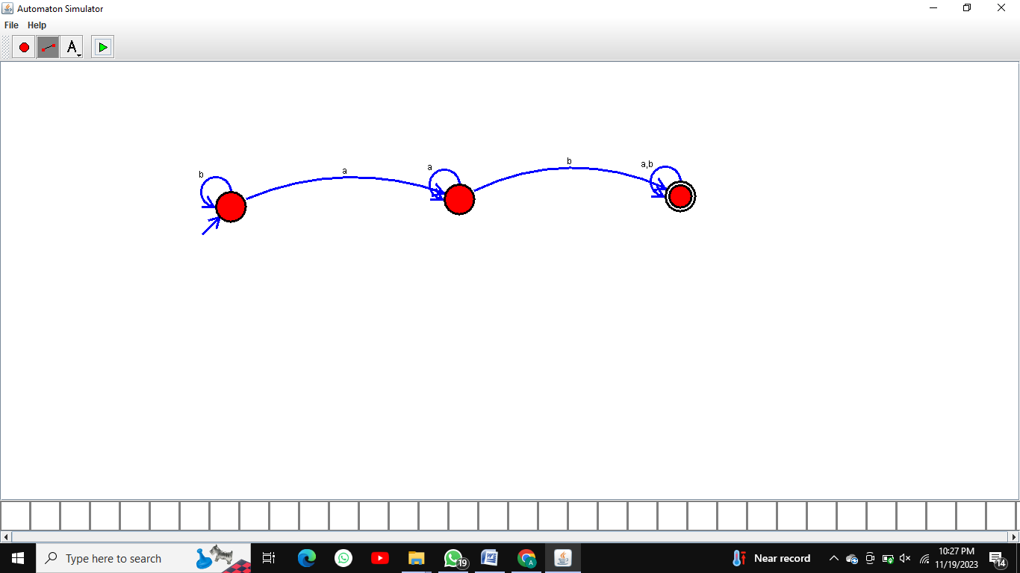

RESULT:  
 THUS THE DESIGNED DFA IS WORKED SUCCESSFULLY