**DFA PROBLEM TO START WITH A OR B**

AIM:

DFA PROBLEM TO START WITH A OR B

OUTPUT:

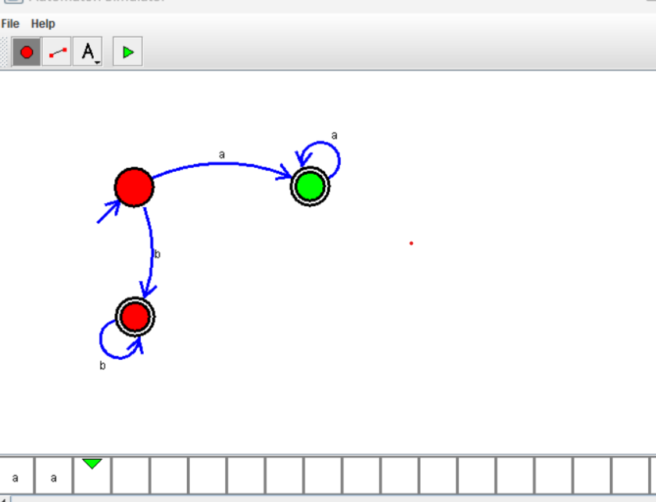

RESULT:

THUS THE DESIGNED DFA IS WORKED SUCCESSFULLY