**DESIGN TM TO ACCEPT STRING IS PALINDROME**

AIM:

DESIGN TM TO ACCEPT STRING IS PALINDROME

OUTPUT:

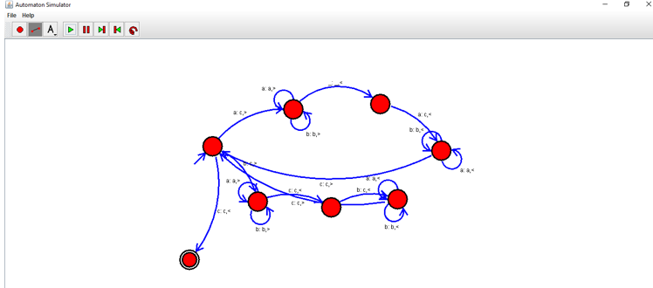

RESULT:

THUS THE DESIGNED TM IS WORKED SUCCESSFULLY