**DESIGN TM SIMULATOR TO ACCEPT STRING WCW:**

AIM:

DESIGN TM SIMULATOR TO ACCEPT STRING WCW

OUTPUT:

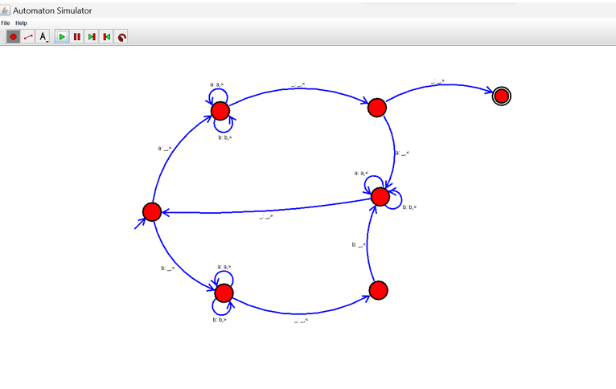

RESULT:

THUS TM IS WORKED SUCCESSFULLY