**DESIGN DFA THAT STRING THAT END WITH ab**

AIM:

DESIGN DFA THAT STRING THAT END WITH AB

OUTPUT:

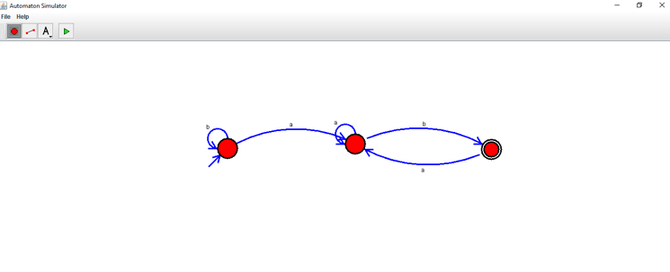

RESULT:

THUS DFA WAS DESIGNED SUCCESSFULLY