**DESIGN DFA THAT STRINGS “a”,”ac”,”bac”**

AIM:

DESIGN DFA THAT STRINGS “a”,”ac”,”bac”

OUTPUT:

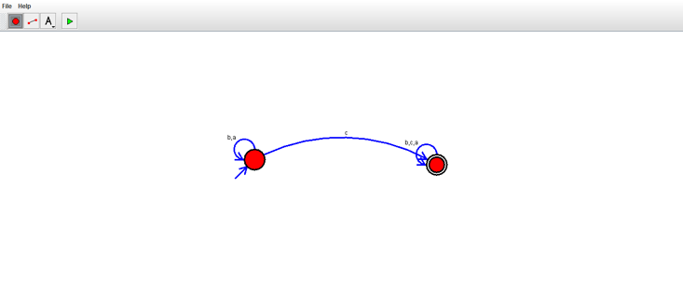

RESULT

THUS DFA WAS DESIGNED SUCCESSFULLY