**DESIGN PDA TO ACCEPT STRING anbn:**

AIM:

DESIGN PDA TO ACCEPT STRING anbn:

OUTPUT:

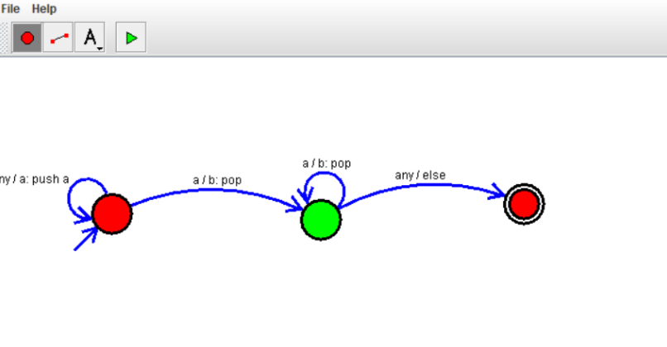

RESULT

THUS PDA WAS DESIGNED SUCCESSFULLY