**DESIGN TM TO COMPARE STRING aba and aba**

AIM:

DESIGN TM TO COMPARE STRING aba and aba

OUTPUT:

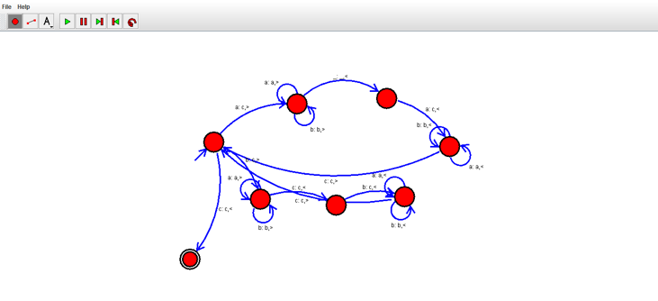

RESULT:

THUS THE TM WAS DESIGNED SUCCESSFULLY