**DESIGN DFA THAT ACCEPT STRING HAVING abc**

AIM:

DESIGN DFA THAT ACCEPT STRING HAVING abc

OUTPUT:

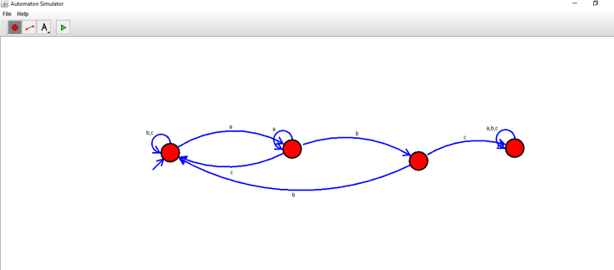

RESULT:

THUS THE DESIGNED DFA WAS WORKED SUCCESSFULLY