**DESIGN DFA TO ACCEPT EVEN NUMBER OF C’S**:

AIM:

DESIGN DFA TO ACCEPT EVEN NUMBER OF C’S:

OUTPUT:

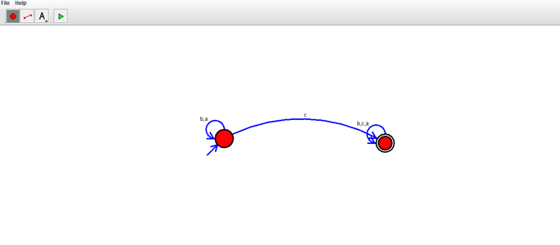

RESULT:

THUS THE DESIGNED DFA WAS WORKED SUCCESSFULY