**DESIGN DFA THAT a IS ALWAYS TRIPLED**

AIM:

DESIGN DFA THAT a IS ALWAYS TRIPLED

OUTPUT:

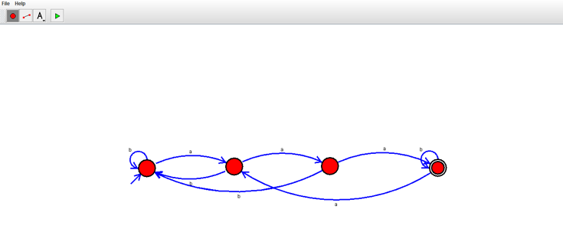

RESULT:

THUS THE DFA WAS DESIGNED SUCCESSFULLY