**DESIGNED NFA STRING THAT START WITH A AND END WITH B:**

AIM:

DESIGNED NFA STRING THAT START WITH a AND END WITH b:

OUTPUT:

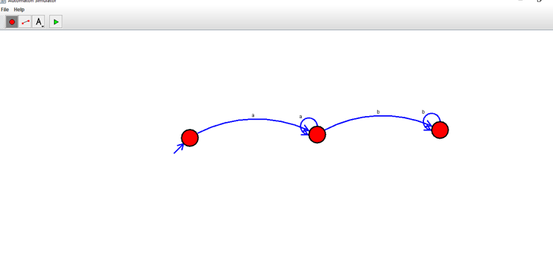

RESULT:

THUS NFA WAS DESIGNED SUCCESSFULLY