**DESIGNED NFA THAT START WITH DIFFERENT SYMBOL AND END WITH DIFFERENT SYMBOL**

AIM:

DESIGNED NFA THAT START WITH DIFFERENT SYMBOL AND END WITH DIFFERENT SYMBOL

OUTPUT:

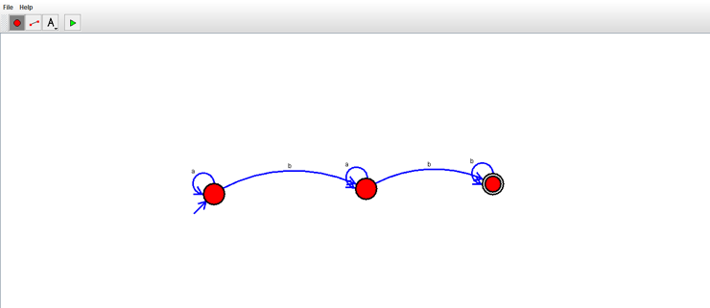

RESULT:

THUS THE NFA WAS DESIGNED SUCCESSFULLY.