**.DESIGNED NFA “bbc”, “c” AND “bcaaa”**

AIM:  
DESIGNED NFA “bbc”, “c” AND “bcaaa”

OUTPUT:  
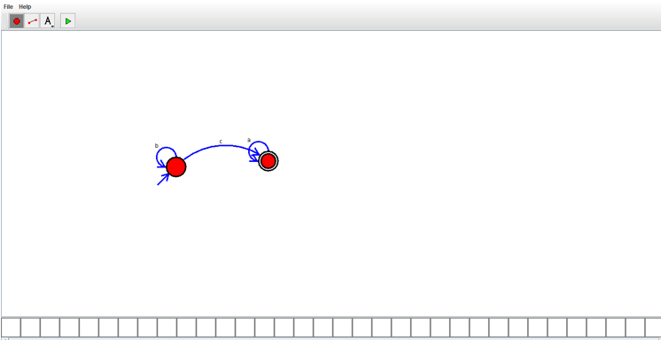

RESULT:

THUS THE DESIGNED NFA WAS DESINED SUCCESSFULLY