**DESIGNED NFA TO ACCEPT ANY NUMBER B’S:**

AIM:

DESIGNED NFA TO ACCEPT ANY NUMBER B’S:

OUTPUT:  
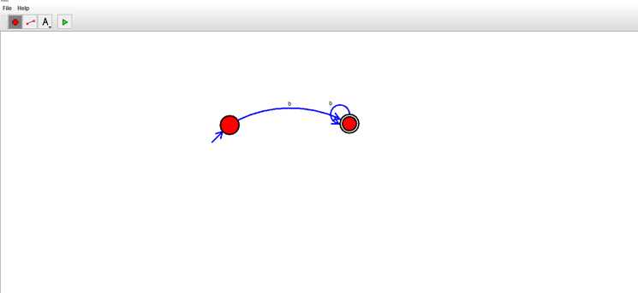

RESULT:

THUS NFA WAS DESIGNED SUCCESSFULLY