**DESIGNED DFA SIMULATOR THAT ACCEPT STRING END WITH ABC**

AIM:

DESIGNED DFA SIMULATOR THAT ACCEPT STRING END WITH ABC

OUTPUT:

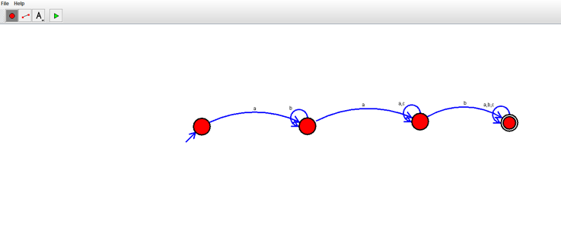

RESULT:  
THUS DFA IS DESIGNED SUCCESSFULLY

;