🌊 MOUJ — Full-Stack Fintech SaaS Strategy & Analysis
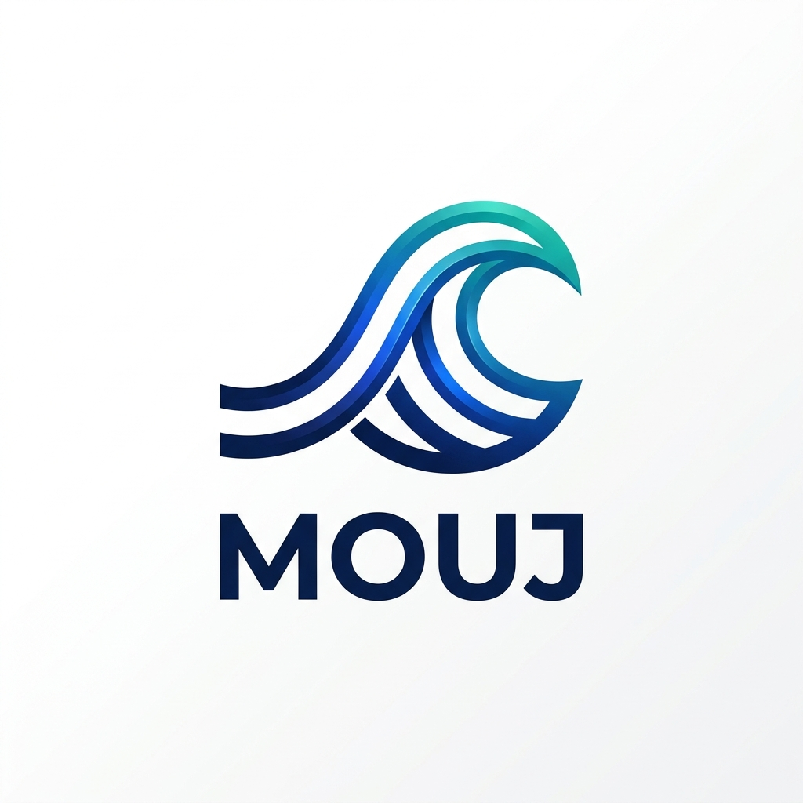
MOUJ Logo

1. Executive Summary
MOUJ (Arabic for “Wave” or “Flow”) is a premium, full-stack fintech platform designed to bridge the financial inclusion gap in Morocco and scale across the Pan-African and European markets. It combines high-fidelity digital banking experiences with a multi-model AI advisor ecosystem.
Attribute | Details
Brand Name | MOUJ
Identity | High-tech, minimalist wave icon with blue/teal glassmorphism aesthetics.
Core Mission | Redefining financial intelligence through accessible, AI-driven banking.
Founder Model | Solo-founder, lean operations, API-first architecture.
Location | Headquarters in Morocco (aligning with Morocco Fintech Center).

2. Market Analysis (Morocco & Beyond)

📊 The Opportunity
- Unbanked Potential: 15 million Moroccans (~56% of adults) remain unbanked.
- Mobile First: 137.5% mobile penetration and ~83% internet access.
- Remittance Flow: $10B+ annual diaspora remittances (top corridor for innovation).
- Insurtech/WealthTech Gap: Significant underserved segments in micro-insurance and automated wealth management.

⚖️ Regulatory Landscape
- Bank Al-Maghrib: Primary regulator for payment & credit licenses.
- CNDP Compliance: Strict data residency and protection (Law 09-08 / GDPR aligned).
- Law 43-20: Enabling digital trust and e-signatures.

3. Product Roadmap & Strategy
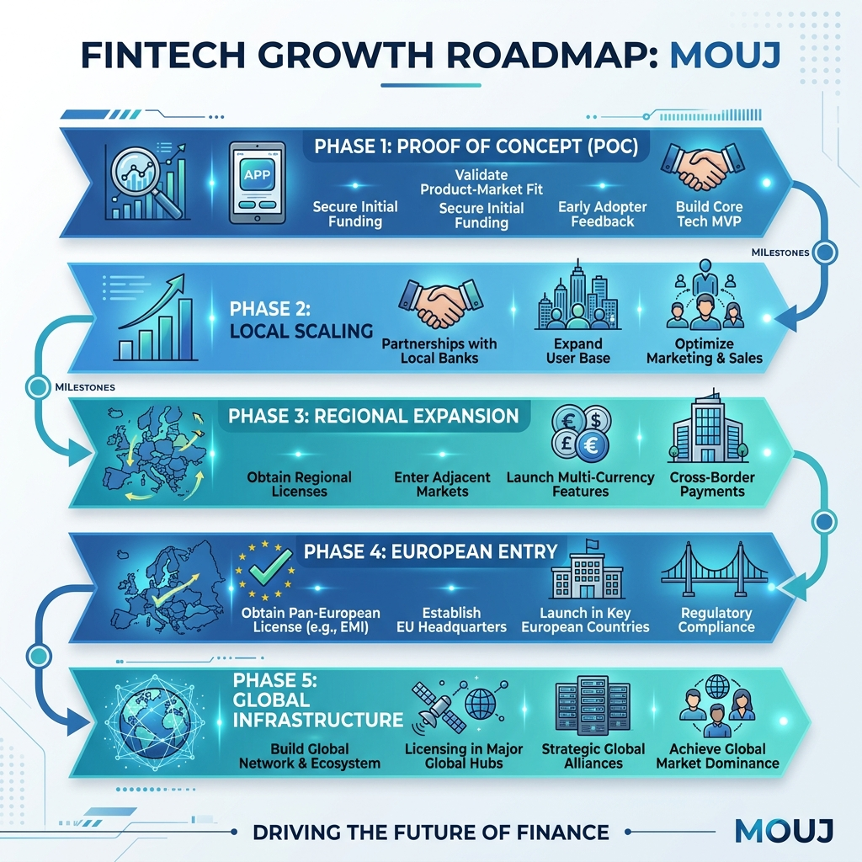
MOUJ Roadmap
- Phase 1: Proof of Concept (Current)
  - Build high-fidelity landing and dashboard.
  - Integrate local LLMs for financial advisory.
  - Pilot with freelance/SME segment.
- Phase 2: Local Scaling
  - Secure Moroccan payment aggregator licenses.
  - Integrate with local banking APIs (API-Aggregation).
- Phase 3: North Africa Expansion
  - Target Francophone West Africa (Ivory Coast, Senegal).
- Phase 4: European Entry
  - Establish EU entity for diaspora remittance and investment.
- Phase 5: Global Fintech Infrastructure
  - Transition to a B2B API platform (Banking-as-a-Service).

4. Platform Architecture

🏗️ Technical Stack
- Frontend: Next.js 15 (App Router), Framer Motion, Lucide React.
- Backend: Node.js + Express (High-performance REST API).
- Database: PostgreSQL with Prisma ORM (Scalable relational data).
- AI Infrastructure: Ollama (Local/Self-hosted multi-model hosting).
- Authentication: JWT with secure cookie-based session management.

🧠 Multi-Model AI Ecosystem
MOUJ uses a specialized “Router” approach to assign specific financial tasks to the best-fit model:
Model | Role | Functional Assignment
qwen3.5:cloud | Primary Advisor | Holistic financial planning & complex advisory.
deepseek-r1:8b | Reasoning Engine | Risk assessment, credit scoring, and logic-heavy analysis.
qwen3.5:9b | General Support | Onboarding, FAQ, and customer interaction.
gemma:7b | Market Analyst | Sentiment analysis and market trend tracking.
gemma4:E4B | Security/Fraud | Anomaly detection and transaction verification.
gemma4:E2B | Quick Processor | Transaction categorization and quick summaries.

5. Data Model & Strategy Mindmap

🗺️ Business Flow Strategy
mindmap
root((MOUJ))
Services
Payments (QR, P2P)
Lending (Micro-loans)
Wealth (AI Portfolios)
Verticals
Insurtech
RegTech
DeFi
Strategy
Lean MVP
Regulatory First
AI-Driven

🗄️ Database Structure
- User: Profile, Auth, Roles.
- Account: Savings, Checking, Multi-currency (MAD/EUR).
- Transaction: Full ledger with AI-categorization.
- Loan: Terms, interest, and AI-scored approvals.
- Investment: Real-time asset tracking.
- ChatMessage: Persistent AI conversation history with model tagging.

6. Implementation Status
- Project Scaffolding: Next.js client + Node.js server.
- Branding: Renamed to MOUJ, new animated logo & favicon created.
- Authentication: JWT Login/Register fully functional.
- Dashboard Overview: Financial KPIs and transaction feeds implemented.
- AI Advisor Interface: Chat system with model routing implemented.
- Diagnostics: All syntax and spelling errors resolved.
- Payments Module: Integration with payment gateways (Phase 2).
- Lending Flow: Finalizing AI risk scoring integration (Phase 2).

7. Operational Instructions

Running the Platform Locally
- Server: cd server && node index.js (Requires Postgres & Ollama).
- Client: cd client && npm run dev (Access via localhost:3000).

MOUJ — Ride the Wave of Financial Intelligence.

