How To Play This Game
This short tutorial is meant to guide the user through our game using live screen-shots. While functionality is simple for the time being, it should be noted that this is not a drag and drop game. Instead, the user will need to click on the tile they wish to move, and click again on the location that they wish to move the tile to.
When you click on a tile in one of the two columns, you should see the following:
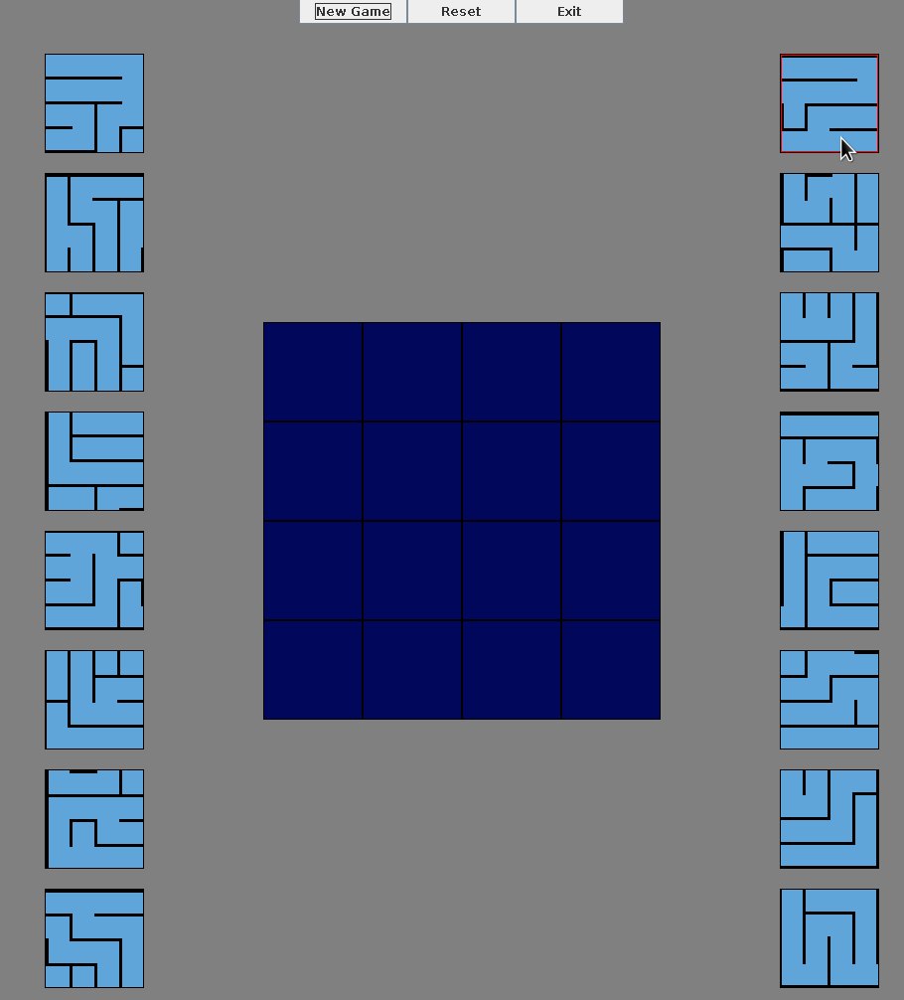
If you click on this same tile again, it will no longer be highlighted with a red border. This means it is no longer transferable, as you have deselected it. If you decide that you want to move another tile when you’ve already selected one, click on the tile that is now highlighted (top right in this case), and then select your other preferred tile. If you don’t do this, the game will let you know that you’ve performed an illegal move with a quick flash.
This game also includes rotation features that allow you to orient your movable game piece by ninety degrees. This is performed via a right click, and will allow you to adjust your piece as many times as needed, anywhere on the board. There is no limit. However, it should be noted that when you decide to rotate a piece, it will be deselected, and cannot be moved again until you perform another left-click. This is to prevent unwanted highlighting and game piece confusion.
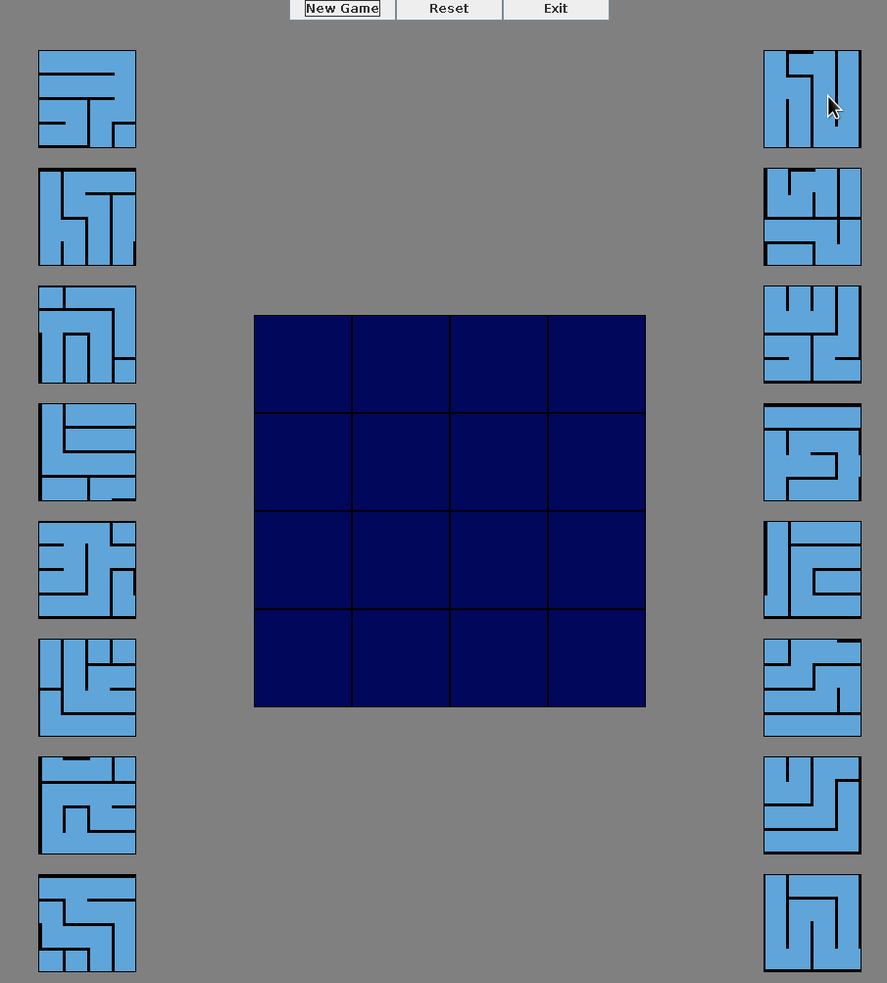

Once you have made your decision on which tile to move, you may move your tile by clicking on any square in the game board. It should be noted that clicking anywhere outside of the game board will result in no action occurring. Your tile will still be selected, awaiting a legal move.
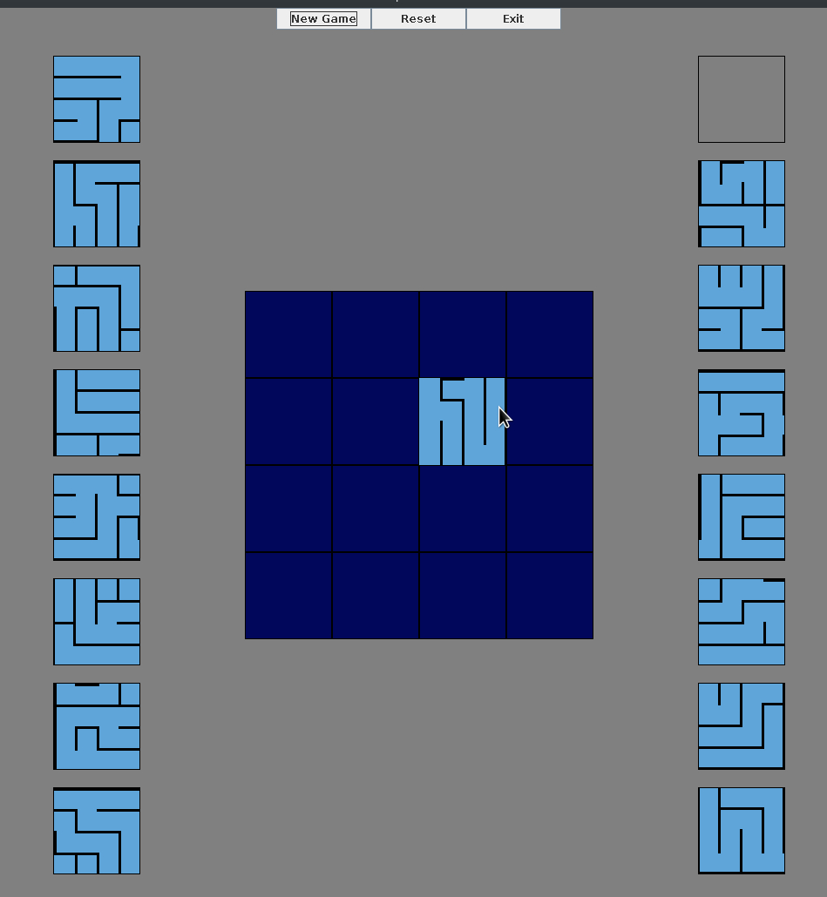
You may move this tile to any position in the game board, at any time. This is applicable for all tiles residing in the game board.
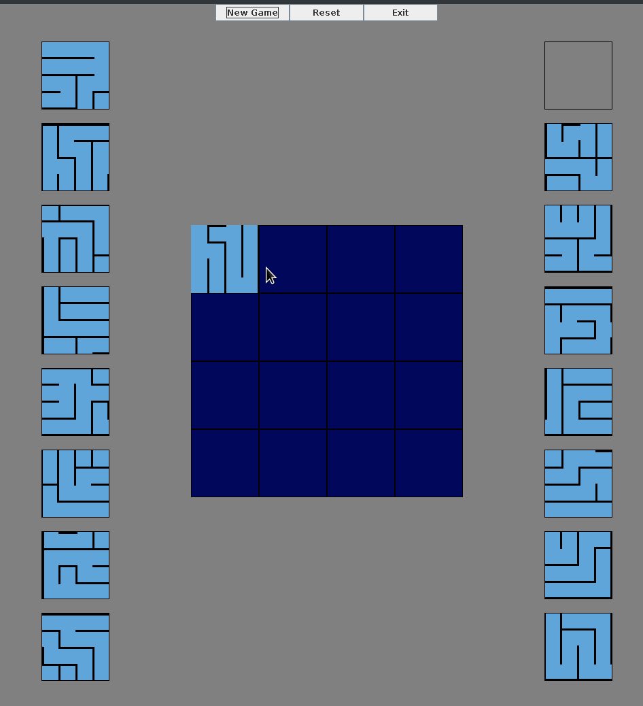
You can begin adding more tiles to the game like so:
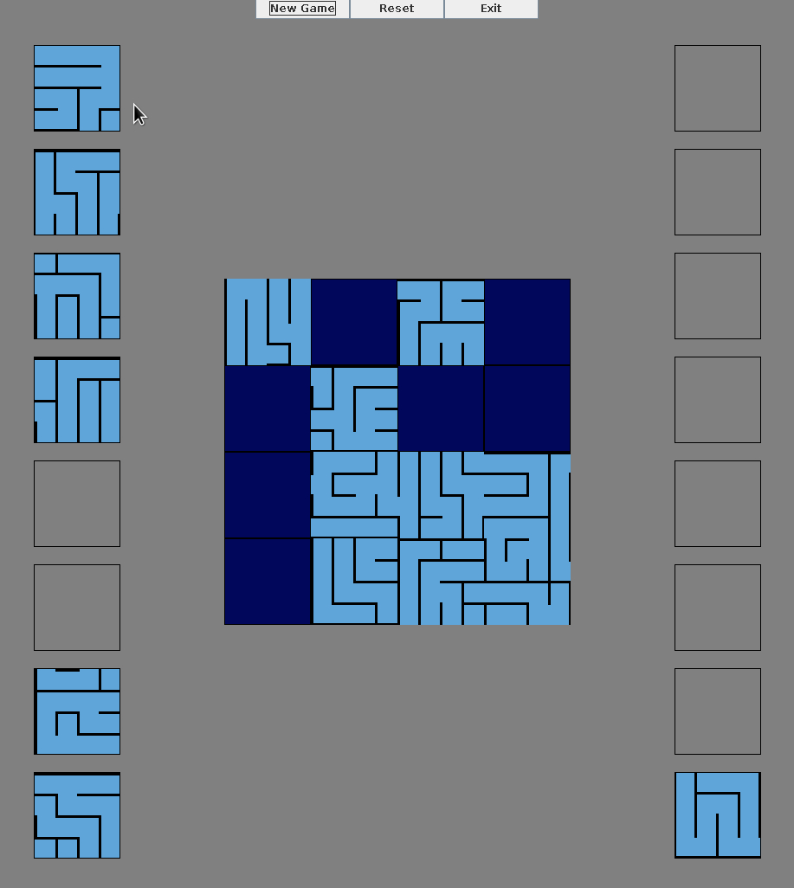
It should be noted that at any time, you can move your tiles from the game board, into any empty tile holder. They can even be transferred from one column to another, if you so desire.
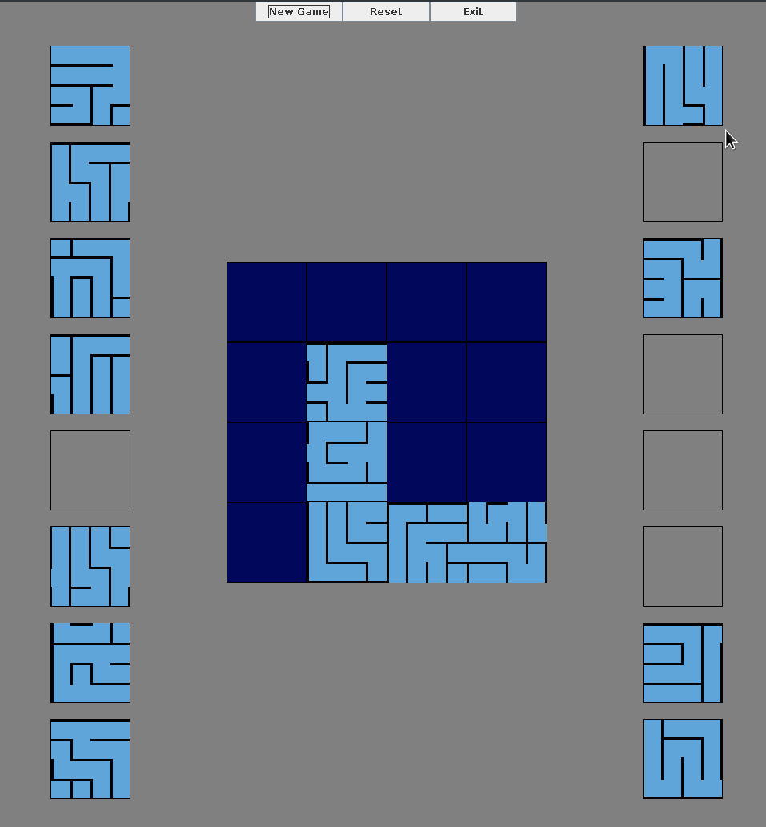
This concludes our brief tutorial, and will be expanding as the functionality of our game improves.

