tint documentation

tint is a simple panel/taskbar intentionally made for openbox3, but should also work with other window managers.

It's based on ttm code http://code.google.com/p/ttm/

The goal is to keep a clean and unintrusive look with code lightweight and compliance with freedesktop specifications.

Install tint from source
tint depend on cairo, pango, glib, imlib2 and xinerama.

cd to src, type make and as root type make install

Run tint
execute tint
or tint -c path-to-config-file

With Openbox, add 'tint &' in Openbox config file $HOME/.config/openbox/autostart.sh

Configure tint
On the first startup, tint create the config file in $HOME/.config/tint/tintrc

You can customize tintrc or specify another file on the command line.

tint -c $HOME/tint.conf

Panel
- panel_mode = single_desktop, multi_desktop or multi_monitor
panel_mode = single_desktop : tint show one taskbar from current desktop
panel_mode = multi_desktop : tint show one taskbar by desktop
you can drag-and-drop task between desktop
and clic on an empty taskbar to switch desktop
panel_mode = multi_monitor : tint show one taskbar by monitor
- panel_monitor = monitor where tint draw the panel
the first monitor is 1.
- panel_position = vertical_position horizontal_position
value for vertical_position : bottom, top
value for horizontal_position : left, right, center
- panel_size = width height
width = 0 to get full monitor width
- panel_margin = horizontal_margin vertical_margin

panel_ mode = multi_monitor
with 2 tasks on monitor 1 and 1 task on monitor 2.
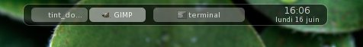

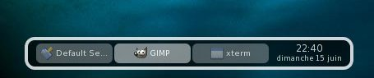
panel_monitor = 1
panel_position = bottom left
panel_size = 400 40
panel_margin = 30 10

Monitor 1
Panel
30
10
400
40

horizontal margin

vertical margin

In multi-monitor environment, you can run one panel per monitor.

One config file for laptop monitor (1024x768) ...
tint -c $HOME/.config/tint/tintrc1 &
panel_monitor = 1
panel_position = bottom center
panel_size = 800 30

And another config file for an external monitor (1280x1024)
tint -c $HOME/.config/tint/tintrc2 &
panel_monitor = 2
panel_position = bottom center
panel_size = 1000 35
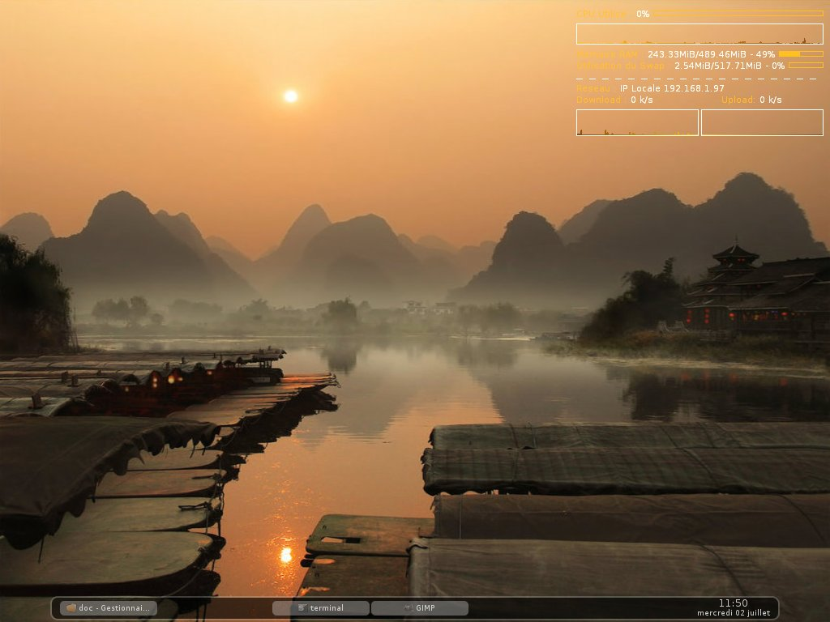

- font_shadow = boolean (0 or 1)

Panel background and border
- panel_padding = horizontal_ padding vertical_ padding
- panel_rounded = number_of_pixels
- panel_border_width = width
- panel_background_color = color opacity
value for color : hexadecimal color code
value for opacity (alpha) : percentage between 0 and 100
opacity = 0 to get backgroung transparency
- panel_border_color = color opacity

panel_padding = 10 5
panel_rounded = 10
panel_border_width = 4
panel_background_color = #000000 60
panel_border_color = #ffffff 80

400
Panel
horizontal padding
5
Clock
10
10
Taskbar
10
40
5

vertical padding

Task
- task_text_centered = boolean (0 or 1)
- task_width = width
task_width = 0 to get full taskbar width
- task_margin = vertical_margin
- task_padding = vertical_padding
- task_icon_size = size
task_icon_size = 0 to hide icon

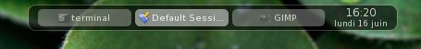
task_text_centered = 1
task_width = 110
task_margin = 4
task_padding = 2
task_icon_size = 13

Taskbar
4
4
2
2
icon & name
task padding
task margin

Task font
- task_font = [FAMILY-LIST] [STYLE-OPTIONS] [SIZE]
- task_font_color = color opacity
- task_active_font_color = color opacity

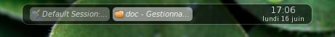
task_font = sans italic 7.5
task_font_color = #ffffff 70
task_active_font_color = #ffffff 90

Task background and border
- task_rounded = number_of_pixels
- task_background_color = color opacity
opacity = 0 to get backgroung transparency
- task_active_background_color = color opacity
opacity = 0 to get backgroung transparency
- task_border_width = width
- task_border_color = color opacity
opacity = 0 to get border transparency
- task_active_border_color = color opacity
opacity = 0 to get border transparency

task_rounded = 6
task_background_color = #00e1ff 50
task_active_background_color = #00e1ff 80
task_border_width = 2
task_border_color = #ffffff 30
task_active_border_color = #ffffff 50

Clock
- time1_format = %H:%M
time1_format use 'strftime' syntax
comment time1_format and time2_format to hide clock
- time1_font = [FAMILY-LIST] [STYLE-OPTIONS] [SIZE]
- time2_format = %A %d %B
- time2_font = [FAMILY-LIST] [STYLE-OPTIONS] [SIZE]
- clock_font_color = color opacity

time1_format = %d/%m %H:%M
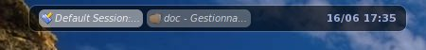
time1_font = sans bold 8
#time2_format = %A %d %B
time2_font = sans 6
clock_font_color = #020d35 80

Mouse
customize mouse action with : none, close, toggle, iconify, shade, toggle_iconify

mouse_middle = none
mouse_right = close
mouse_scroll_up = toggle
mouse_scroll_down = iconify

Launcher

Not yet done.

Copyright
tint and documentation are distributed under the MIT License.

- 2008 thierry lorthiois (lorthiois@bbsoft.fr)
- 2007 Pål Staurland (staura@gmail.com)

