Instructions

# UV Layout

# 

This texture is made op of a standard color map with an extra ambient occlusion (AO). The AO map takes care of adding shadows to the texture. By disabling the AO it’s a lot easier to edit the color of the textures without messing with shadows. In this case we are projecting photos onto the texture which makes it a little bit more difficult with shadows. If we look at the default shadow map:

## 

You can see that there are no shadows on the side. If the shadows on the front and back are annoying, or do not match the picture, you can remove those from the AO map (by making them white). The Hinge and the stand pad supports require the AO map because these smaller parts cannot be projected from an image. I have added instructions for how to add hinge and stand pad support colors in this document.

After adding the AO map and selecting the blending mode to “Multiply”, you may see some weird artifacts like this:  
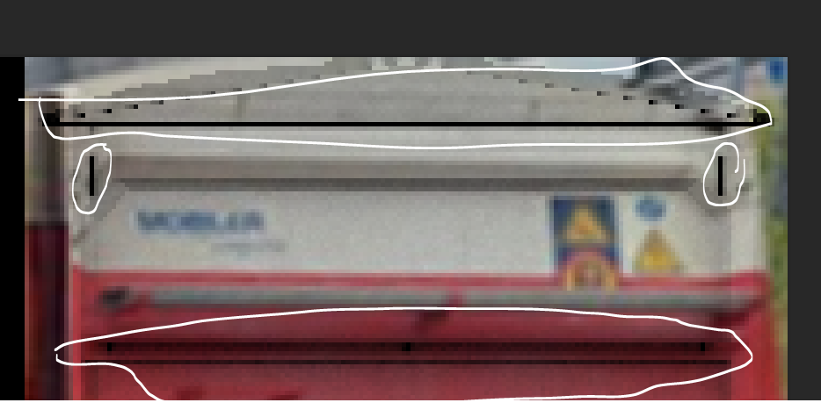

This is not an issue because at those texture coordinates the 3d model is fully occluded (no light can reach it because it is blocked by other geometry. These black spots give a nice sharp/realistic edge to the hinges, the standing pad and the door hinge.

## Hinge

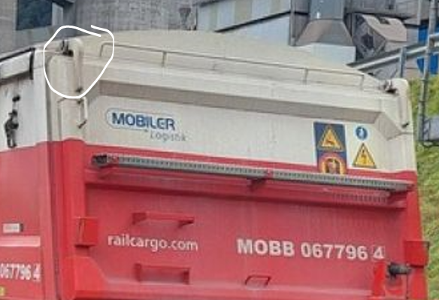

The hinge color can be given by sampling an area with a similar color:  
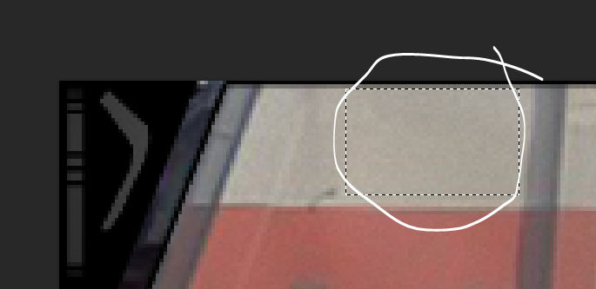

And dragging it over the UV’s of the hinge:  
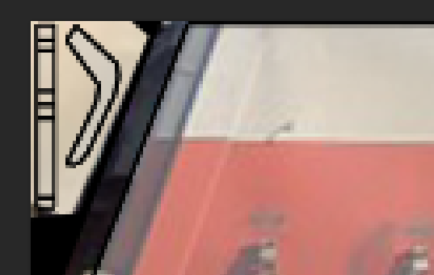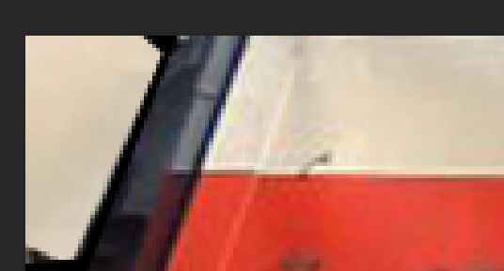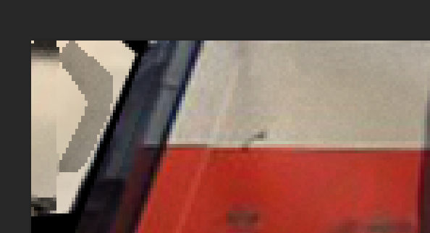

With UV Map Without UV Map With AO (Blending mode: Multiply)

## Stand pad supports

The stand pad supports are the following things that connect the standing pad to the door:

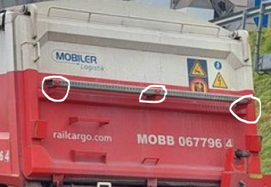

To give them an appropriate color, you can sample the red area below it for example, in the same way as we did with the hinge:

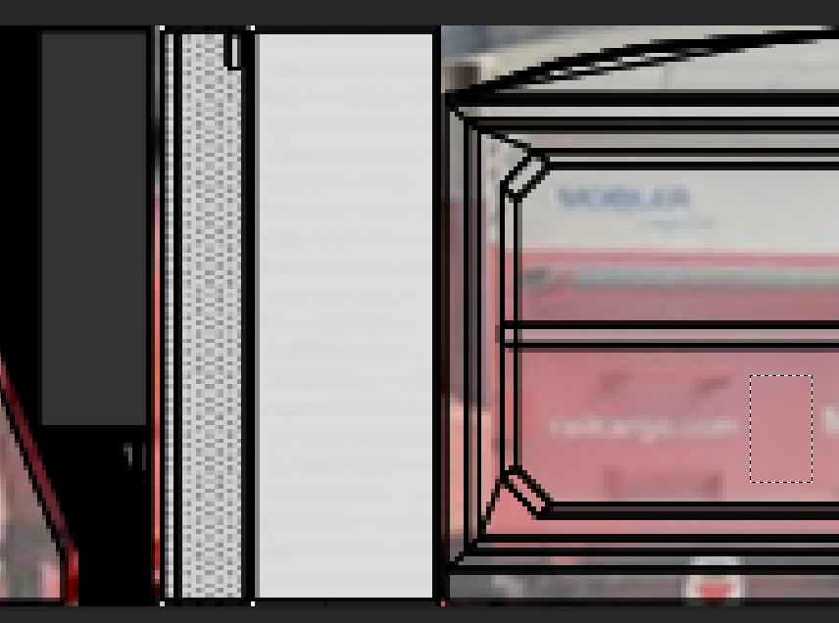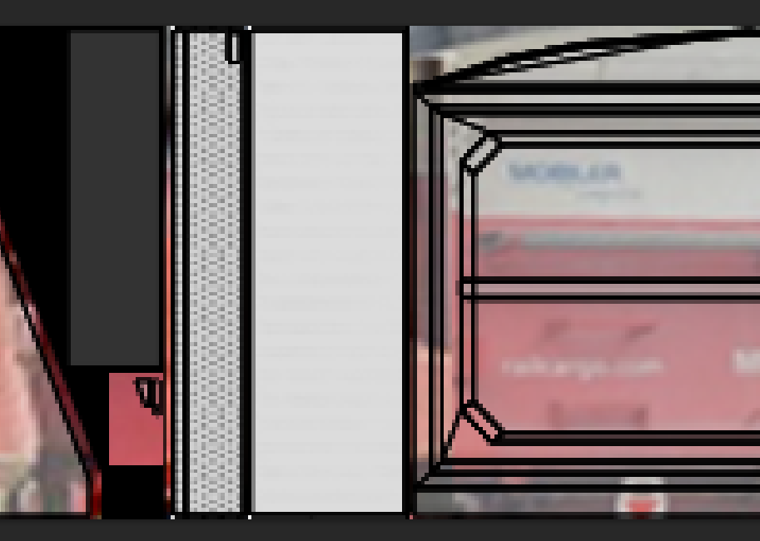

Sample And paste it into location

The AO map will ensure that it looks good and has the appropriate shadows:

