Project: Generative AI-Based Ligand Binding Pose Refinement from Physics-Based Priors
Report 1: Understanding of Proteins, Substrate and Molecular Docking

Topics:
- Proteins (Amino Acids)
- Protein-Ligand Interaction
- Molecular Docking

Name: Samarth Mukesh Pawar (25110283)

I PROTEINS:
- Proteins transport nutrients, catalyze chemical reactions and are the structural components of living organisms.
- Proteins are made up of 20 set of standard amino acids.

AMINO ACIDS:
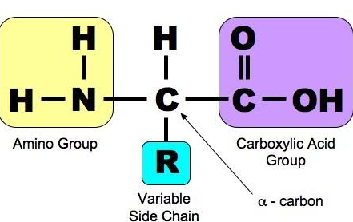
- Amino Acids are classified by their side chain (-R group) structure.
  - Hydrophobic: The side chain that repel water molecules. (non-polar group).
  - Hydrophilic: The side chain which favorably interact with water molecules (through hydrogen bonding).
  - Charged: Interact with oppositely charged molecules/amino acids. (acidic or basic groups).
PRIMARY STRUCTURE OF PROTEINS:
- The primary structure of proteins is formed due to the linear sequential joining of amino acids as encoded by the DNA.
- The amino acids are joined via peptide bonds.

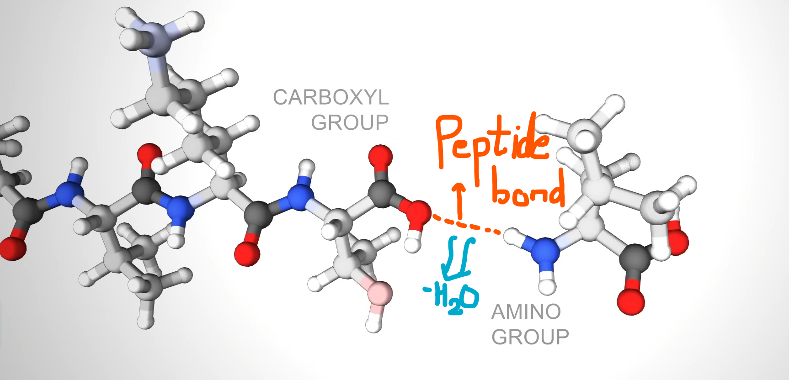

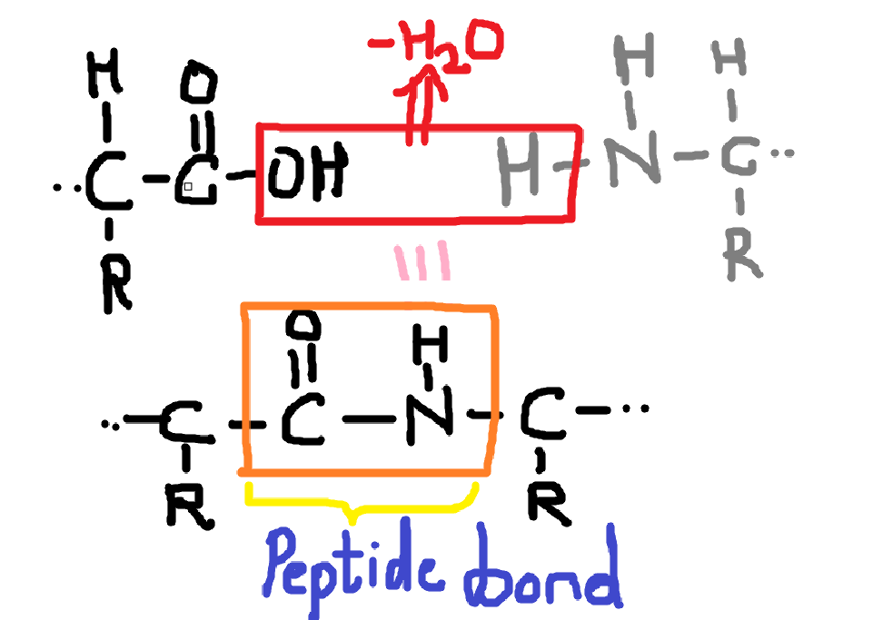

SECONDARY STRUCTURE OF PROTEINS:
- Alpha helix: It’s a right-handed coil stabilized by hydrogen bonds between nearby amine and carboxylic groups.
- Beta sheet: It is formed when hydrogen bonds stabilize two or more adjacent strands.

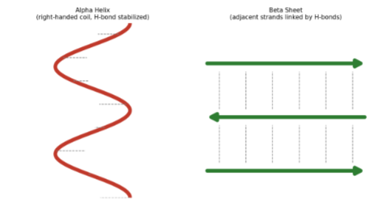

TERTIARY STRUCTURE OF PROTEINS:
The tertiary structure is the overall 3D shape of a single protein chain, determined by the properties of its amino acids.
- Many proteins fold into globular shapes with hydrophobic side chains tucked inside, shielded from surrounding water.
- Membrane-bound proteins instead cluster hydrophobic residues on the outside, allowing them to interact with lipid membranes.
- Charged amino acids let proteins interact with molecules bearing complementary (opposite) charges.

II PROTEIN-LIGAND INTERACTION
ENZYME-SUBSTRATE INTERACTIONS:
- Enzymes are special proteins with a specific part typically referred to as the “lock” (active site).
- Substrates are the “keys” (molecules) that fit into the lock.
- When a substrate binds to an enzyme, it undergoes a chemical reaction and is converted into a product.
- Enzyme releases the product after the reaction and returns to its original shape.

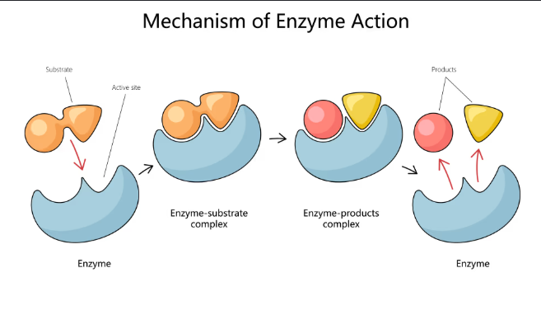

PROTEIN-NUCLEIC ACID INTERACTIONS:
- Proteins can connect to nucleic acids (DNA and RNA) to regulate gene expression, DNA replication, and RNA processing.
- Some proteins can bind to specific spots in the DNA and prevent those spots from being “read”, ensuring that genes are activated or suppressed when needed.

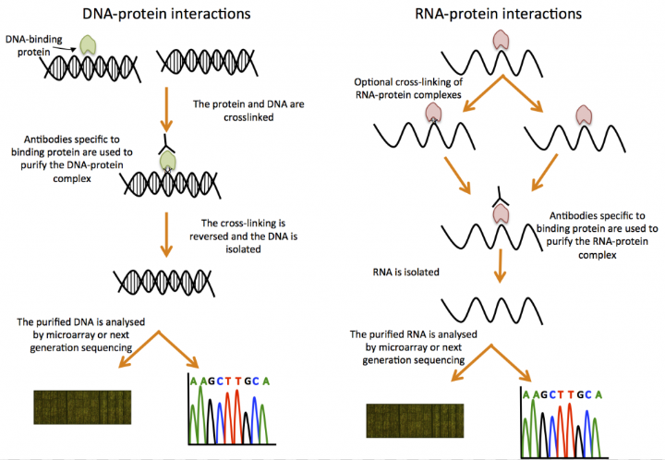

BINDING AFFINITY AND DISSOCIATION CONSTANT:
- Binding affinity is the measure of how tightly a ligand binds with the active site.
- Suppose we represent ligand as {L} and protein as {P} then when they are bound together we will represent them as {LP}. This is a two-state process and can be represented as:
L + P $⇌$ LP
- The dissociation constant can be calculated as:
$$k_{D}=\frac{\left[L\right][P]}{[LP]}$$
- A lower dissociation constant means higher binding affinity and a higher dissociation constant means lower binding affinity.
- Ideal drug candidates have higher binding affinity to intended targets.

III MOLECULAR DOCKING
UNDERSTANDING DOCKING
- Molecular recognition is the ability of biomolecules to recognize other biomolecules and selectively interact with them in order to promote fundamental biological events this is known as Molecular Docking.
- Types of Molecular Docking:
- Lock and Key Theory: A substrate fits into the active site of a macromolecule, just like a key fits into a lock.
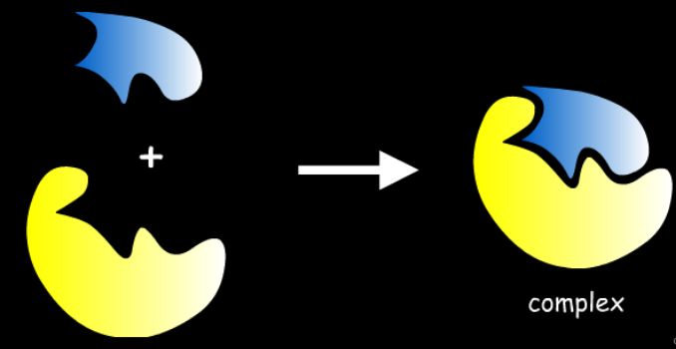

- Induced-Fit Theory: Both ligand and target mutually adapt their structure until an optimal fit is achieved.
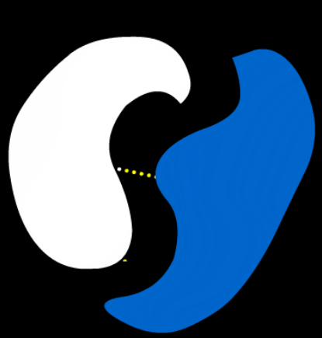

COMPUTATIONAL DOCKING:
- It is a computational science aiming at predicting the optimal binding pose of interacting molecules.
- Most common docking systems: protein-protein, nucleic acid-protein and protein-small molecule.

DOCKING PROBLEM:
- The task of predicting how molecules interact with each other is called docking problem.
- Molecular docking software is like a black box whose input is set of 3D structures to be docked and output is the predicted complexes of molecules.
- The main goal is to find the 3D structure of the complex and binding affinity.

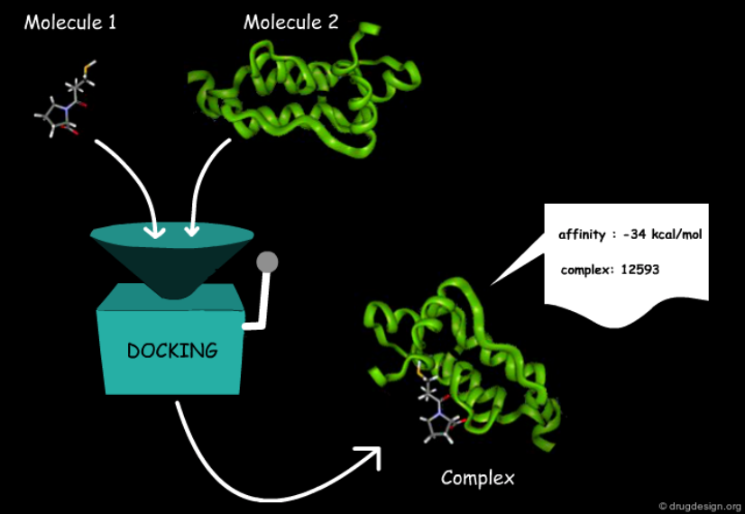

CLASSIFICATION OF DOCKING PROBLEMS
By Molecular Flexibility:
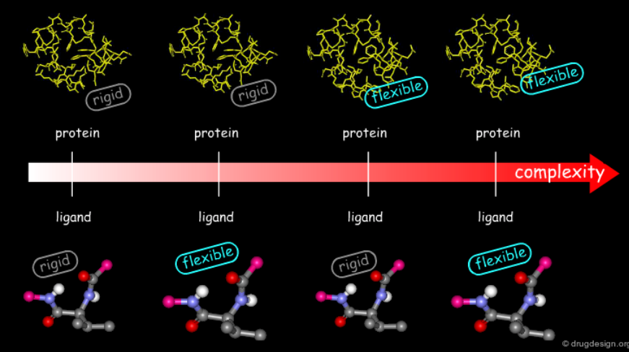

By Availability of Structural Data:
Docking difficulty also depends on what structural information is available in the start of the process.
- Bound Docking: The experimental structure of complex is already known. Used mainly to calibrate the software.

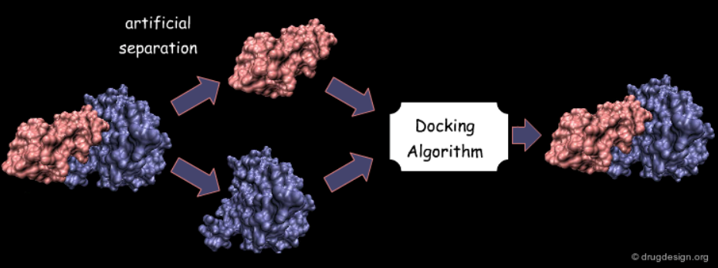

- Unbound Docking: Only the separate molecule structures are known. You’ll have to correctly develop the model for this condition.

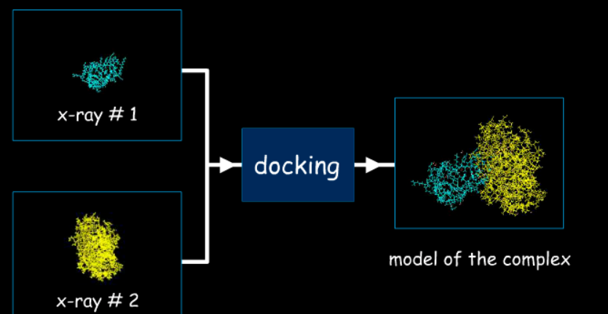

- Modeled Docking: No experimental structure at all. It relies on homology modeling.

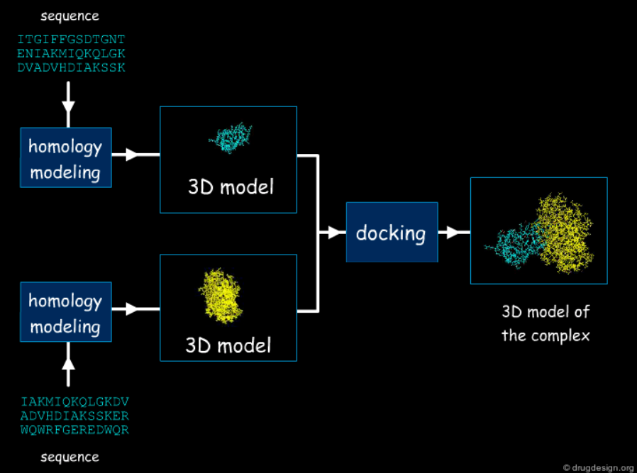

SCORING METHODS
- Binding is governed by three main factors: interaction energies, desolvation/solvation energies and entropic effects.
- Interaction Forces:
  - Favorable Forces: Good hydrophobic contacts, hydrogen bonding (strong and directional), attractive electrostatic (strong and directional).
  - Unfavorable Forces: bad hydrophobic contacts (steric clashes) and repulsive electrostatic interactions.
- Desolvation: Hydrophobic groups associate to reduce contact with surrounding water.
- Entropy: Molecular flexibility affects binding energy.

BINDING AND FREE ENERGY
- Binding energy is the energy required to separate complex into its parts, =E(complex) – [E(protein) + E(ligand)]
- deltaG=-RTln(K)
- deltaG change of about 6 kJ/mol corresponds to roughly one order of magnitude in log K - which can be the difference between a micromolar and a nanomolar compound.
- Calculating deltaG directly from the Gibbs equation is hard because the entropic term is difficult to estimate, so it's often neglected as a first approximation.
- With entropy neglected and constant pressure assumed, deltaG can be approximated using internal energy (deltaU) via molecular mechanics.
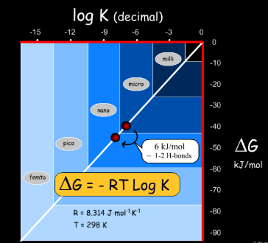

SCORING FUNCTION
- Two categories:
  - Empirical scoring func: The software counts how many specific interactions occur in a modeled drug-protein pose; Each type of interaction is multiplied by a predefined weight.
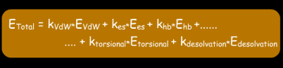
  - Knowledge-Based scoring func: Computational tools scan the database (PDB); The tools count how many times atom pair occur at some specific distance; Using statistical mechanics, high-frequency distances are assumed to be energetically favourable (low energy), while rare distances are classified as unfavourable (high energy); These probabilities are converted into statistical energy scores called PMFs.

