Assignment

1) Write a program to check given number is palindrome or not.

using System;

using System.Collections.Generic;

using System.Linq;

using System.Text;

namespace Ass1

{

class demo

{

public int n, r, sum = 0, temp;

public void read()

{

Console.Write("Enter the Number: ");

n = Convert.ToInt32(Console.ReadLine());

temp = n;

}

public void display()

{

while (n > 0)

{

r = n % 10;

sum = (sum * 10) + r;

n = n / 10;

}

if (temp == sum)

Console.Write("Number is Palindrome.");

else

Console.Write("Number is not Palindrome");

}

}

class Program

{

static void Main(string[] args)

{

demo d1 = new demo();

d1.read();

d1.display();

Console.ReadLine();

}

}

}

2) Write a program to check given number is Perfect or not.

using System;

using System.Collections.Generic;

using System.Linq;

using System.Text;

namespace Ass2

{

class demo

{

public int number,sum=0,n;

public void read()

{

Console.Write("enter the Number");

number = Convert.ToInt32(Console.ReadLine());

n = number;

for (int i = 1; i < number; i++)

{

if (number % i == 0)

{

sum = sum + i;

}

}

if (sum == n)

{

Console.WriteLine("\n Entered number is a perfect number");

Console.ReadLine();

}

else

{

Console.WriteLine("\n Entered number is not a perfect number");

}

}

}

class Program

{

static void Main(string[] args)

{

demo d1 = new demo();

d1.read();

Console.ReadLine();

}

}

}

3) Write a program to check given number is Armstrong or not.

using System;

using System.Collections.Generic;

using System.Linq;

using System.Text;

namespace Ass3

{

class demo

{

public int n, r, sum = 0, temp;

public void show()

{

Console.Write("Enter the Number= ");

n = Convert.ToInt32(Console.ReadLine());

temp = n;

while (n > 0)

{

r = n % 10;

sum = sum + (r * r * r);

n = n / 10;

}

if (temp == sum)

Console.Write("Armstrong Number.");

else

Console.Write("Not Armstrong Number.");

}

}

class Program

{

static void Main(string[] args)

{

demo d1 = new demo();

d1.show();

Console.ReadLine();

}

}

}

4) Write a program to check given number is prime or not.

using System;

using System.Collections.Generic;

using System.Linq;

using System.Text;

namespace Ass4

{

class demo

{

public int n, a = 0;

public void show()

{

Console.Write("Enter the Number to check Prime: ");

n = Convert.ToInt32(Console.ReadLine());

for (int i = 1; i <= n; i++)

{

if (n % i == 0)

{

a++;

}

}

if (a == 2)

{

Console.WriteLine("{0} is a Prime Number", n);

}

else

{

Console.WriteLine("Not a Prime Number");

}

}

class Program

{

static void Main(string[] args)

{

demo d1 = new demo();

d1.show();

Console.ReadLine();

}

}

}

5) Write a program to print prime numbers in given range.

using System;

using System.Collections.Generic;

using System.Linq;

using System.Text;

namespace Ass5

{

class demo

{

public int no1, no2;

public Boolean n = true;

public void show()

{

Console.WriteLine("range to find prime number ");

no1 = Convert.ToInt32(Console.ReadLine());

no2 = Convert.ToInt32(Console.ReadLine());

Console.WriteLine("prime number is");

for (int j = no1; j <= no2; j++)

{

for (int i = 2; i < j; i++)

{

if ((j % i) == 0)

{

n = false;

break;

}

}

if (n == true)

{

Console.WriteLine(j);

}

n = true;

}

}

}

class Program

{

static void Main(string[] args)

{

demo d1 = new demo();

d1.show();

Console.ReadLine();

}

}

}

6) Write a program to print factorial of given numbers.

using System;

using System.Collections.Generic;

using System.Linq;

using System.Text;

namespace Ass6

{

class demo

{

public int i, fact = 1, number;

public void show()

{

Console.Write("Enter any Number: ");

number = Convert.ToInt32(Console.ReadLine());

for (i = 1; i <= number; i++)

{

fact = fact * i;

}

Console.Write("Factorial of " + number + " is: " + fact);

}

}

class Program

{

static void Main(string[] args)

{

demo d1 = new demo();

d1.show();

Console.ReadLine();

}

}

}

7) Write a program to print reverse number.

using System;

using System.Collections.Generic;

using System.Linq;

using System.Text;

namespace Ass7

{

class demo

{

public int n, reverse = 0, rem;

public void show()

{

Console.Write("Enter a number: ");

n = Convert.ToInt32(Console.ReadLine());

while (n != 0)

{

rem = n % 10;

reverse = reverse * 10 + rem;

n /= 10;

}

Console.Write("Reversed Number: " + reverse);

}

}

class Program

{

static void Main(string[] args)

{

demo d1 = new demo();

d1.show();

Console.ReadLine();

}

}

}

8) Write a program to print addition of three digit number.

using System;

using System.Collections.Generic;

using System.Linq;

using System.Text;

namespace Ass8

{

class demo

{

public int n, sum = 0, m;

public void show()

{

Console.Write("Enter a number: ");

n =Convert.ToInt32(Console.ReadLine());

while (n > 0)

{

m = n % 10;

sum = sum + m;

n = n / 10;

}

Console.Write("Sum is= " + sum);

}

}

class Program

{

static void Main(string[] args)

{

demo d1 = new demo();

d1.show();

Console.ReadLine();

}

}

}

9) Write to program to "Teach One, Each One, Tree One" given numbers of time.

using System;

using System.Collections.Generic;

using System.Linq;

using System.Text;

namespace Ass9

{

class demo

{

public int n;

public void show()

{

Console.Write("enter number");

n = Convert.ToInt32(Console.ReadLine());

for (int i = 1; i <= n; i++)

{

Console.Write("Teach one,Each one Tree one\n");

}

}

}

class Program

{

static void Main(string[] args)

{

demo d1 = new demo();

d1.show();

Console.ReadLine();

}

}

}

10) Write a program to show use of different operators.

using System;

using System.Collections.Generic;

using System.Linq;

using System.Text;

namespace Ass10

{

class demo

{

public int a, b;

public void read()

{

Console.WriteLine("enter number of a");

a = Convert.ToInt32(Console.ReadLine());

Console.WriteLine("enter number of b");

b = Convert.ToInt32(Console.ReadLine());

}

public void display()

{

Console.WriteLine("add is" + (a + b));

Console.WriteLine("sub is" + (a - b));

Console.WriteLine("mul is" + (a * b));

Console.WriteLine("div is" + (a / b));

Console.WriteLine("mod is" + (a % b));

}

}

class Program

{

static void Main(string[] args)

{

demo d1=new demo();

d1.read();

d1.display();

Console.ReadLine();

}

}

}

11) Write a program to show use of looping construct.

using System;

using System.Collections.Generic;

using System.Linq;

using System.Text;

namespace Ass11

{

class demo

{

public int n,i;

public void show()

{

Console.WriteLine("enter number");

n=Convert.ToInt32(Console.ReadLine());

for (i = 1; i <= 10; i++)

{

Console.WriteLine(i * n);

}

}

}

class Program

{

static void Main(string[] args)

{

demo d1 = new demo();

d1.show();

Console.ReadLine();

}

}

}

12) Write a program to show use of class and object.

using System;

using System.Collections.Generic;

using System.Linq;

using System.Text;

namespace Ass12

{

class demo

{

public String name;

public int rollno;

public void show()

{

Console.Write("enter your name");

name = Convert.ToString(Console.ReadLine());

Console.Write("enter your rollno");

rollno=Convert.ToInt32(Console.ReadLine());

Console.Write("name is="+name+"\n");

Console.Write("rollno is="+rollno+"\n");

}

}

class Program

{

static void Main(string[] args)

{

demo d1=new demo();

d1.show();

Console.ReadLine();

}

}

}

13) Write a program to show use of constructor.

using System;

using System.Collections.Generic;

using System.Linq;

using System.Text;

namespace Ass13

{

class demo

{

public demo()

{

Console.Write("Constructor called");

}

}

class program

{

static void Main(string[] args)

{

demo d = new demo();

Console.ReadLine();

}

}

}

14) Write a program to show use of Copy constructor.

using System;

using System.Collections.Generic;

using System.Linq;

using System.Text;

namespace Ass14

{

class demo

{

int a, b, sum;

public demo(int x, int y)

{

a = x;

b = y;

}

public demo(demo d)

{

a=d.a;

b = d.b;

sum=a+b;

Console.Write("add is="+sum);

}

}

class program

{

static void Main(string[] args)

{

demo d = new demo(10, 20);

demo d1 = new demo(d);

Console.ReadLine();

}

}

}

15) Write a program to demonstrate Single inheritance.

using System;

using System.Collections.Generic;

using System.Linq;

using System.Text;

namespace Ass15

{

class A

{

public int a, b, sum;

public void methodA()

{

Console.Write("enter two number");

a=Convert.ToInt32(Console.ReadLine());

b=Convert.ToInt32(Console.ReadLine());

sum=a+b;

}

}

class B : A

{

public void methodB()

{

Console.Write("add is="+sum);

}

}

class Program

{

static void Main(string[] args)

{

B obj = new B();

obj.methodA();

obj.methodB();

Console.ReadLine();

}

}

}

16) Write a program to demonstrate multiple inheritances.

using System;

using System.Collections.Generic;

using System.Linq;

using System.Text;

namespace Ass16

{

interface demo

{

void display();

}

class demo1

{

public int a, b;

public void input()

{

Console.Write("enter two number");

a = Convert.ToInt32(Console.ReadLine());

b = Convert.ToInt32(Console.ReadLine());

}

}

class demo2 : demo1,demo

{

public void display()

{

Console.Write("add is=" + (a + b));

}

}

class Program

{

static void Main(string[] args)

{

demo2 d = new demo2();

d.input();

d.display();

Console.ReadLine();

}

}

}

17) Write a program to demonstrate hierarchical inheritance.

using System;

using System.Collections.Generic;

using System.Linq;

using System.Text;

namespace Ass17

{

class a

{

public void display()

{

Console.WriteLine("Display...");

}

}

class b : a

{

public void displayOne()

{

Console.WriteLine("Display One");

}

}

class c : a

{

public void displayTwo()

{

Console.WriteLine("Display Two");

}

}

class Program

{

static void Main(string[] args)

{

b b1=new b();

b1.display();

b1.displayOne();

c c1=new c();

c1.display();

c1.displayTwo();

Console.ReadLine();

}

}

}

18) Write a program to show use of exception handling. (Divide By Zero)

using System;

using System.Collections.Generic;

using System.Linq;

using System.Text;

namespace Ass18

{

class demo

{

public void show()

{

int a, b;

Console.Write("enter two number");

a = Convert.ToInt32(Console.ReadLine());

b = Convert.ToInt32(Console.ReadLine());

try

{

Console.Write(a / b);

}

catch (ArithmeticException e)

{

Console.Write("Divided by zero operation cannot possible");

}

}

}

class Program

{

static void Main(string[] args)

{

demo d = new demo();

d.show();

Console.ReadLine();

}

}

}

19) Write a program to show use of exception handling. (Array Index out of bound)

using System;

using System.Collections.Generic;

using System.Linq;

using System.Text;

namespace Ass19

{

class demo

{

public void show()

{

int difference = 0;

int n;

int[] number = new int[5] { 1, 2, 3, 4, 5 };

Console.Write("enter number");

n = Convert.ToInt32(Console.ReadLine());

try

{

for (int i = 1; i <= n; i++)

{

difference = difference - number[i];

}

Console.WriteLine("The difference of the array is:" + difference);

}

catch (IndexOutOfRangeException e)

{

Console.WriteLine(e.Message);

}

}

}

class program

{

static void Main(string[] args)

{

demo d = new demo();

d.show();

Console.ReadLine();

}

}

}

20) Write the program to demonstrate function overriding.

using System;

using System.Collections.Generic;

using System.Linq;

using System.Text;

namespace Ass20

{

public class Animal

{

public virtual void eat()

{

Console.WriteLine("Eating...");

}

}

public class Dog : Animal

{

public override void eat()

{

Console.WriteLine("Eating bread...");

}

}

class Program

{

static void Main(string[] args)

{

Dog d = new Dog();

d.eat();

Console.ReadLine();

}

}

}

21) Write the program to demonstrate function overloading.

using System;

using System.Collections.Generic;

using System.Linq;

using System.Text;

namespace Ass21

{

public class demo

{

public void add(int a, int b)

{

Console.Write("add is=" + (a + b));

}

public void add(int a, int b, int c)

{

Console.Write("\nadd is=" + (a + b + c));

}

}

class Program

{

static void Main(string[] args)

{

demo d = new demo();

d.add(10, 20);

d.add(10,20, 30);

Console.ReadLine();

}

}

}

22) Write a program to demonstrate interface.

using System;

using System.Collections.Generic;

using System.Linq;

using System.Text;

namespace Ass22

{

public interface demo

{

void show();

}

public class demo1 : demo

{

public void show()

{

Console.WriteLine("demonstration of interface");

}

}

class Program

{

static void Main(string[] args)

{

demo1 d=new demo1();

d.show();

Console.ReadLine();

}

}

}

23) Write a program to demonstrate multiple interfaces.

using System;

using System.Collections.Generic;

using System.Linq;

using System.Text;

namespace Ass23

{

public interface demo

{

void method1();

}

public interface demo1

{

void method2();

}

class demo3 : demo,demo1

{

public void method1()

{

Console.WriteLine("first interface ");

}

public void method2()

{

Console.WriteLine("second interface");

}

}

class Program

{

static void Main(string[] args)

{

demo3 d = new demo3();

d.method1();

d.method2();

Console.ReadLine();

}

}

}

24) Write the program to demonstrate command line argument.

using System;

using System.Collections.Generic;

using System.Linq;

using System.Text;

namespace Ass24

{

class demo

{

void show()

{

Console.WriteLine("First Name is " + args[0]);

Console.WriteLine("Last Name is " + args[1]);

}

}

class Program

{

static void Main(string[] args)

{

demo d = new demo();

Console.ReadLine();

}

}

}

25) Create a simple C# application using label, text box, button controls.

using System;

using System.Collections.Generic;

using System.ComponentModel;

using System.Data;

using System.Drawing;

using System.Linq;

using System.Text;

using System.Windows.Forms;

namespace Ass25

{

public partial class Form1 : Form

{

public Form1()

{

InitializeComponent();

label3.Hide();

label4.Hide();

}

private void button1_Click(object sender, EventArgs e)

{

label3.Text = textBox1.Text;

label4.Text = textBox2.Text;

label3.Show();

label4.Show();

}

}

}

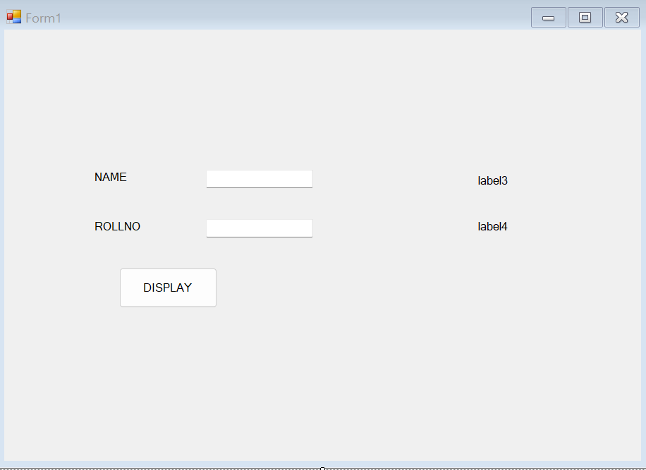

26) Create a simple C# application using list box, combo box controls.

using System;

using System.Collections.Generic;

using System.ComponentModel;

using System.Data;

using System.Drawing;

using System.Linq;

using System.Text;

using System.Windows.Forms;

namespace Ass26

{

public partial class Form1 : Form

{

public Form1()

{

InitializeComponent();

label4.Hide();

label5.Hide();

label6.Hide();

}

private void button1_Click(object sender, EventArgs e)

{

label4.Text = textBox1.Text;

label5.Text = listBox1.Text;

label6.Text = comboBox1.Text;

label4.Show();

label5.Show();

label6.Show();

}

}

}

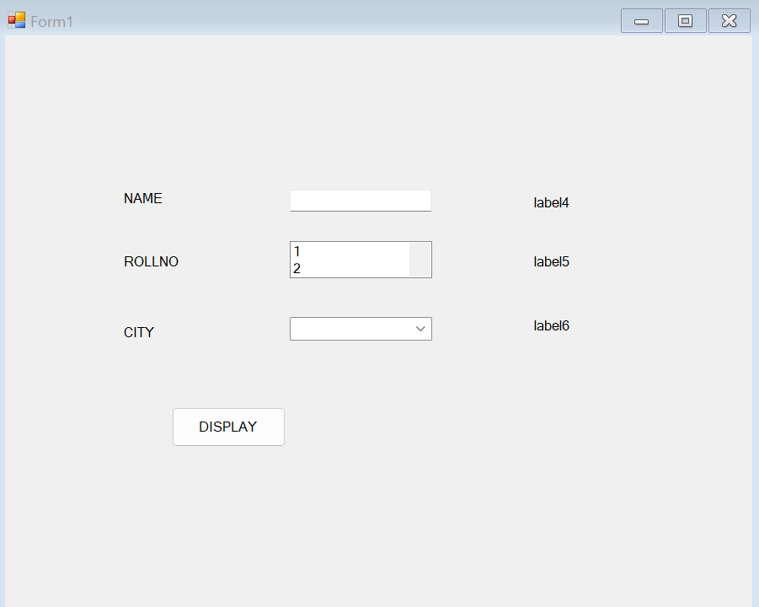

27) Create a C# application using picture box, scrollbar controls.

using System;

using System.Collections.Generic;

using System.ComponentModel;

using System.Data;

using System.Drawing;

using System.Linq;

using System.Text;

using System.Windows.Forms;

namespace Ass27

{

public partial class Form1 : Form

{

public Form1()

{

InitializeComponent();

}

private void hScrollBar1_Scroll(object sender, ScrollEventArgs e)

{

label1.Text = hScrollBar1.Value.ToString();

}

}

}

**Step 1**  : Create a form

**Step 2** : Insert picture in picture box

**Step 3** : Write code for hScrollBar1

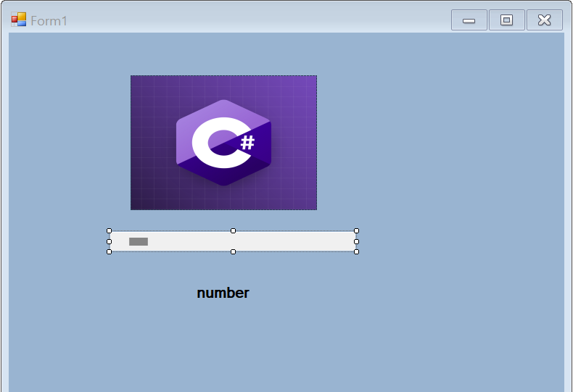

28) Demonstrate the use of timer control in C#.

using System;

using System.Collections.Generic;

using System.ComponentModel;

using System.Data;

using System.Drawing;

using System.Linq;

using System.Text;

using System.Windows.Forms;

namespace Timer

{

public partial class Form1 : Form

{

int second = 0;

public Form1()

{

InitializeComponent();

}

private void progressBar1_Click(object sender, EventArgs e)

{

}

private void Form1_Load(object sender, EventArgs e)

{

timer1.Interval = 1000;

timer1.Start();

progressBar1.Value = 0;

}

private void timer1_Tick(object sender, EventArgs e)

{

label1.Text = DateTime.Now.ToString();

second = second + 1;

progressBar1.Visible = true;

progressBar1.Value = progressBar1.Value + 1;

if (progressBar1.Value == 15)

{

Form2 f2 = new Form2();

f2.Show();

progressBar1.Visible=false;

}

if (second >= 15)

{

timer1.Stop();

MessageBox.Show("Exiting..........");

}

}

}

}

Before 15 second 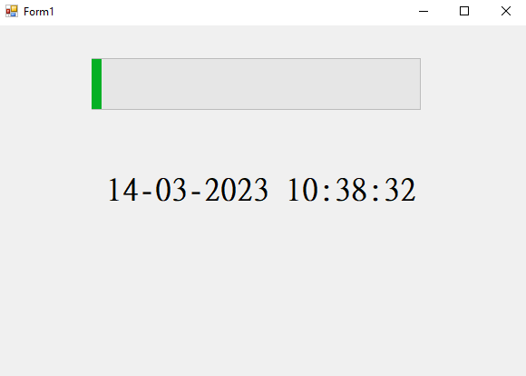

After 15 Second

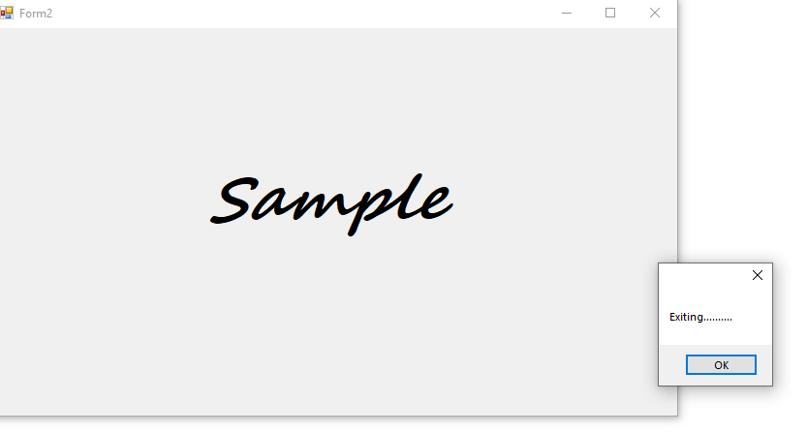

29) Write CH.Net application to perform insert, delete record from database.

using System;

using System.Collections.Generic;

using System.ComponentModel;

using System.Data;

using System.Drawing;

using System.Linq;

using System.Text;

using System.Windows.Forms;

using System.Data.OleDb;

namespace Ass29

{

public partial class Form1 : Form

{

public Form1()

{

InitializeComponent();

}

private void button1_Click(object sender, EventArgs e)

{

OleDbConnection con = new OleDbConnection("Provider=Microsoft.Jet.OLEDB.4.0;Data Source=E:\\Ass29.mdb");

OleDbCommand cmd = new OleDbCommand("insert into stud(sname,srollno) values('" + textBox1.Text + "'," + textBox2.Text + ")", con);

con.Open();

cmd.ExecuteNonQuery();

MessageBox.Show("insert successful");

}

private void button2_Click(object sender, EventArgs e)

{

OleDbConnection con = new OleDbConnection("Provider=Microsoft.Jet.OLEDB.4.0;Data Source=E:\\Ass29.mdb");

OleDbCommand cmd = new OleDbCommand("Delete from stud where srollno=" + textBox2.Text + "", con);

con.Open();

cmd.ExecuteNonQuery();

MessageBox.Show("delete successful");

}

}

}

**Step 1**  : Create a form

**Step 2** : Write code for insert button

**Step 3** : Write code for delete button

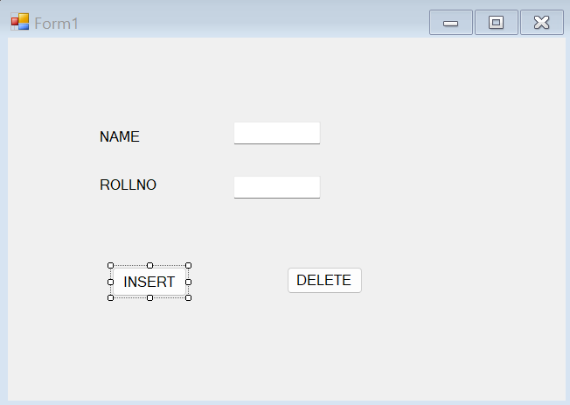

30) Write C#.net code to create login form.

using System;

using System.Collections.Generic;

using System.ComponentModel;

using System.Data;

using System.Drawing;

using System.Linq;

using System.Text;

using System.Windows.Forms;

namespace Ass30

{

public partial class Form1 : Form

{

public Form1()

{

InitializeComponent();

}

private void button1_Click(object sender, EventArgs e)

{

if (textBox1.Text == "rcp" && textBox2.Text == "imrd")

{

MessageBox.Show("Login Successfully");

}

else

{

MessageBox.Show("Username And Password incorrect");

}

}

}

}

**Step 1**  : Create a form

**Step 2** : Write code for login button

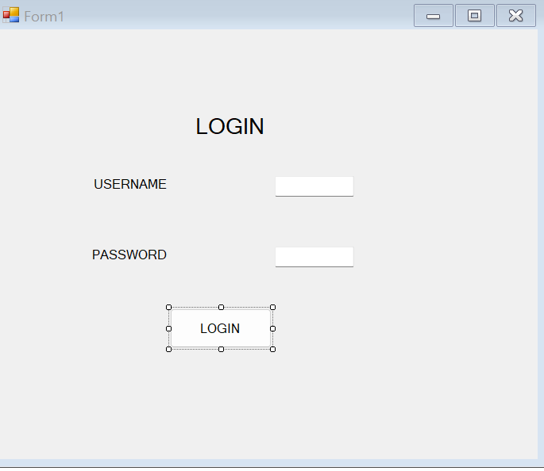

31) **.Write C#.Net Application To Perform Insert ,Update and Display Records From Database(MSACCESS)**

**Step 1**  : Create a database ex. demo

**Step 2** : Create a database ex. Stud

**Step 3** : Create a form

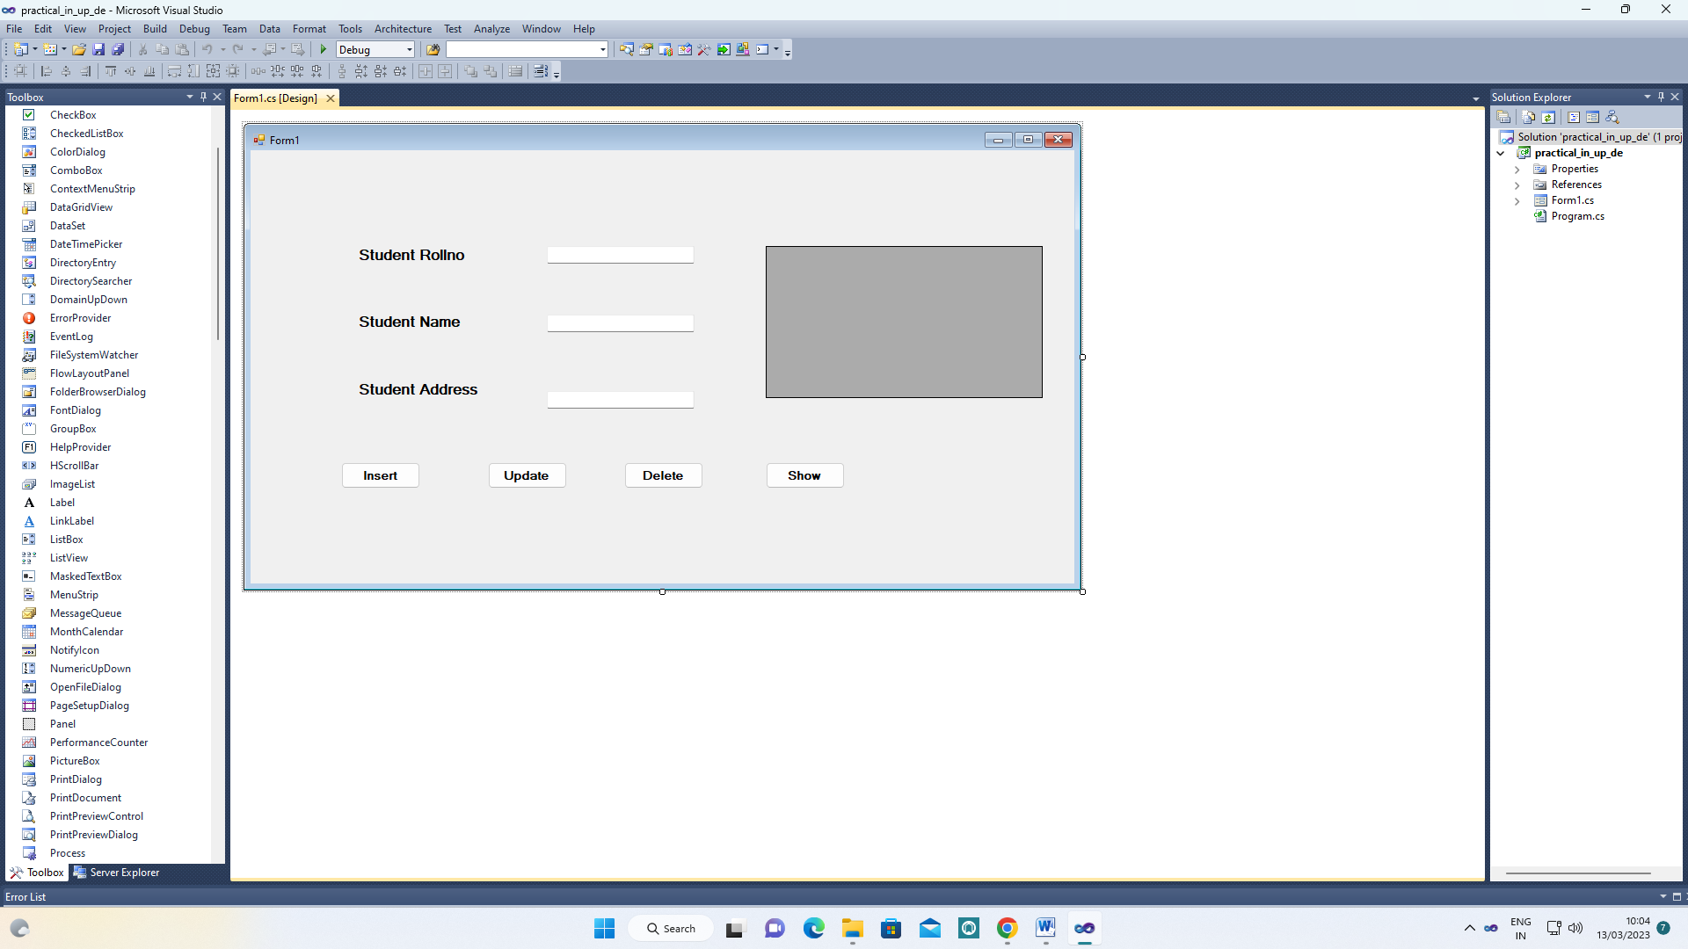

**Step 4** : Write code on button

**Insert button code :**

private void button1_Click(object sender, EventArgs e)

{

OleDbConnection con = new OleDbConnection("Provider=Microsoft.ACE.OLEDB.12.0;Data Source=E:\\nik\\practical.accdb");

OleDbCommand cmd = new OleDbCommand("insert into Stud(sroll,sname,sadd) values("+textBox1.Text+",'"+textBox2.Text+"','"+textBox3.Text+"')",con);

con.Open();

cmd.ExecuteNonQuery();

MessageBox.Show("insert successful");

}

**Update button code :**

private void button2_Click(object sender, EventArgs e)

{

OleDbConnection con = new OleDbConnection("Provider=Microsoft.ACE.OLEDB.12.0;Data Source=E:\\nik\\practical.accdb");

OleDbCommand cmd = new OleDbCommand("update Stud set sadd='"+textBox3.Text+"' where sroll="+textBox1.Text+"", con);

con.Open();

cmd.ExecuteNonQuery();

MessageBox.Show("update successful");

}

**Delete button code :**

private void button3_Click(object sender, EventArgs e)

{

OleDbConnection con = new OleDbConnection("Provider=Microsoft.ACE.OLEDB.12.0;Data Source=E:\\nik\\practical.accdb");

OleDbCommand cmd = new OleDbCommand("delete from Stud where sroll=" + textBox1.Text + "", con);

con.Open();

cmd.ExecuteNonQuery();

MessageBox.Show("delete successful");

}

**Show button code :**

private void button4_Click(object sender, EventArgs e)

{

OleDbConnection con = new OleDbConnection("Provider=Microsoft.ACE.OLEDB.12.0;Data Source=E:\\nik\\practical.accdb");

OleDbDataAdapter da = new OleDbDataAdapter("select * from stud",con);

con.Open();

DataSet ds = new DataSet();

da.Fill(ds,"stud");

dataGridView1.DataSource = ds.Tables["stud"].DefaultView;

}

37)

using System;

using System.Collections.Generic;

using System.Linq;

using System.Text;

namespace Ass37

{

class demo

{

public void display()

{

int []arr = { 1, 2, 3, 4, 5};

for (int i = 0; i < arr.Length; i++)

{

Console.WriteLine(arr[i]);

}

}

}

class Program

{

static void Main(string[] args)

{

demo d = new demo();

d.display();

Console.ReadLine();

}

}

}

38)

using System;

using System.Collections.Generic;

using System.Linq;

using System.Text;

namespace Ass38

{

class demo

{

public void display()

{

int[,] arr = { { 1, 2, 3 }, { 4, 5, 6 }, { 7, 8, 9 } };

for (int i = 0; i < 3; i++)

{

for (int j = 0; j < 3; j++)

{

Console.Write(arr[i, j] + " ");

}

Console.WriteLine();

}

}

}

class Program

{

static void Main(string[] args)

{

demo d = new demo();

d.display();

Console.ReadLine();

}

}

}

39)

using System;

using System.Collections.Generic;

using System.Linq;

using System.Text;

namespace Ass39

{

class demo

{

public void display()

{

int[][] arr = new int[3][]

{

new int[] { 11, 21, 56, 78 },

new int[] { 2, 5, 6, 7, 98, 5 },

new int[] { 2, 5 }

};

for (int i = 0; i < arr.Length; i++)

{

for (int j = 0; j < arr[i].Length; j++)

{

System.Console.Write(arr[i][j] + " ");

}

System.Console.WriteLine();

}

}

}

class Program

{

static void Main(string[] args)

{

demo d = new demo();

d.display();

Console.ReadLine();

}

}

}