1. Version

In contrast to the pendulum or a sine curve, the course of the energy generated by wind power cannot be predicted with a single feature RNN.

Possible Solutions:

1. change past and future target 🡪 not effective
2. change the number of neurons per layer 🡪 not effective
3. change activation function 🡪 not effective
4. more data than only one year 🡪 waiting for data from electricity map
5. influence of date and time: 🡪 not effective
   * map date to number of days
   * time from 0 to 23

Result: time and wind power don’t provide enough information to make the ki learn the course of the wind power production. However, the code works perfectly for a simple sine wave

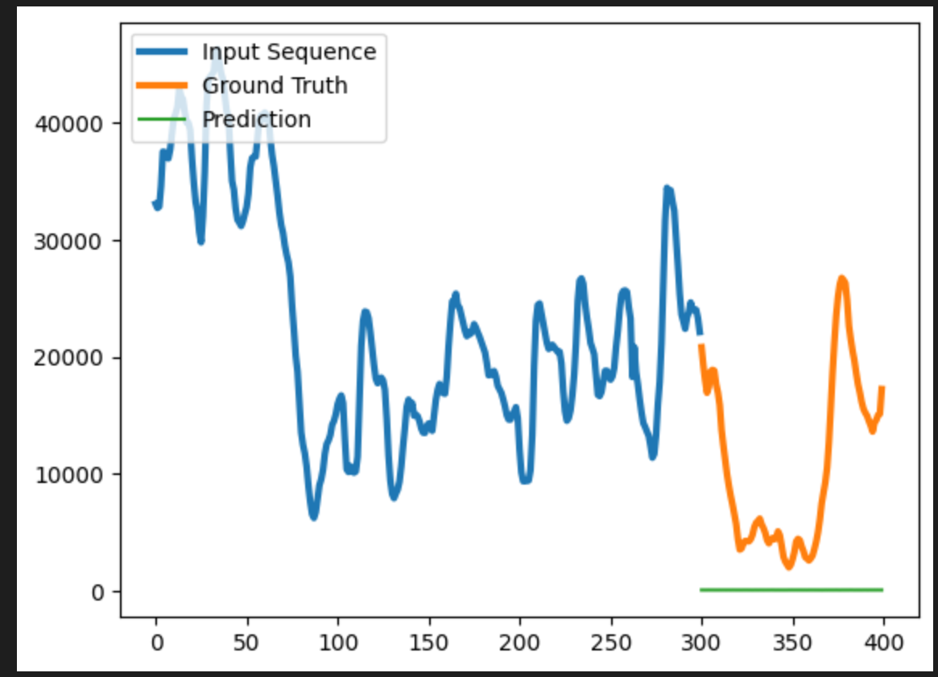 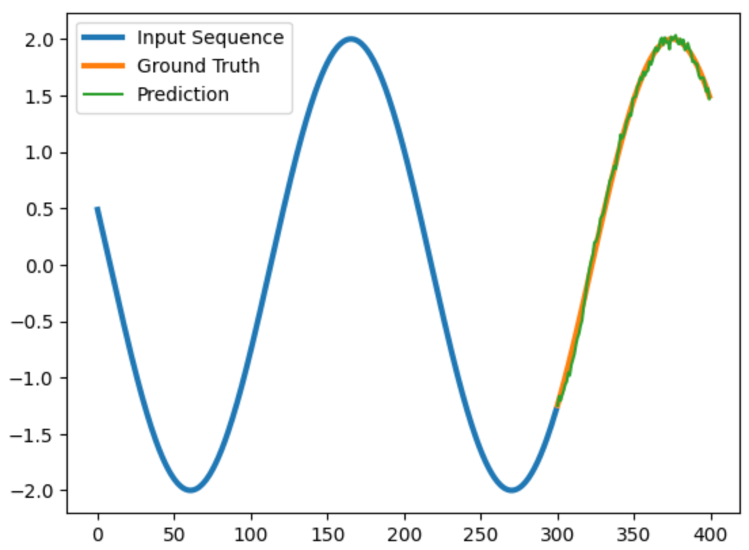

Learning is not possible, due to missing normalization of data.

When multiplied by 10, there are also issues in the sine wave production. Left is the result with selu as activation function, in the middle tanh activation

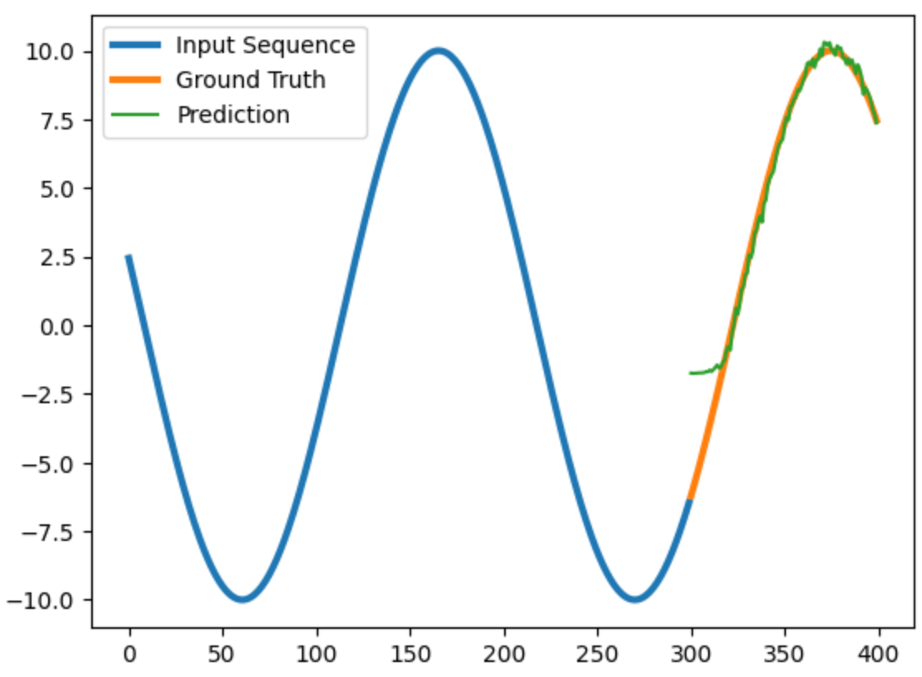 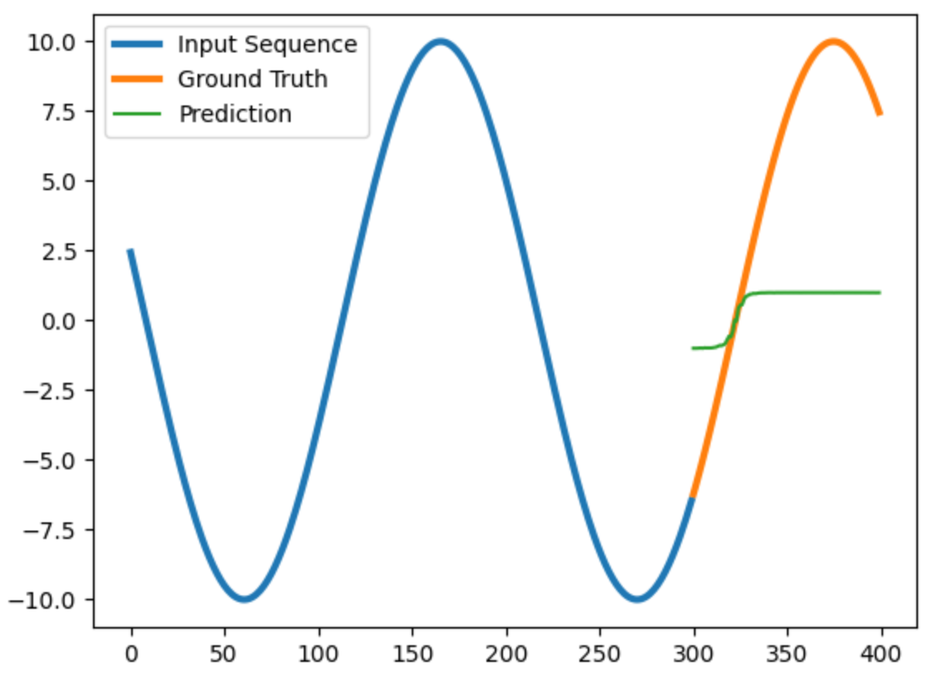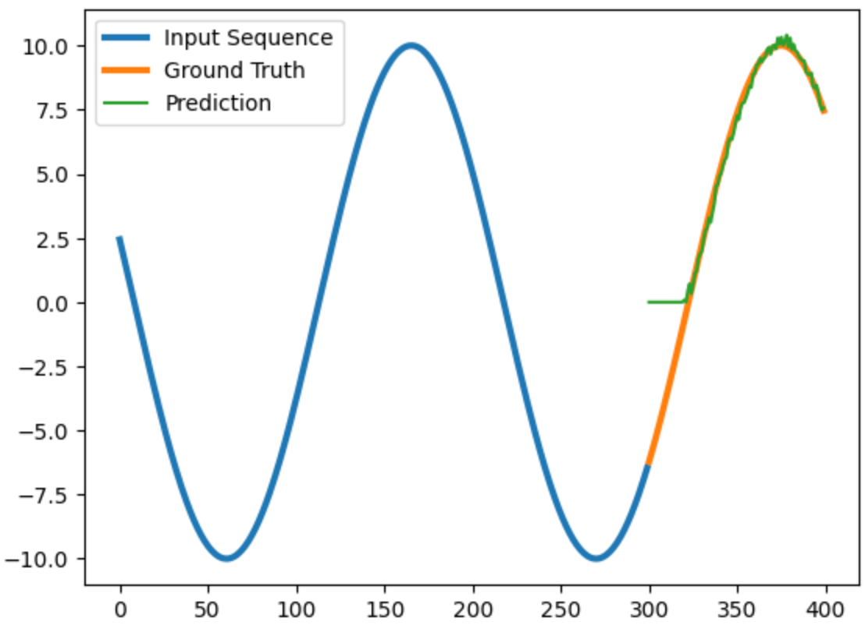

Explanation: tanh is only able to predict values between 0 and 1, selu and relu don’t provide negative values. Even larger Problems occur when setting an offset (relu):

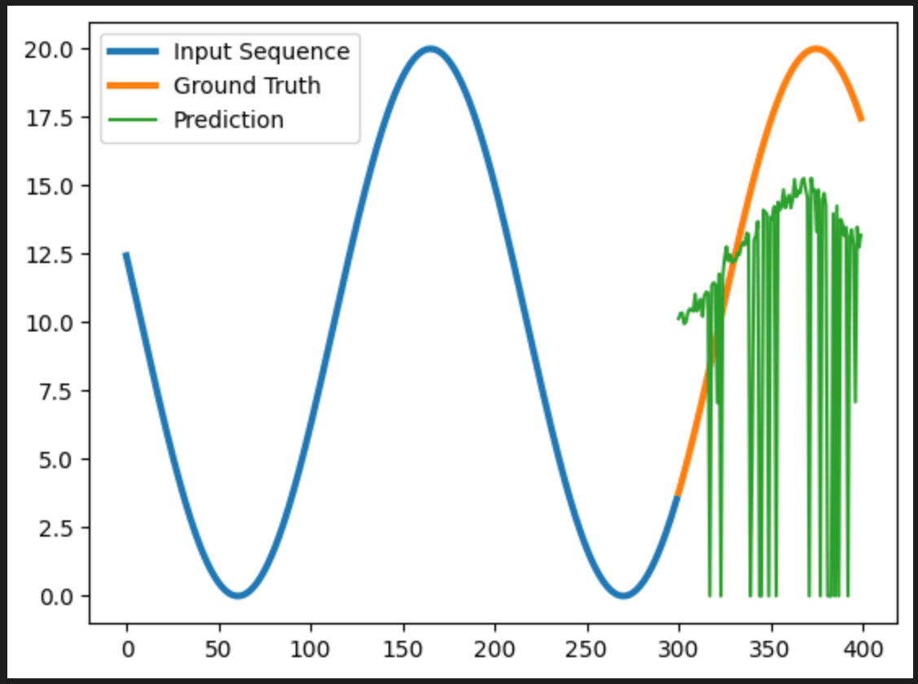 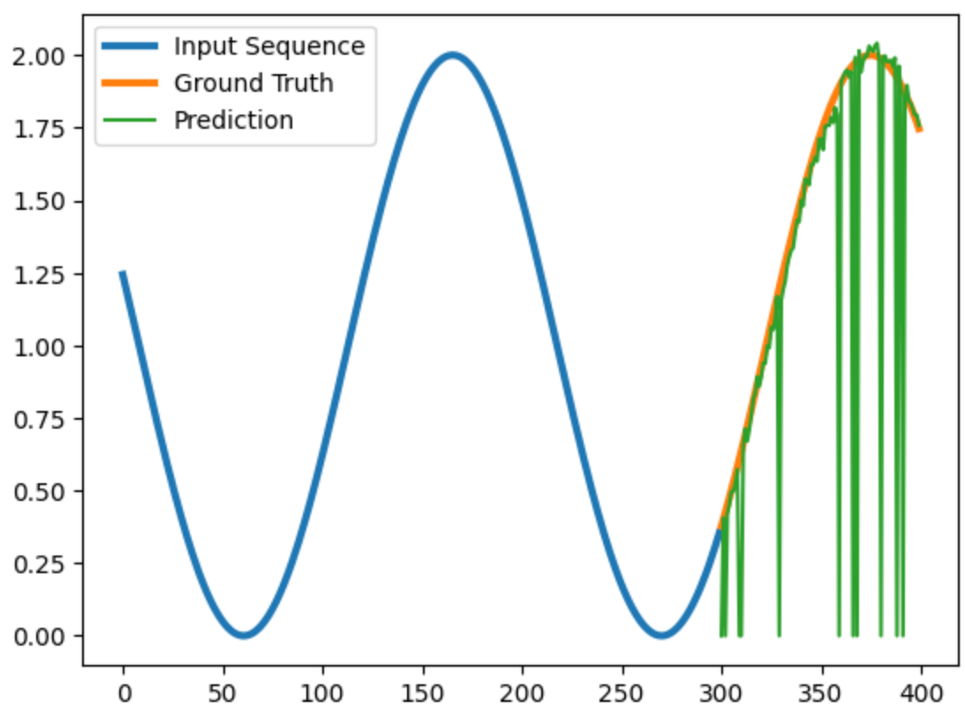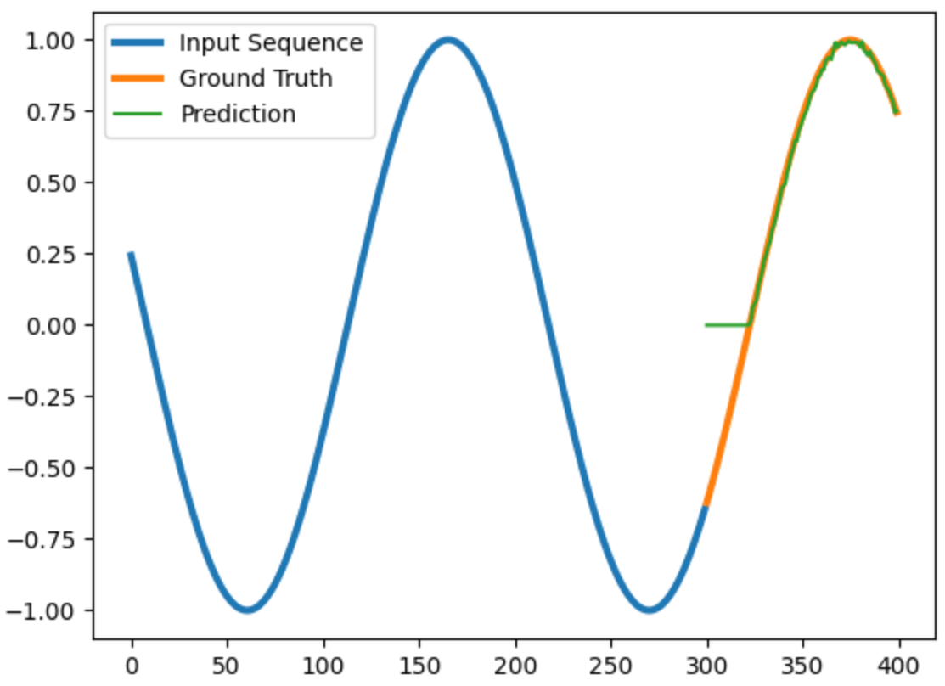

10+10*sin(0.3x) 1+sin(0.3x) sin(0.3x)

Better results after normalizing data left relu, middle selu, right tanh.

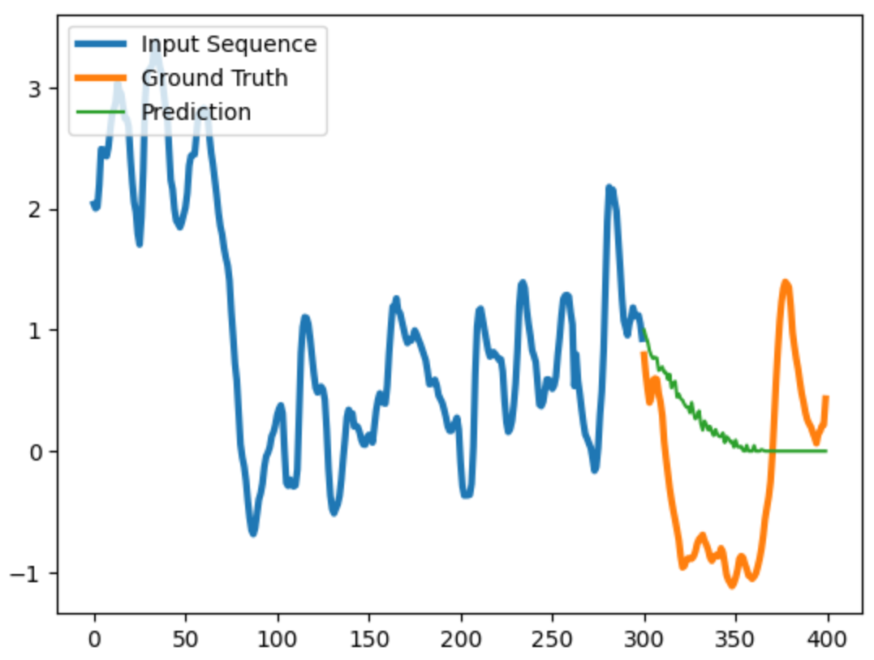 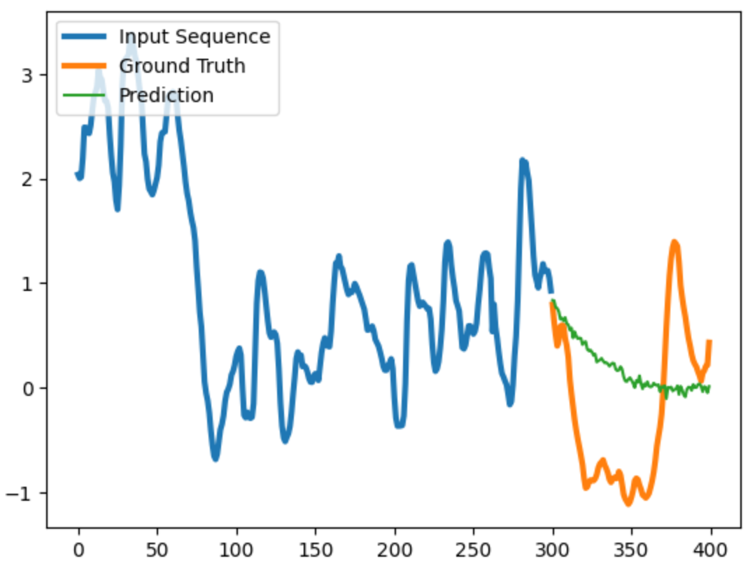 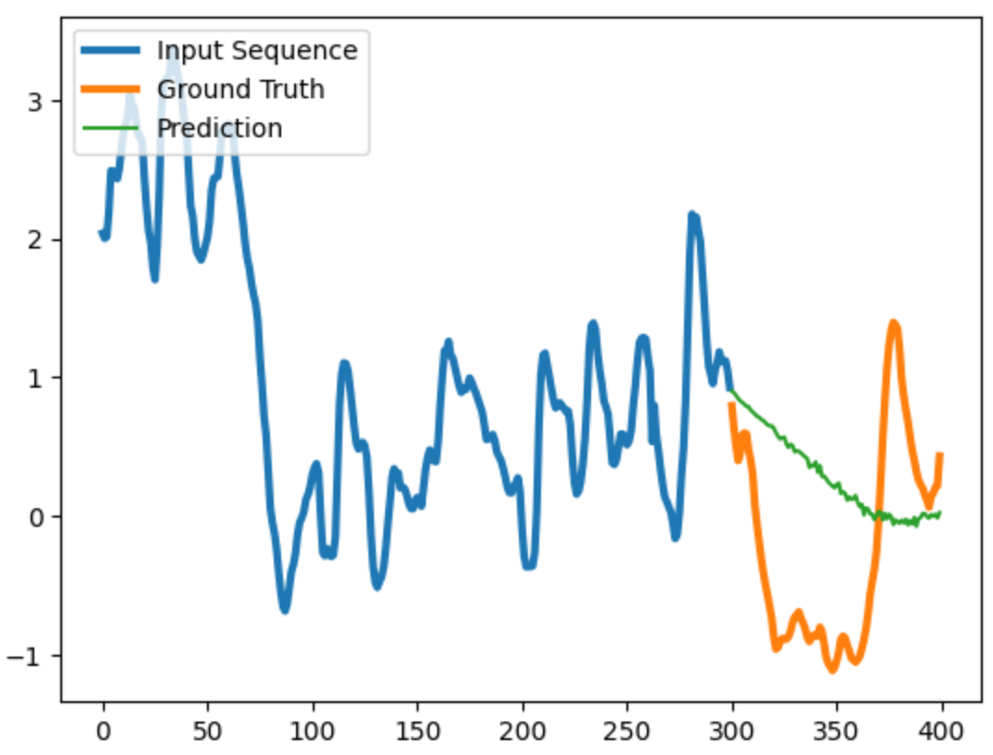

* Although there are large differences between the ground truth and prediction in all three cases, the **selu** activation function fits best for the given case.

1. A longer past and a shorter future target obviously leads to better results. The left graph was calculated with the past 25 days, the middle with 15 days, and the right graph with 5 days. Apart from a little offset, the future estimations look the same.

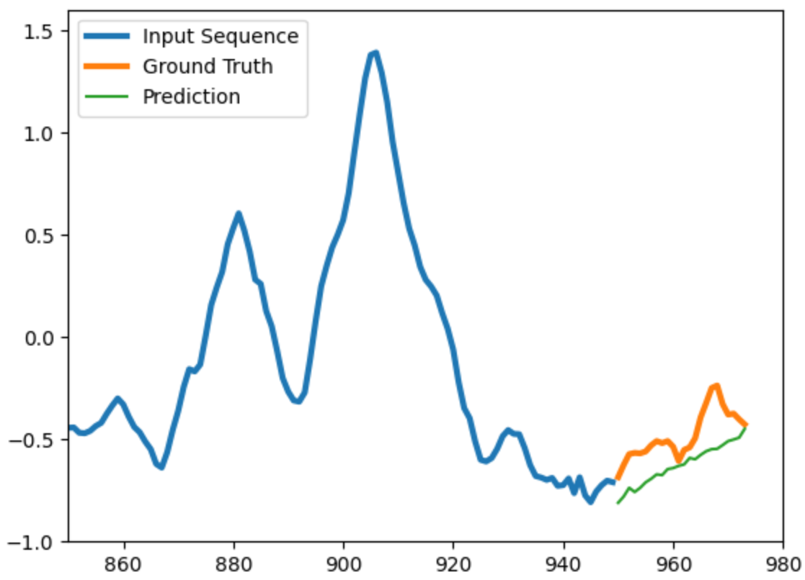 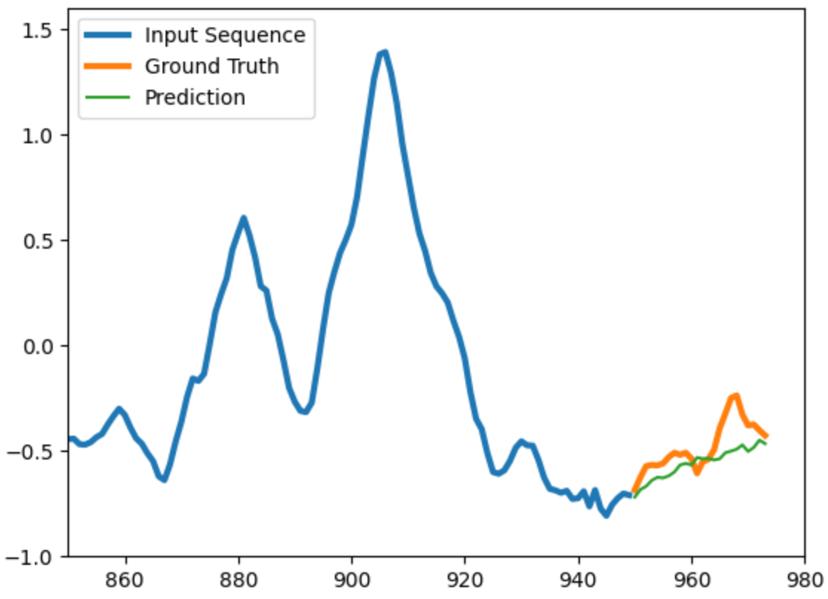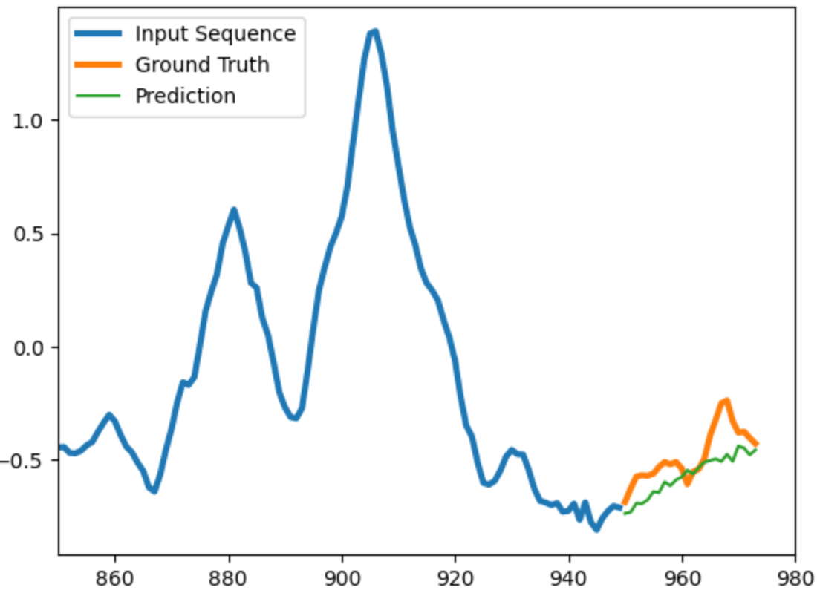

However, jumps in the curve cannot be adequately predicted with the given single feature RNN. 🡪 more than one feature required.