|  |  |
| --- | --- |
| **Topic** | Oracle SQL Language Fundamentals I |
| **Document Name** | SQL02-EX-01-05 |
|  |  |

## Exercise SQL02-EX-01:

**Definiton :** Write an SQL query that selects employee’s id, employee’s first name, employee’s last name and employee’s **number of months** from hire_date to today for all employees. (Hint:MONTHS_BETWEEN)

**SQL**:

SELECT employee_id, first_name, last_name, MONTHS_BETWEEN (SYSDATE, HIRE_DATE)

AS NUMBER_OF_MONTHS

FROM hr.employees;

**Screenshot:**

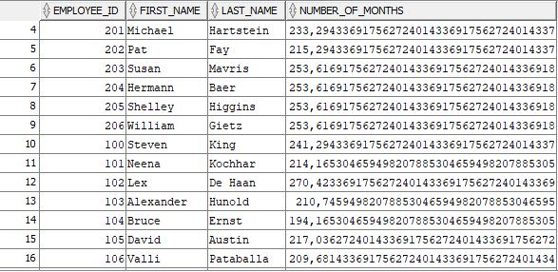

## Exercise SQL02-EX-02:

**Definiton :** Write a query that displays the grade of all employees based on the value of the column JOB_ID, using the following data: (Use DECODE)

|  |  |
| --- | --- |
| **Job** | **Grade** |
| AD_PRES | A |
| ST_MAN | B |
| IT_PROG | C |
| SA_REP | D |
| ST_CLERK | E |
| None of the above | 0 |

**SQL:**

SELECT DISTINCT JOB_ID AS Job,

DECODE(JOB_ID, 'AD_PRES',

'A', 'ST_MAN',

'B', 'IT_PROG',

'C', 'SA_REP',

'D', 'ST_CLERK',

'E', 'O') Grade

FROM hr.employees ORDER BY grade;

**Screenshot:**

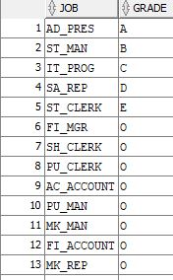

## Exercise SQL02-EX-03:

**Definiton :** Write a query for SQL02-EX-02(previous question) with using **CASE WHEN.**

**SQL:**

SELECT DISTINCT job_id AS Job,

CASE job_id

WHEN 'AD_PRES' THEN 'A'

WHEN 'ST_MAN' THEN 'B'

WHEN 'IT_PROG' THEN 'C'

WHEN 'SA_REP' THEN 'D'

WHEN 'ST_CLERK' THEN 'E'

ELSE '0'

END AS Grade

FROM hr.employees

ORDER BY Grade;

**Screenshot:**

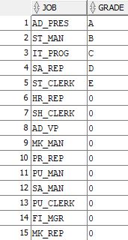

## Exercise SQL02-EX-04:

**Definiton :** Write a query that displays the employee number and last name of all employees who work in a department with any employee whose last name contains a “i”.

**SQL:**

SELECT employee_id, last_name

FROM hr.employees e

WHERE e.last_name LIKE '%i%' ORDER BY employee_id;

**Screenshot:**

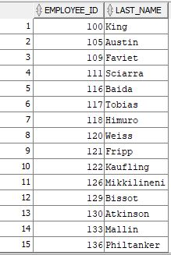

## Exercise SQL02-EX-05:

**Definiton :**

* Create a table for MY_EMP_TABLE with following columns
* Insert following rows,
* Update salary with 1.10 times of salary value
* Delete rows which first_name is David
* Truncate table.

|  |  |  |  |
| --- | --- | --- | --- |
| **ID** | **LAST_NAME** | **FIRST_NAME** | **SALARY** |
| 1 | Black | John | 1100 |
| 2 | White | Kent | 1300 |
| 3 | Orange | David | 1700 |
| 4 | Pink | Alissa | 1900 |

**SQL:**

CREATE TABLE MY_EMP_TABLE(

ID NUMBER(5),

LAST_NAME VARCHAR(20)NOT NULL,

FIRST_NAME VARCHAR(20),

SALARY NUMBER(20));

INSERT INTO MY_EMP_TABLE VALUES ('1','Black','John','1100');

INSERT INTO MY_EMP_TABLE VALUES ('2','White','Kent','1300');

INSERT INTO MY_EMP_TABLE VALUES ('3','Orange','David','1700');

INSERT INTO MY_EMP_TABLE VALUES ('4','Pink','Alissa','1900');

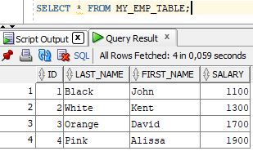

UPDATE MY_EMP_TABLE

SET salary = salary*1.1;

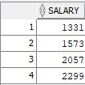

DELETE MY_EMP_TABLE WHERE FIRST_NAME = 'David';

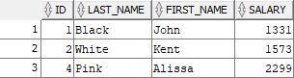

TRUNCATE TABLE MY_EMP_TABLE;

