|  |  |
| --- | --- |
| **Topic** | Oracle SQL Language Fundamentals I |
| **Document Name** | SQL03-EX-01-05 |
|  |  |

## Exercise SQL03-EX-01:

**Definiton :** Write followig SQL queries:

* Add a colum to employees table named MAX_SALARY.
* Update MAX_SALARY with maximum salary amount with subquery.
* Delete employee who have minimum salary using subquery.

**SQL:**

ALTER TABLE hr.employees

ADD (MAX_SALARY INT);

UPDATE hr.employees

SET MAX_SALARY = (SELECT MAX(salary) FROM hr.employees);

DELETE FROM hr.employees WHERE salary =(SELECT MIN(salary) FROM hr.employees);

**Screenshot:**

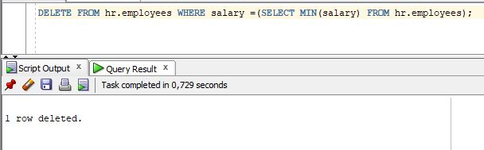

## Exercise SQL03-EX-02:

**Definiton :** Write followig SQL queries:

* Define index (named DPR_NAME_IDX) on DEPARTMENT_NAME column of DEPARTMENTS table.
* Define constraint (named CNSTR_SALARY) on employee salary. (Salary must be between 1000$ and 100.000$)
* Drop defined index.
* Enable, disable, drop defined constraint.

**SQL:**

CREATE INDEX DPR_NAME_IDX

ON hr.departments(department_name);

ALTER TABLE hr.employees ADD CONSTRAINT CNSTR_SALARY

CHECK (SALARY BETWEEN 1000 AND 1000000);

ALTER TABLE HR.employees ENABLE CONSTRAINT CNSTR_SALARY;

ALTER TABLE HR.employees DISABLE CONSTRAINT CNSTR_SALARY;

ALTER TABLE HR.employees DROP CONSTRAINT CNSTR_SALARY;

**Screenshot:**

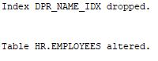

## Exercise SQL03-EX-03:

**Definiton :** Create a table from EMPLOYEES with distinct department_id column. Add department_name to that table. With DEPARTMENTS table, update department_name for included department_ids and insert department_id and department_name values for not included rows. Use MERGE keyword.

**SQL:**

CREATE TABLE DISTINCT_TABLE AS (SELECT department_id FROM hr.employees);

ALTER TABLE DISTINCT_TABLE ADD (department_name VARCHAR2(35));

MERGE INTO DISTINCT_TABLE i USING (SELECT * FROM HR.departments) d

ON (i.department_id = d.department_id) WHEN MATCHED THEN

UPDATE SET i.department_name = d.department_name;

**Screenshot:**

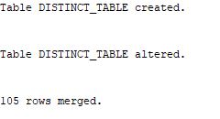

## Exercise SQL03-EX-04:

**Definiton :** Using **WITH** keyword, do following jobs:

* Firstly select first_name, last_name, job_id, department_id from employees table whoes job_id starts with ‘S’.
* Additionally select job_title and min-max salary amount.
* Add department_name to that query.
* Lastly concat first_name and last_name with space as full_name alias and list with other selected columns.

**SQL:**

WITH EMP_JOBS AS (SELECT FIRST_NAME,LAST_NAME,JOB_ID,DEPARTMENT_ID FROM EMPLOYEES WHERE FIRST_NAME LIKE 'S%'),

JOB_MAX_MIN AS ( SELECT JOB_ID,JOB_TITLE,MIN_SALARY,MAX_SALARY FROM JOBS),

DEP_DET AS ( SELECT DEPARTMENT_ID,DEPARTMENT_NAME FROM DEPARTMENTS)

SELECT E.FIRST_NAME,E.LAST_NAME,E.JOB_ID,

JM.JOB_TITLE,JM.MAX_SALARY,JM.MIN_SALARY,

D.DEPARTMENT_NAME,

CONCAT(E.FIRST_NAME,E.LAST_NAME) AS FULL_NAME FROM EMP_JOBS E

JOIN JOB_MAX_MIN JM ON E.JOB_ID = JM.JOB_ID

JOIN DEP_DET D ON E.DEPARTMENT_ID = D.DEPARTMENT_ID;

**Screenshot :**

## Exercise SQL03-EX-05:

**Definiton :** Search for COMMIT and ROLLBACK keywords and explain them.

**SQL:**

"COMMIT," bir işlem veya işlemler kümesini kalıcı olarak veritabanına uygulama ve verilerin değişikliklerini veritabanında kaydetme işlemidir. Bir COMMIT işlemi, veritabanı yönetim sistemine yapılan tüm değişikliklerin tamamlanmış olduğunu ve geri alınamayacağını belirtir.

"ROLLBACK," yapılan bir işlem veya işlemleri geri almak ve veritabanında yapılan değişiklikleri geri döndürmek için kullanılan bir komuttur. ROLLBACK komutu, bir işlemi tamamlamadan veya bir hata durumunda geri almak ve veritabanını başlangıç durumuna geri getirmek için kullanılır.