1. )

HR.EMPLOYEES tablosu dataları kullanarak   
Departmandaki tüm çalışan personelleri yanyana yazabilir misiniz?

SELECT department_id, LISTAGG(first_name || ' ' || last_name,':')

WITHIN GROUP( ORDER BY employee_id) AS names

FROM HR.employees

GROUP BY department_id;

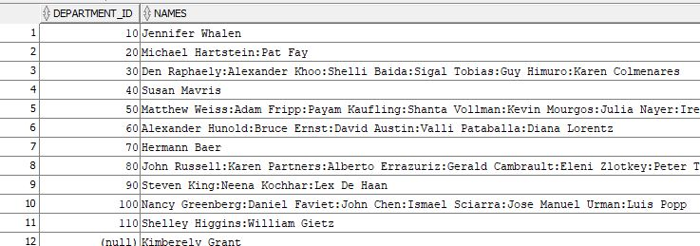

1. ) JOBID YE GORE GRUPLANACAK  
    EMPID YE SIRALANACAK GORE HERKESIN KENDINDEN 1 ONCEKI VE 1 SONRAKI  
   SALARY TOPLAMI BULUNACAK

SELECT employee_id,first_name,salary,SUM(salary)

OVER (PARTITION BY job_id ORDER BY employee_id ROWS BETWEEN 1 PRECEDING AND 1 FOLLOWING) TOTAL

FROM hr.employees;

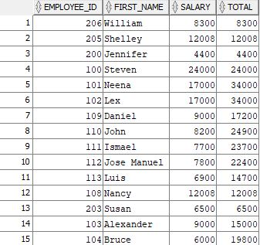

3-)TELEFON NO HERKESIN KENDINDEN BIR SONRAKI KISININ TELEFON NUMARASINI  
YANINA YAZIN HIRE_DATE E GÖRE SIRALI DEPARTMENT_ID göre gruplanmalı

SELECT employee_id,hire_date,first_name,phone_number,

LEAD(phone_number) OVER (PARTITION BY department_id ORDER BY hire_date) AS newNumber

FROM hr.employees;

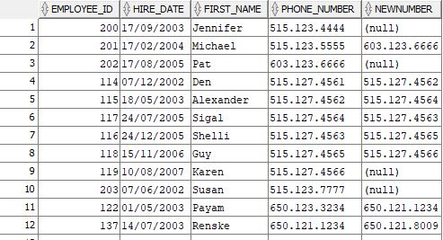

4-)MAASLARA GORE 1 DEN BASLAYARAK SIRALA EMPLOYEES TABLOSU ICINDE  
MAAS AYNI ISE KIDEME(İŞE GİRİŞ TARİHİ) GORE SIRALA

SELECT e.*,

RANK() OVER(ORDER BY salary ASC, hire_date ASC) AS new_salary

FROM

HR.employees e;

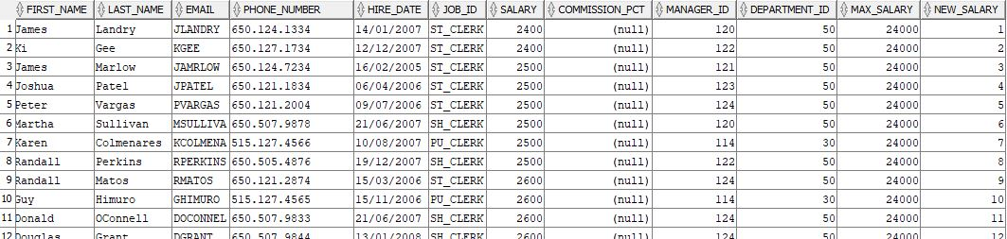

1. )TÜM TABLOYU EMPLOYEES ILK 10 İÇİN 1 DIGER 10 İÇİN 2... YAZACAK. Sıralamayı EMPLOYEE_ID üzerinden yapabilir misiniz?

SELECT

employee_id,

first_name,

NTILE(10) OVER (ORDER BY employee_id ASC) AS number_new

FROM HR.employees;

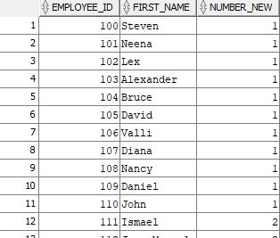

6-)HER DEPARTMAN İÇİN ORTALAMA MAAŞIN ALTINDAKİLER 0 ÜSTÜNDEKİLER 1  
OLARAK GÖSTERİLSİN.

SELECT employee_id, salary, department_id,

CASE WHEN salary < avg_salary_dept THEN 0 ELSE 1

END AS salary_number,

avg_salary_dept AS avg_department

FROM (SELECT employee_id, salary, department_id,

AVG(salary) OVER (PARTITION BY department_id) AS avg_salary_dept

FROM hr.employees)

ORDER BY employee_id;

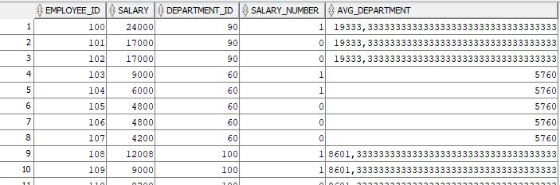

7-)employees tablosu yıl içinde işe başlayan ilk personelleri listeleyebilir misiniz?

SELECT * FROM (( SELECT e.*,

ROW_NUMBER() OVER (PARTITION BY EXTRACT(YEAR FROM hire_date) ORDER BY hire_date) AS rn

FROM hr.employees e ))ranked_employees

WHERE rn = 1;

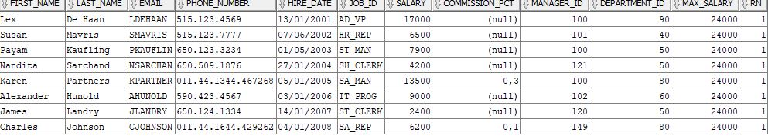

8-)Her departmanda en yüksek ücret alan personel dışındaki tüm kayıtlar gelsin.

SELECT employee_id, first_name, salary,department_id FROM hr.employees

WHERE (department_id, salary) NOT IN (

SELECT department_id, MAX(salary)

FROM hr.employees

GROUP BY department_id);

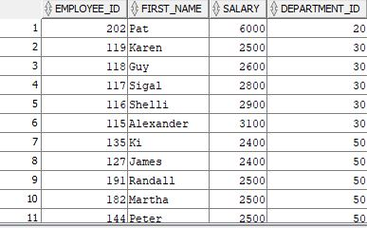

1. )Her departmanda en yüksek ücret alan 2 personelin kayıtları gelsin.

SELECT *FROM ( SELECT first_name,employee_id, salary,department_id,

DENSE_RANK() OVER( PARTITION BY department_id ORDER BY salary DESC )

AS rank FROM hr.employees ) WHERE rank <= 2 ;

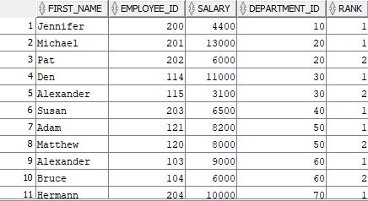

1. )Her departmanda en kıdemli personelden başlayarak ondan önce ve sonra bölüme başlayan personelin ad soyad bilgisini gösterebilir misiniz

SELECT employee_id, department_id, first_name, hire_date,

LAG(first_name) OVER( PARTITION BY department_id ORDER BY hire_date ) AS previous,

LEAD(first_name)OVER( PARTITION BY department_id ORDER BY hire_date ) AS next FROM

(SELECT employee_id, department_id, first_name, hire_date,

RANK() OVER ( PARTITION BY department_id ORDER BY hire_date ) AS rn

FROM hr.employees) WHERE rn =1 ORDER BY employee_id;

