DSA 210: Introduction to Data Science Fall 2025 – 2026 Term Project

Predicting Demo Availability in Video Games

SENA YOLCU

22626

1. Motivation

The use of demos in video games has been a debate topic in the gaming industry. Despite how demos allow the player to evaluate a game before purchasing, their impact on game sales is unclear. Because of this, game developers have conflicting opinions on whether demos increase player trust and engagement or demos may discourage purchases by revealing too much of the game experience. Thus, many game studios avoid developing demos since it can take many hours, money and effort.

The motivation behind this project is to investigate if the demos are associated with different outcomes of games such as sales and review scores. In this way, developers and consumers may have an insight of whether a demo presence is essential.

2. Datasets

In this project, we will be using three primary datasets:
- Steam games data set which contains Metacritic review scores for Steam games.
- Steam demo dataset which identifies the Steam games with playable demos.
- Sales dataset which provides sales information for video games from different platforms.

3. Data Collection & Preparation

In this section, the raw datasets will be converted into clean, easy to understand and ready to be analyzed datasets.

Steps:
- Firstly, we convert review scores and sales values into numeric values.
- Rows with missing values (Na) are removed.
- For accurate merging, game titles are standardized by a consistent format across all datasets.
- A binary variable indicating demo presence is created, then used as a target variable for classification models.
After these steps, the dataset is ready and suitable for further analyses.

4. Exploratory Data Analysis (EDA)

To understand the distributions and relationships between demo presence, review scores and global sales, we need exploratory data analysis. This section presents visualization of identify trends, potential outliers, and differences between games with demos and games without demos.
4.1 Global Sales

The following plot shows the distribution of global sales of all games in the dataset:

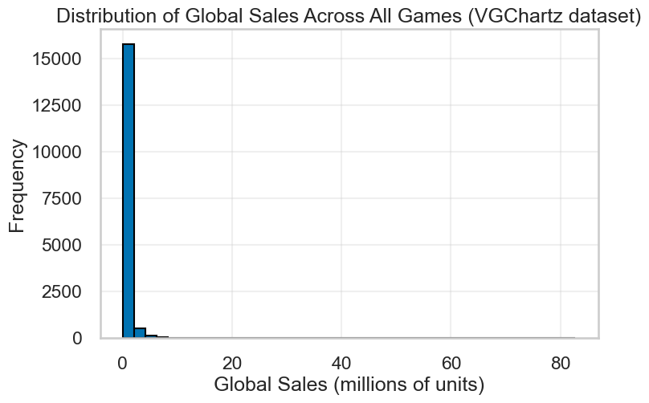

As seen in the figure, the distribution is highly right skewed, and most games obtained relatively low sales. The skewness implies that sales may be influenced by small number of popular games. Thus, we should be cautious while comparing groups of unequal sizes.

4.2 Metacritic Scores

The following plot shows the distribution of Metacritic review scores for all games in the dataset.

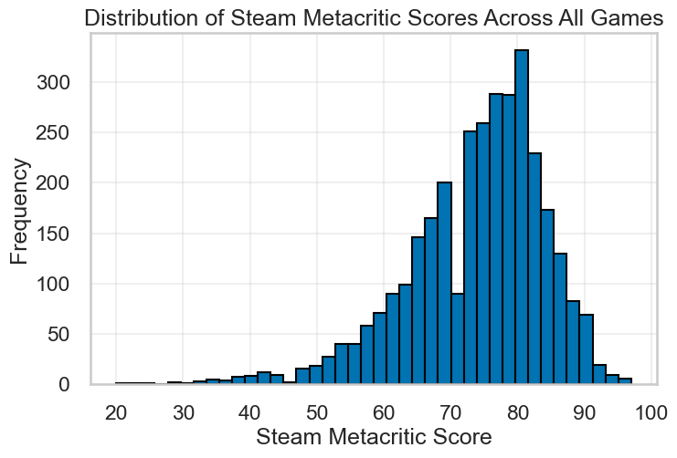

This plot is more concentrated and balanced compared to the sales plot above. As a result, we can suggest that review scores data are less unstable than sales data and, games with and without demos may be observed more stable.

4.3 Comparing Scores of Demos and Non-demo Games

The following box plot represents comparison of review scores by demo presence.

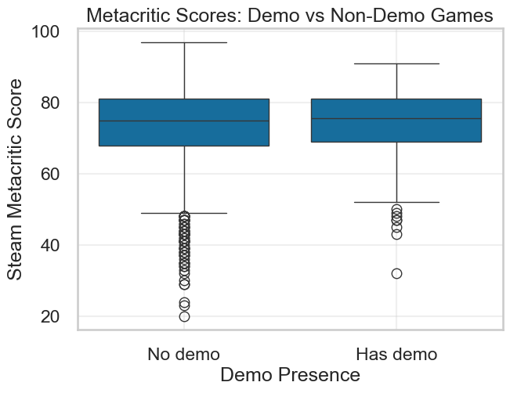

We can observe that both means are relatively similar. There is no noticeable visual difference between the two groups, except slight differences in distribution. Thus, the demo presence alone may not have strong impact on review scores.

4.4 Relationship Between Metacritic Scores and Global Sales

The scatter plot below shows the relationship between game popularity and global sales of games that has a demo.

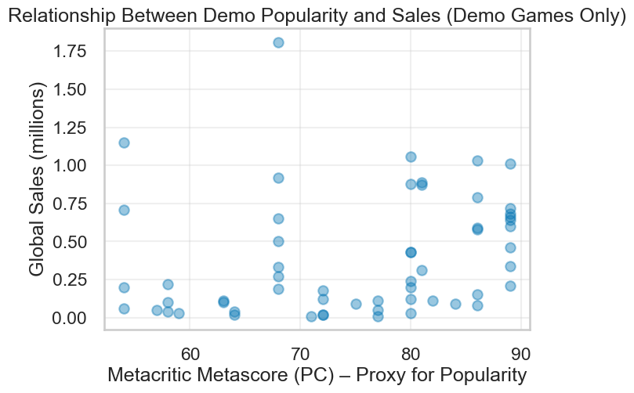

Game popularity is measured by Metacritic Scores and sales performance is measured by global sales. Generally, the plot shows that the data points are widely spread. Thus, we cannot assume that game popularity alone is enough to explain the global sales of demo games.

5. Hypothesis Testing

5.1 Hypothesis 1
Null Hypothesis (H₀): Demo presence has no effect on full game scores.
Alternative Hypothesis (H₁): Demo presence increases full game scores.

Two tailed t-test will be used to compare the mean Metacritic scores of games with demos and games without demos.

5.1.1 Result

Mean of demo game: 73.97
Std of demo games: 9.95

Mean of non-demo games: 73.90
Std of non-demo games: 10.30

t-statistic: 0.101
p-value: 0.919

The test did not provide enough evidence to reject the null hypothesis. So we can say that demo presence is not associated with a statistically significant difference in review scores.

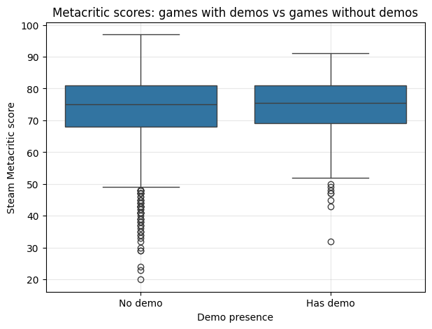

5.2 Hypothesis 2
Null Hypothesis (H₀): Demo popularity has no effect on full game sales.
Alternative Hypothesis (H₁): Demo popularity increases the full game sales.

Since direct measures of demo popularity were not available, Metacritic scores will be used as a proxy. A two tailed t-test will be applied to compare sales-related measures.

5.2.1 Result

Mean of demo games: 0.784
Std of demo games: 0.453

Mean of non-demo games: 0.825
Std of non-demo games: 0.724

t-statistic: -2.181
p-value: 0.029

Although the null hypothesis is rejected, indicating a statistically significant difference in sales related measures, the effect size is limited. As a result, demo popularity does not appear to have a strong or practically meaningful impact on global sales.

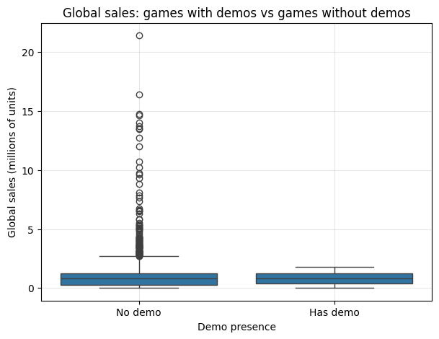

6. Machine Learning Modelling
A supervised classification is used to explore patterns in data and address questions.

6.1 Machine Learning Question
We aim to answer the following question with machine learning:
Can we distinguish games with demos from games without demos using metacritic scores and global sales data?

6.2 Decision Tree Results

The confusion matrix for the decision tree classifier is shown below.

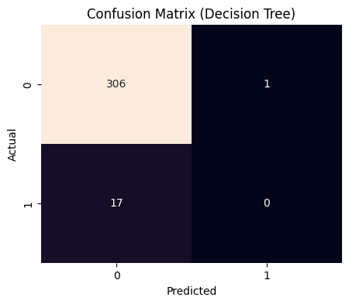
Accuracy: 0.944

Classification Results:
precision recall f1-score support

False 0.95 1.00 0.97 307
True 0.00 0.00 0.00 17

accuracy 0.94 324
macro avg 0.47 0.50 0.49 324
weighted avg 0.90 0.94 0.92 324

Decision Tree achieved high overall accuracy. The confusion matrix shows that the model mainly predicts the majority class (e.g. non-demo games). The model struggles to correctly identify the games with demos because of the class imbalance.

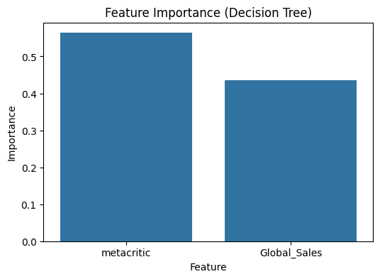

The feature importance plot shows that both Metacritic score and global sales contribute to the predictions. Metacritic score holds slightly higher importance in the analysis.

6.3 K-Nearest Neighbors Results

The confusion matrix for the decision KNN classifier is shown below.

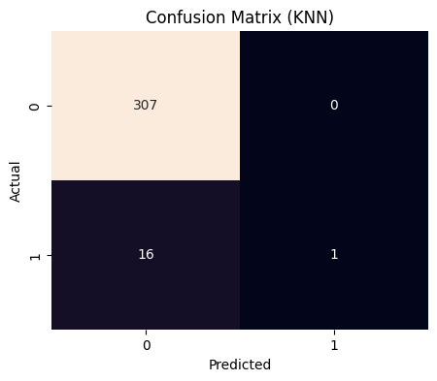

KNN Accuracy (k=5): 0.951
KNN Classification Results:
precision recall f1-score support

False 0.95 1.00 0.97 307
True 1.00 0.06 0.11 17

accuracy 0.95 324
macro avg 0.98 0.53 0.54 324
weighted avg 0.95 0.95 0.93 324

The KNN classifier achieves high accuracy but struggles to correctly classify games with demos because of the class imbalance.

7. Limitations & Future Work

7.1 Limitations
- The study has highly imbalanced dataset since non-demo games outnumbers demo games.
- Limited number of features.

7.2 Future Work
- Expend the dataset to include more features and possibly to balance the classes.

8. AI Tool Usage Disclosure
AI was used for guidance in report writing, formatting, and debugging the codes.

