|  |
| --- |
| Digital Accessibility Reporting Tool |
|  |
| How to generate a Report  Verfasser: Edrian Helbing  München, 29.07.2024 |

Inhaltsverzeichnis

1 Run DART 3

2 Create a JSON report file for a page 4

3 Put the pieces together to create the PDF report 6

Änderungshistorie

|  |  |  |  |
| --- | --- | --- | --- |
| Version | Datum | Verfasser | Bemerkung |
| 1.0 | 29.07.2024 | Edrian Helbing | Initial setup |
|  |  |  |  |

# Run DART

You need DART on your computer. So if you haven’t downloaded the program yet, you can find the code in the [Senacor GitHub Repository](https://github.com/senacor/digital-access-reporting-tool) and download it there. Once you have the program on your computer follow these steps:

1. Open a **console** on Windows or a **terminal** on MacOS.
2. Navigate to the folder where the program is located.
3. Follow the instructions of the [README.md](https://github.com/senacor/digital-access-reporting-tool/blob/main/README.md) file of the GitHub Repository on how to run the tool.

If everything is done correctly and worked out, you can open a browser and navigate to  
<http://localhost:3000/>.

You should see this:

Ein Bild, das Text, Screenshot, Schrift, Design enthält.

Congratulations, you started the tool successfully!

# Create a JSON report file for a page

Now you need to use the tool to create a report in form of a JSON object and store it in a file. The tool also creates a screenshot of the page you want to create the report for.

Fill out the *Create accessibility report* form and click the *Create Report* button (Like shown the image below). The form and the button will then be disabled until the report is generated.

* The first input is the URL of the page you want to create the report for.
* The second input is the URL of the **company** **logo** for the mentioned page.

Ein Bild, das Text, Schrift, Screenshot, Design enthält.

**! NOTE:**

* Websites that require a login to be viewed, are not being scanned by the tool.
* Websites that are so called Single Page Applications (SPAs) can be scanned but the tool will most likely not catch all URLs because the pages are not linked via anchors   
  (=> **<a href=”/example-route” />**) but via JavaScript code which the tool cannot analyze.

Once the report generation is finished, the form will be enabled again, and the report will be printed as a JSON object in the *Results* section below the form.

Ein Bild, das Text, Screenshot, Design enthält.

Then you can just click the *Copy* button and paste the object inside a text editor program and save the file as a **.json** file which will then be used later.

Congratulations, you successfully save the JSON report!

# Put the pieces together to create the PDF report

Now you’ve all the pieces on your computer to create the report. Well, at least I hope so. You also need [Power BI Desktop](https://www.microsoft.com/de-de/power-platform/products/power-bi/desktop?) installed on your computer which can be a bit tedious if you have a MacOS (Then you’ll need to run it on a virtual machine that runs windows and you should contact ITI).

I assume you’ve Power BI Desktop installed. Now let’s gather everything you need:

1. The *power-bi-report-project* folder: You can find it in the *power-bi-desktop* folder in your DART folder.
2. The screenshot that automatically got created in the previous step: You can find the screenshot in a *screenshots* folder in your DART folder:  
   E.g.: *<path to your DART folder>/screenshots/www.devk.de.png*
3. The JSON report you created in the previous step.

After you’ve found everything, you need follow the next steps and make sure you also do it in the same order:

* Copy the *power-bi-report-project* folder (1) somewhere else on your computer to not mess with the repository files (except you want to update the report and push it to GitHub again, so other people also get your changes).
* In the copied folder navigate to the *RegisteredResources* folder:   
  E.g.: *<path to the copied folder>/power_bi_report.Report/StaticResources/RegisteredResources*
* Here you’ll find a PNG file that starts with *screenshot* followed by some numbers. Replace this file with the screenshot from (2) and make sure to keep the exact same filename. (E.g.: *screenshot5306011529060841.png*).  
  => This will replace the screenshot in the Power BI report while keeping all its formatting. There are other ways to do this, but they are way more tedious.
* Navigate back to the root of your copied folder and open the [*power_bi_report.pbip*](https://github.com/senacor/digital-access-reporting-tool/blob/main/power-bi-desktop/power-bi-report-project/power_bi_report.pbip) file with Power BI Desktop. It should look similar to this: 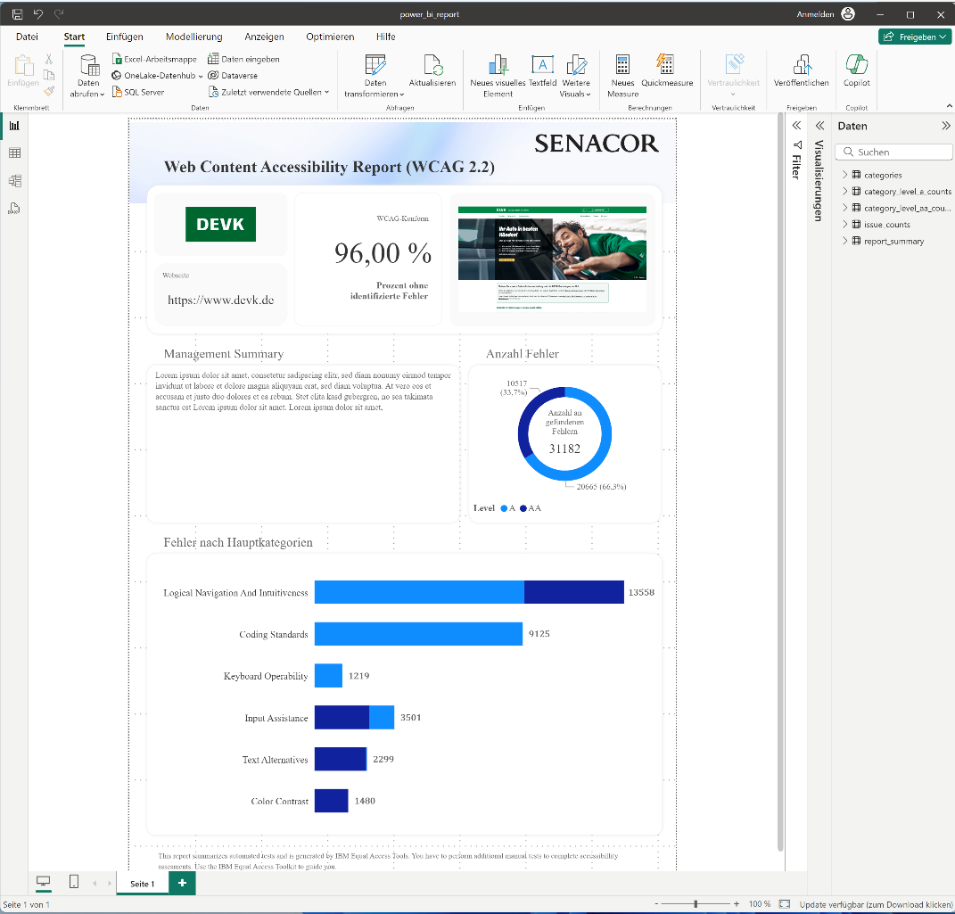
* Now you have to click on the expand arrow on the *Transform Data* button, to select *Data Source Options:* Ein Bild, das Text, Schrift, Software, Screenshot enthält.

  Automatisch generierte Beschreibung
* Then you click on the *Change Source* button. Ein Bild, das Text, Screenshot, Software, Webseite enthält.

  Automatisch generierte Beschreibung
* This will open another dialog where you can change the data source of the report. Change the source to the **.json** fileyoucreated (3). Then click okay and close the *Data Source Options* dialog. Ein Bild, das Text, Screenshot, Software, Zahl enthält.

  Automatisch generierte Beschreibung
* Then click on *Apply Changes* which will then open a small dialog with some loading information and after that the data from the **.json** file is being used in the report. Ein Bild, das Text, Screenshot, Schrift, Reihe enthält.

  Automatisch generierte Beschreibung
* Now you can change the text below the *Management Summary* headline to whatever you’d like it to say.
* Save the file and export it as a PDF. The PDF gets opened immediately by your default PDF viewer. I’d suggest to save the PDF in a different location since it’s currently saved in a temporary folder and it’s tedious to locate it in your system.

Congratulations, that’s it! Now you’re finished and good to go to impress some customers.