**10.35 Describe the advantages of applying traditional metalworking techniques to the formation of plastics.**

Traditional metalworking techniques can be applied to the formation of plastics with few, or no additional operations required. Compared to metals, plastics melt or cure at relatively lower temperatures, this makes plastics easier to handle and require less energy to process.

**10.38 Would you use thermosetting plastics for injection molding? Explain.**

Due to the irreversible polymerization and crosslinking that occur during the molding of thermosets, conventions injection molding methods are not suitable. Instead, thermosets are molded in heated molds, where polymerization and cross-linking take place. After the part is sufficiently cured, the molds are opened, and the part is ejected. Essentially in thermoset injection molding, cold material is injected into an extremely hot mold to create a part.

**10.39 By inspecting plastic containers, such as for baby powder, you can see that the lettering on them is raised rather than sunk. Can you offer an explanation as to why they are molded in that way?**

Raising the lettering on an injection molded part may be preferred to sinking the lettering due firstly, the ease of manufacturability of the part. Raised lettering can be easily stamped into the mold, whereas a sunk lettering may require a more complex mold design which may increase the manufacturing cost. Secondly, the sunk lettering may fade faster over time compared to the raised lettering. And finally, the raised lettering can have a more pleasing tactile quality, which may enhance the overall aesthetic of the part.

**10.40 Give examples of several parts that are suitable for insert molding. How would you manufacture these parts if insert molding were not available?**

Parts that are suitable for insert molding include threaded inserts, screw drivers, electrical and computer components (i.e., USB drives, wall plug-ins). Without insert molding, these parts may be manufactured using drilling and tapping the molded part, fasteners, adhesive.  
  
**10.90 A rectangular cantilever beam 100 mm high, 50 mm wide, and 1 m long is subjected to a concentrated force of 100 N at its end. Select two different unreinforced and reinforced materials from Table 10.1 and calculate the maximum deflection of the beam. Then select aluminum and steel, and for the same beam dimensions, calculate the maximum deflection. Compare the results.**

+---------------------------+-------------------------------+-----------------------+

| Material | Modulus of Elasticity (GPa) | Max deflection (mm) |

|---------------------------+-------------------------------+-----------------------|

| Acetal | 3.5 | 2.28571 |

| Acetal, reinforced | 10 | 0.8 |

| Polycarbonate | 3 | 2.66667 |

| Polycarbonate, reinforced | 6 | 1.33333 |

| Aluminum | 62 | 0.129032 |

| Steel | 196 | 0.04 |

+---------------------------+-------------------------------+-----------------------+

Observation: The maximum deflection decreases as the modulus of elasticity increases

**W3-1**

**Find a complex injection molded component (or two). Power tools, toys, electronics, packaging/containers, consumer products, kitchen appliances, and automotive parts are great places to look. You may have to disassemble a little bit.**

**Take photographs of the component and label all of the design features you observe such as, constant wall thickness, strengthening ribs of appropriate thickness, fastening features (screw boss, snap-fit, etc.), fillets on all corners, appropriate draft all surfaces, gating location, ejector pin locations, textured surfaces, fastening features, and creative designs that avoid the use of cross-slides. Compare these features with the design rules from the GE design guide. Comment on where you see any deviations from the rules (if any).**

**PowerPoint is a great tool for labeling your photographs.**

**Constant wall thickness**

*Guideline: The basic wall of the part should be kept uniform.*

**Ejector pin locations**

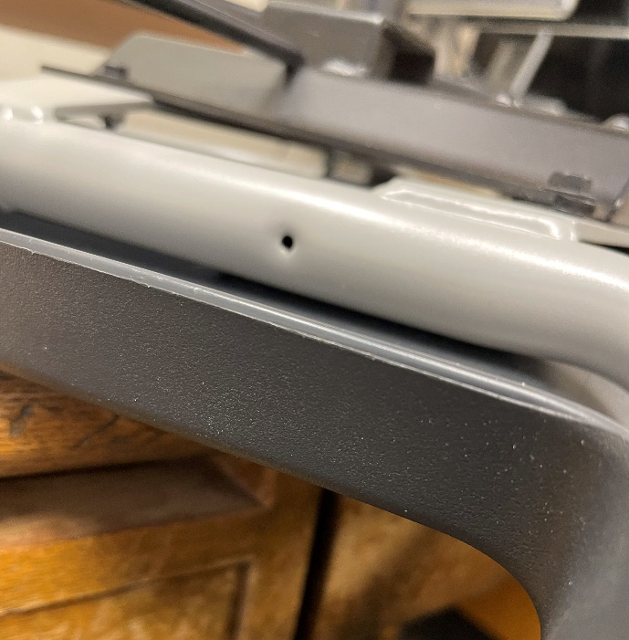**Parting line**

**Textured surface**

**Ribs**

*Guideline: The thickness of the rib at the intersection with the nominal wall should be 50 to 60% of the nominal wall.*

$$rib thickness=0.069"$$

$$wall thickness=0.148"$$

$$50\% of wall thickness=0.07" ≈ rib thickness$$

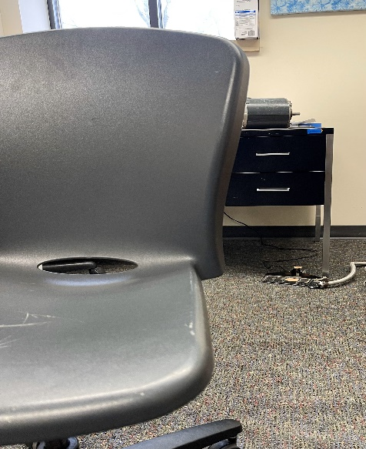**Ejection**

*Guideline: On surfaces in the draw of the die, a minimum of 1/2˚ should be specified. Typical draft is 1˚. More draft aids ejection but may generate a material mass on sections contained in one side of the mold.*

