**11.15 Why do mechanical and physical properties depend on the density of PM parts? Explain with appropriate sketches.**

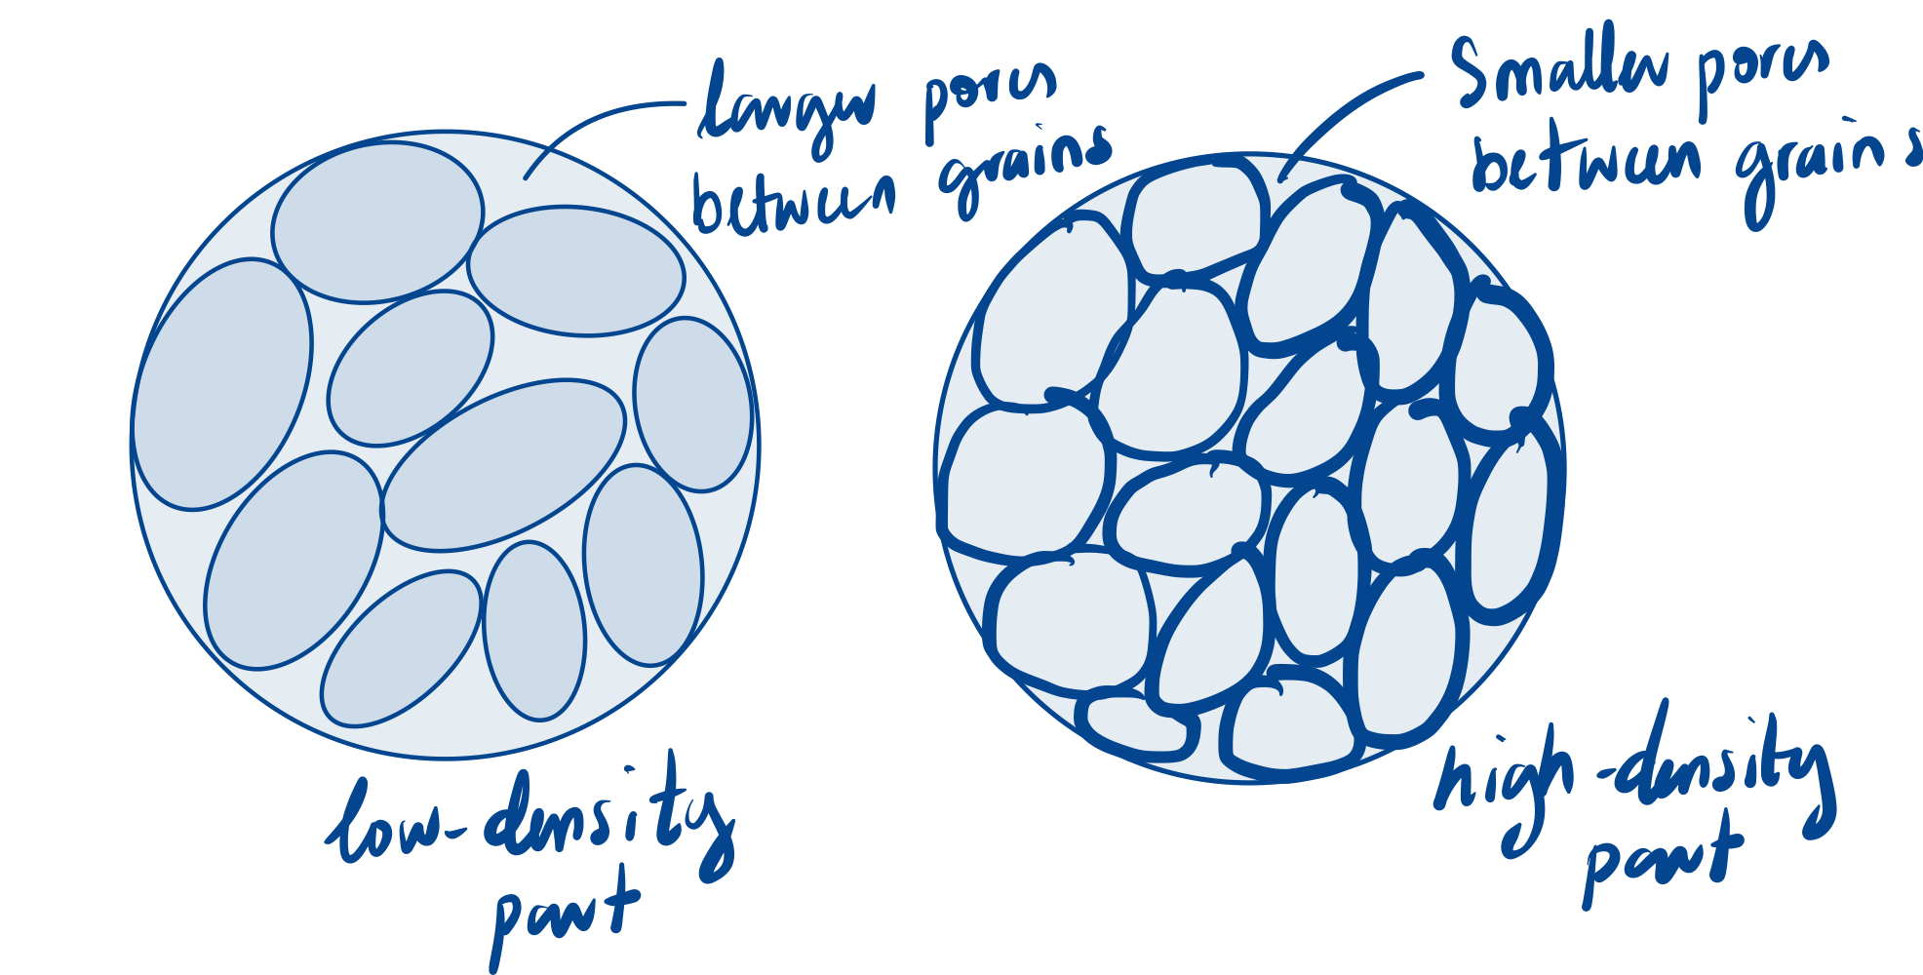This is because, the higher the density, the higher the amount of solid material in the same volume, hence the greater the part's resistance to external forces. A low-density part would have larger pores and lower grain interconnectivity while a high-density part would have smaller pores and higher grain interconnectivity.

**11.75 Derive an expression similar to Eq. (11.2) for compaction in a square die with dimensions a by a.**

Balancing the vertical forces acting on this element,

$$Area of square=a^{2}$$

$$a^{2}p_{x}-a^{2}\left(p_{x}+dp_{x}\right)-\left(4a\right)\left(μσ_{r}\right)dx=0$$

which can be simplified to:

$$adp_{x}-4μσ_{r}dx=0$$

This results in one equation, but two unknowns ( $p_{x}$ and $σ_{r}$). At this point, a factor k is introduced, which is a measure of the interparticle friction during compaction:

$$σ_{r}=kp_{x}$$

If there is no friction between the particles, $k = 1$, the powder behaves like a fluid, and thus $σ_{r} = p_{x}$, signifying a state of hydrostatic pressure. Using this expression yields

$$dp_{x}-\frac{4μkp_{x} dx}{a}=0$$

Integrate both sides and set the boundary condition in this case is when $p_{x} = p_{o}$ when $x = 0$:

$$\int{\frac{dp_{x}}{p_{x}}}=-\int{\frac{4μk dx}{a}}$$

$\ln{p_{x}}+C=-\frac{4μkx}{a}$ eqn. (1)

Solving for C;

$p_{x} = p_{o}$ and $x = 0$

$$\ln{p_{o}}+C=0$$

$$\ln{p_{o}}=-C (C is a constant so the "\text{-}\text{ve}\text{" }can be dropped$$

$$e^{\ln{p_{o}}}=e^{C}$$

$$p_{o}=e^{C}$$

From eqn. (1)

$$\ln{p_{x}}=-\frac{4μkx}{a}+C$$

$$e^{\ln{p_{x}}}=e^{-\frac{4μkx}{a}}+e^{C}$$

$$p_{x}=e^{-\frac{4μkx}{a}}+e^{C}$$

Substitute $p_{o}=e^{C}$ into eqn.

$$p_{x}=e^{-\frac{4μkx}{a}}+e^{C}$$

$$p_{x}=e^{-\frac{4μkx}{a}}+p_{o}$$

**11.104 Compare the design considerations for PM products with those for (a) products made by casting and (b) products made by forging. Describe your observations.**

1. Compared with products made by casting:
   1. Casting may be preferred for larger parts with simpler geometry while PM may be preferred for smaller and/or more complex geometry.
   2. As with casting, PM parts may shrink in the sintering process. Hence design allowances should be made to account for shrinkage.
   3. Holes or recesses in PM components should be parallel to the axis of punch travel while casting components may not.
   4. Porosity can be detrimental to parts made by casting and PM, so careful considerations must be made in the design of parts made by these methods.
   5. Parts made with casting and PM should be made with the widest dimensional tolerances, consistent with their intended applications.
   6. For casting and PM parts, sharp radii in parts should be avoided as much as possible.
2. Products made by forging:
   1. Forged components are more likely to require additional machining processes while PM components may not.
   2. For die design in forging, proper selection of die radii is essential to ensure smooth flow of metal throughout the die cavity and improvement of die life. Like PM, sharp radii in parts should be avoided.
   3. Forging may be preferred for parts that require high ductility, while PM may be preferred for parts that require high strength.