Project Title: Decentralized Auction Engine using Hyperledger-Fabric Blockchain Framework.

Project Goal: To create an “Auction Engine” where buyers, sellers, and auctioneer are all distributed and use the BlockChain Technology.

Gap Analysis: Currently, Process of Auctioning involves an Third party which acts as a Mediator Between Sellers and Buyers and it conducts and managers whole auctioning process.But it may so happen that Mediator might become biased and favours a particular bidder,thus it can’t be trusted.by using Blockchain Technology, we aim to remove this Mediator and thus Create a Trustworthy auctioning engine whicch is unbiased and make whole Auctioning Process “Transparent” .

Architecture:

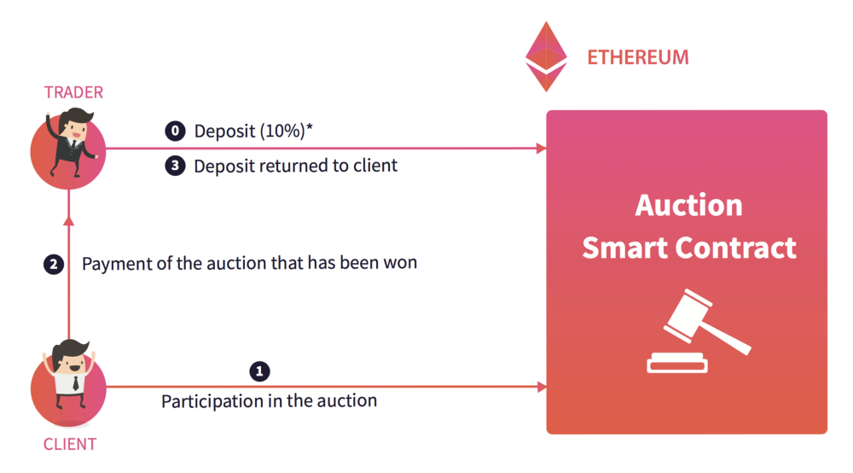
fig1:-High Level Use Case Diagram
image source:-https://medium.com/domraider/blockchain-application-to-the-auction-mechanism-9c7f557a8e13

RoadMap:

