3.5 Administrative Dashboard
ID | Requirement | Priority | Source
FR-40 | The admin shall be able to view all posts filtered by status, domain, and date. | High | Brief 4.5
FR-41 | The admin shall be able to remove inappropriate posts. | High | Brief 4.5
FR-42 | The admin shall be able to list users filtered by role. | Medium | Brief 4.5
FR-43 | The admin shall be able to suspend user accounts. | High | Brief 4.5
FR-44 | The admin shall be able to view system statistics including total posts, active users, and daily actions. | Medium | Brief 4.5

3.6 Activity Logging & Audit Trail
ID | Requirement | Priority | Source
FR-50 | The system shall log critical actions including login, post creation, post deletion, meeting request submission, and account deletion. | High | Brief 4.6
FR-51 | Each log entry shall include timestamp, user ID, action type, and target resource ID. | High | Brief 4.6
FR-52 | The admin shall be able to filter logs by date range and user. | Medium | Brief 4.6
FR-53 | The admin shall be able to export logs in CSV format. | Medium | Brief 4.6

4. Non-Functional Requirements
ID | Requirement | Metric | Category
NFR-01 | Page load time shall be less than 3 seconds. | < 3 seconds | Performance
NFR-02 | The system shall support at least 100 concurrent users. | ≥ 100 users | Performance
NFR-03 | API response time shall be less than 500 milliseconds. | < 500 ms | Performance
NFR-04 | All communication shall be secured using HTTPS protocol. | 100% HTTPS | Security
NFR-05 | User authentication shall be managed using JWT tokens. | Token expiration: 24 hours | Security
NFR-06 | The system shall implement Role-Based Access Control (RBAC). | 3 roles supported | Security
NFR-07 | Passwords shall meet complexity requirements. | Min 8 chars, uppercase, number | Security
NFR-08 | Users shall be able to delete their account and all personal data. | ≤ 30 days deletion | GDPR / Privacy
NFR-09 | Users shall be able to export their data in JSON format. | JSON download available | GDPR / Privacy
NFR-10 | The system shall not store sensitive medical or patient data. | 0 sensitive data stored | GDPR / Privacy
NFR-11 | The system shall comply with WCAG 2.1 AA accessibility standards. | WCAG 2.1 AA | Accessibility
NFR-12 | The system shall support keyboard navigation. | Full keyboard support | Accessibility
NFR-13 | The interface shall be easy to understand for new users. | ≤ 20 seconds comprehension | Usability
NFR-14 | Error messages shall be clear and user-friendly. | 100% readable errors | Usability

5.3 UC-03: Admin Manages System
Name: UC-03: Admin Manages System
Actor(s): Admin
Precondition:
The admin must be logged in.
Main Flow:
- The admin opens the admin panel.
- The admin views users and posts.
- The admin applies filters to the data.
- The admin removes inappropriate posts.
- The admin suspends user accounts if necessary.
- The admin reviews activity logs.
- The admin exports logs as CSV.
Postcondition: System data is managed and updated.
Alternative Flow: 3a. If no data is found, the system displays an empty state message.

6. Data Model
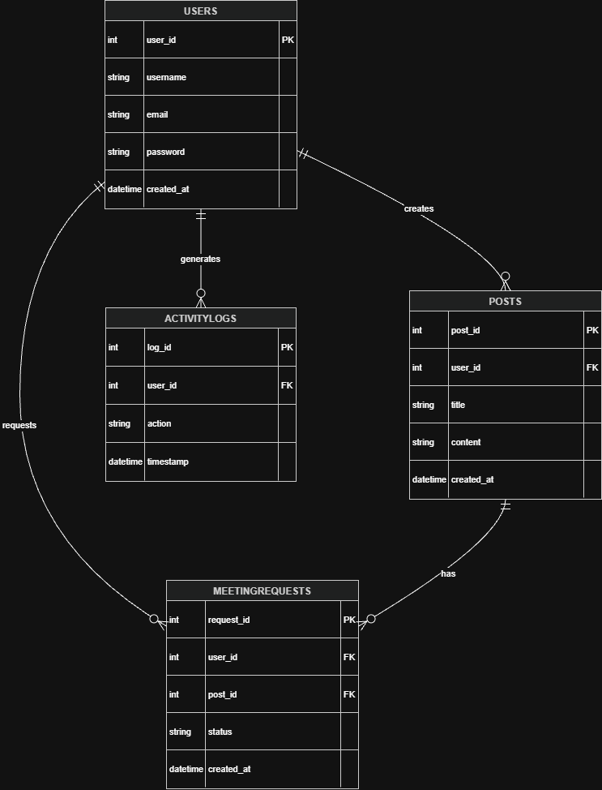
Figure 1 ER Diagram of the System
The system is based on four main entities: Users, Posts, MeetingRequests, and ActivityLogs. These entities represent the core structure of the platform and define how users interact with the system.
The Users entity stores all registered user information, including authentication details, role, and profile data. Each user can create posts, send meeting requests, and generate activity logs.
The Posts entity represents collaboration opportunities created by users. Each post belongs to a single user and contains detailed information such as domain, required expertise, project stage, and confidentiality level.
The MeetingRequests entity represents meeting requests sent by users in response to posts. Each request is linked to both a user and a post, and includes proposed time slots, NDA acceptance, and request status.
The ActivityLogs entity stores system activity records. Each log entry tracks user actions such as login, post creation, meeting requests, and account-related operations.
The relationships between entities are as follows:
- One User can create multiple Posts (1-to-many)
- One Post can have multiple MeetingRequests (1-to-many)
- One User can send multiple MeetingRequests (1-to-many)
- One User can generate multiple ActivityLogs (1-to-many)

7. Interface Requirements

7.1 User Interface (UI)
Page | URL | Description
Register | /register.html | New user registration with .edu email validation
Login | /login.html | User login page
Dashboard | /dashboard.html | Main page showing posts and summary
Post Feed | /post-feed.html | List of posts with filtering
Create Post | /create-post.html | Post creation form
Post Detail | /post-detail.html | Detailed post view
Meeting Request | /meeting-request.html | Meeting request workflow
Profile | /profile.html | Profile management and GDPR actions
Admin Panel | /admin.html | Admin dashboard for managing users, posts, and logs

7.2 External System Interfaces
- Email service is used for account verification and notifications
- Meetings are conducted via external platforms such as Zoom or Microsoft Teams
- The system only provides meeting links and does not host meetings

8. Requirements Traceability Matrix
Requirement ID | Description | Source | Use Case
FR-01 | .edu email requirement | Brief 4.1 | UC-01
FR-02 | Email verification | Brief 4.1 | UC-01
FR-10 | Create post | Brief 4.2 | UC-01
FR-11 | Post lifecycle | Brief 4.2 | UC-01
FR-14 | Post expiry | Brief 4.2 | -
FR-20 | Post filtering | Brief 4.3 | UC-02
FR-30 | Express interest | Brief 4.4 | UC-02
FR-33 | Meeting scheduled status | Brief 4.4 | UC-02
FR-40 | Admin post management | Brief 4.5 | UC-03
FR-41 | Remove post | Brief 4.5 | UC-03
FR-42 | User listing | Brief 4.5 | UC-03
FR-43 | Suspend user | Brief 4.5 | UC-03
FR-50 | Activity logging | Brief 4.6 | -
FR-51 | Log details | Brief 4.6 | -
FR-52 | Log filtering | Brief 4.6 | UC-03
FR-53 | Export logs | Brief 4.6 | UC-03

