ANNUAL SERVICE PROPOSAL
STERNER GLOBAL-MASTERCORR
PREVENTIVE MAINTENANCE · INGEPRO MONITORING · PREDICTIVE AI · INDUSTRIAL SPARE PARTS CHANNEL
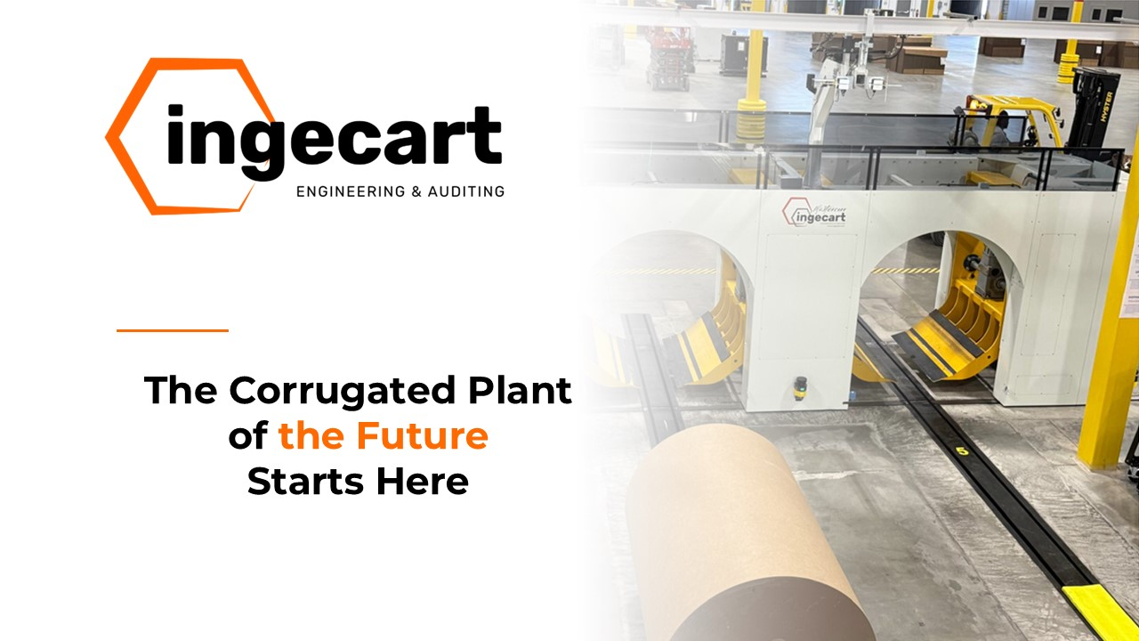
INGECART after-sales service - annual maintenance and reliability proposal
Customer | Sterner Global-Mastercorr
Project | Smart Plant Annual Maintenance Programme + INGEPRO - Sterner Global-Mastercorr
Proposal reference | OFF-2026-S137
Date | September 28, 2026
Duration | 12 months
Commercial basis | EUR | After-sales service according to the configured scope, service levels and commercial conditions.

Included annual services
Service | Frequency | Coverage | Annual amount
Annual Preventive Maintenance Programme | 4 on-site visits + monthly remote follow-up | All Sterner Global-Mastercorr equipment | €33,984.00
INGEPRO Monitoring + Predictive AI | 24/7 continuous | Alerting, predictive analytics, recommendations and OEE/LPI follow-up | €18,000.00
Operational + Maintenance + Management Training | 12 sessions/year (onsite and remote) | Operators, maintenance technicians and plant managers | €11,150.00
INGEPRO Wholesale Industrial Purchasing Channel | Continuous supply service | Multi-OEM spare parts with Tetrace-type cost/lead-time benchmark | €4,818.00
RECOMMENDED ANNUAL TOTAL |  |  | €67,952.00
Move from reactive repair to predictable asset performance: longer component life, stable output, fewer emergency interventions and a clear annual service budget.

CONTENTS

1 OFFER LETTER
Dear Sterner Global-Mastercorr Team,
INGECART is pleased to submit the service proposal OFF-2026-S137 for Smart Plant Annual Maintenance Programme + INGEPRO - Sterner Global-Mastercorr. The proposal consolidates scope, deliverables, service levels and commercial conditions in an executive format ready for internal validation and approval.
The objective of this release is to provide a technically consistent, commercially traceable service programme that minimizes unplanned downtime and secures equipment availability.

2 EXECUTIVE SUMMARY
- Customer: Sterner Global-Mastercorr. Proposal: Smart Plant Annual Maintenance Programme + INGEPRO - Sterner Global-Mastercorr.
- This annual proposal consolidates preventive maintenance, INGEPRO monitoring and the adoption of predictive AI to secure availability and operational continuity of the critical assets defined in the Smart Plant Dashboard.
- Recommended annual investment: €67,952.00.
- Move from reactive repair to predictable asset performance: longer component life, stable output, fewer emergency interventions and a clear annual service budget.
- Main deliverables: Operational dashboard per role with availability, OEE, risk and PM compliance KPIs | Monthly technical report + quarterly executive review | Prioritised list of improvements, spare parts and downtime-reduction actions | Annual maintenance calendar aligned to production stops.
- Response commitment: Remote response (Within 4 business hours) | On-site urgent dispatch (24-48 h in peninsula) | Scheduled preventive visit (Agreed annual calendar) | Service report delivery (Within 5 business days).

3 SCOPE AND SERVICE DESCRIPTION
This annual proposal consolidates preventive maintenance, INGEPRO monitoring and the adoption of predictive AI to secure availability and operational continuity of the critical assets defined in the Smart Plant Dashboard.
The programme combines scheduled Total Productive Maintenance (TPM) routines based on the INGECART templates for Ingetrans lines, 24/7 INGEPRO monitoring with predictive AI, continuous training by role and an industrial spare-parts purchasing channel.

3.1 Offered services
The proposal includes the following annual services, with their frequency, coverage and included activities:

3.1.1 Annual Preventive Maintenance Programme
Maintenance programme per installed base, based on the INGECART TPM templates for Ingetrans lines: weekly condition inspection, monthly backlog review, planned quarterly stops and annual reliability audit.
Frequency: 4 on-site visits + monthly remote follow-up | Coverage: All Sterner Global-Mastercorr equipment
- 4 on-site preventive visits planned in the annual calendar and aligned with production stops.
- Daily operator checks: pneumatic pressures (6-8 bar), hydraulic oil level, visual inspection of rollers and belts, work-area cleaning.
- Weekly maintenance checks: lubrication of critical points, belt tension, roller alignment, compressed-air filter cleaning.
- Monthly technician checks: calibration of measuring systems, blade and counter-blade condition, safety systems, main motor vibration analysis.
- Quarterly checks: hydraulic oil change, complete electrical revision, critical-part wear verification, control software update.
- Monthly remote follow-up of the maintenance backlog and annual reliability audit.
- Visit report with condition status, wear trend and prioritised corrective actions.

3.1.2 INGEPRO Monitoring + Predictive AI
INGEPRO enables 24/7 monitoring, criticality-based alerts and predictive recommendations for Operators, Maintenance and Management, with actionable playbooks per role.
Frequency: 24/7 continuous | Coverage: Alerting, predictive analytics, recommendations and OEE/LPI follow-up
- 24/7 monitoring of status, alarms and KPIs of the critical assets defined in the Smart Plant Dashboard.
- Alerts classified by criticality with agreed escalation protocol.
- Predictive analytics and early failure detection.
- Actionable playbooks per role: Operators, Maintenance and Management.
- Follow-up of OEE/LPI, availability, risk and PM compliance.
- Remote technical support included.

3.1.3 Operational + Maintenance + Management Training
Continuous training programme including AI applied to the plant, early failure detection and data governance for intervention and improvement decisions.
Frequency: 12 sessions/year (onsite and remote) | Coverage: Operators, maintenance technicians and plant managers
- Operator training: normal cycle, alarms, recovery and daily TPM checks.
- Maintenance training: TPM routines, diagnosis and component replacement.
- Management sessions: KPIs, OEE, risk and improvement prioritisation.
- AI applied to the plant, early failure detection and data governance.

3.1.4 INGEPRO Wholesale Industrial Purchasing Channel
The INGEPRO channel includes direct requests for spare parts for any equipment, with volume negotiation and supply traceability to improve lead time and price. Equivalent functional service reference: https://www.tetrace.com/en/spare-parts.
Frequency: Continuous supply service | Coverage: Multi-OEM spare parts with Tetrace-type cost/lead-time benchmark
- Direct multi-OEM spare parts requests through INGEPRO.
- Volume negotiation and cost/lead-time benchmark.
- End-to-end supply traceability.
- Access to the INGECART permanent stock of critical parts and original Ingetrans spare parts.

3.2 Maintenance programme per installed base
- Ingetrans Rail Transfer (site5_ingetrans_01)
- 10-Lane Reel Exchange Grid (site5_grid_01)
- Warehouse RFID Station (site5_rfid_01)
- Corrugating line: single facer, double facer, preheaters, glue machine bridge, humidifier group.
- Converting line: slitter-scorer, rotary and counter-rotary knives, flexographic printer, rotary die-cutter, flatbed die-cutter.
- Handling and finishing: automatic stacker, sheet counter, palletizing system, strapping machine, conveyor belts.
- Auxiliary equipment: correcting groups, paper feeding systems, air compressors, hydraulic power units, glue drying / curing ovens.
- Control systems: PLCs, automatic systems, sensors, encoders, frequency drives, operator panels / HMI.
Frequencies: weekly condition inspection, monthly backlog review, planned quarterly stops and annual reliability audit.

3.3 INGETRANS & corrugated line TPM preventive maintenance

3.3.1 Daily check (operator)
- Verify pneumatic pressures (6-8 bar).
- Check hydraulic oil level.
- Visual inspection of rollers and belts.
- General cleaning of work area.

3.3.2 Weekly check (maintenance)
- Lubrication of critical points (bearings, guides).
- Belt tension check.
- Roller alignment verification.
- Compressed air filter cleaning.

3.3.3 Monthly check (technician)
- Calibration of measuring systems.
- Blade and counter-blade condition check.
- Safety system verification.
- Main motor vibration analysis.

3.3.4 Quarterly check
- Hydraulic oil change.
- Complete electrical system revision.
- Critical parts wear verification.
- Control software update when applicable.

3.4 Deliverables
- Operational dashboard per role with availability, OEE, risk and PM compliance KPIs.
- Monthly technical report + quarterly executive review.
- Prioritised list of improvements, spare parts and downtime-reduction actions.
- Annual maintenance calendar aligned to production stops.
- Operator, maintenance and technician-level TPM checklists.
- Visit report with condition status and corrective recommendations after each visit.

3.5 Optional additional services
Services available on request, quoted separately and activatable at any time during the contract:
Service | Frequency | Coverage
Urgent on-site technical assistance | On demand, 24-48 h in peninsula | Critical breakdowns on covered equipment
Repair and reconditioning in own workshop | On demand | Rollers, knives, correcting groups, gearboxes and mechanical assemblies
Critical spare parts kit on site | Annual review | Critical parts per machine and risk level
Control software update and backups | Quarterly / per release | PLCs, HMI, frequency drives and control systems
Retrofit and modernization study | On request | End-of-life equipment or equipment with performance gaps
- Urgent on-site technical assistance: Dispatch of the multidisciplinary INGECART team (mechanical, electrical, automation) to recover production after critical breakdowns.
- Repair and reconditioning in own workshop: Own 1,200 m² workshop with specialized machinery, complete plans and original technical documentation of Ingetrans equipment.
- Critical spare parts kit on site: Recommended on-site stock of critical parts to minimise downtime, defined from the installed base and failure history.
- Control software update and backups: Controlled update of control software with previous backup, change log and functional validation.
- Retrofit and modernization study: Technical and economic study to extend equipment life, close performance gaps and integrate new control or safety functionality.

3.6 Exclusions
- Major repairs or rebuilds outside the agreed TPM scope.
- Consumables, blades, belts and wear parts not listed in the agreement.
- Civil works, foundations, customer utilities and third-party interfaces.
- Production losses due to customer-side delays or unavailable access.

3.7 Assumptions and execution conditions
- Customer provides safe, prepared access during scheduled windows.
- Equipment is reachable with standard lifting means.
- Technical documentation and latest software backups are available.
- Customer notifies critical alarms within the agreed escalation window.

3.8 Why INGECART
- Over 30 years of experience in the corrugated cardboard sector.
- Own 1,200 m² workshop with specialized machinery.
- Permanent stock of critical spare parts.
- Multidisciplinary technical team (mechanical, electrical, automation).
- 24-48 h response time in the peninsula.
- Deep equipment knowledge from own manufacturing and assembly.
- Complete plans, technical documentation and original spare parts.
- Continuous training for client operators and remote support included.

3.9 Response commitment
- Remote response: Within 4 business hours
- On-site urgent dispatch: 24-48 h in peninsula
- Scheduled preventive visit: Agreed annual calendar
- Service report delivery: Within 5 business days

4 SERVICE EXECUTION AND ACCEPTANCE
Service execution will follow the agreed annual calendar, each visit report and the quarterly KPI review. Acceptance will be the service report sign-off and fulfilment of the defined SLAs.

4.1 SERVICE LEVELS AND RESPONSE COMMITMENT
- Remote response: Within 4 business hours.
- On-site urgent dispatch: 24-48 h in peninsula.
- Scheduled preventive visit: Agreed annual calendar.
- Service report delivery: Within 5 business days.

5 COMMERCIAL CONDITIONS
Commercial conditions applicable to the annual service programme.
Commercial item | Condition
Currency | EUR
Duration | 12 months from service activation.
Start-up | Start-up in less than 30 days from offer approval.
Invoicing and payment | As agreed in the service contract.
Validity | 30 calendar days from proposal date, subject to material and supplier price availability.

5.1 Economic summary
- Annual Preventive Maintenance Programme: €33,984.00 / year
- INGEPRO Monitoring + Predictive AI: €18,000.00 / year
- Operational + Maintenance + Management Training: €11,150.00 / year
- INGEPRO Wholesale Industrial Purchasing Channel: €4,818.00 / year
Recommended total: €67,952.00 / year

6 WARRANTY AND GENERAL TERMS
- Service work is performed under the INGECART general terms of sale in force at the acceptance date.
- Supplied spare parts keep the original manufacturer warranty.
- Repairs, parts or work outside the described scope will be quoted separately before execution.

7 OFFER ACCEPTANCE
Acceptance of this service proposal confirms the scope, agreed annual calendar, service levels and commercial conditions set out herein. Any scope change will be handled as a written commercial variation.
This proposal can be activated per plant with start-up in less than 30 days from approval.
Accepted by customer | Date

