TheHammer 2.0
Class Reference



TheHammer 2.0 Documentation Project

Revision 2.0.0
Revision date: June 13, 2003

Introduction

To easy maintain and understand TheHammer source for developers who would like to improve this fine Visual Dataflex® source code editor, we have publish this document.

Please note. TheHammer sources is not intended to be used by newbies in dataflex programming. Most of classes are very sophisticated and hardly uses Windows API interfaces. But it is a good point to get information on “How To?” question and study VDF programming in depth along with programming for Windows.

The level of programmer should be Intermediate or higher. But of course, some of the classes may be easy used by newbies as well.

Also, please note: TheHammer is a free, open source project created by the team of the Visual Dataflex® programmers and friends. Please do not expect direct technical support on the sources published along with TheHammer Binary revision. Please post your messages into Hammer news group at VDF-Guidance site (news://news.mijnwebapp.nl/Hammer).

TheHammer 2.0 Classes

Base classes

- cCodeMaxEdit
- cFolderTabs

TheHammer classes

- cClassBitmaps

cCodeMax Class

Purpose

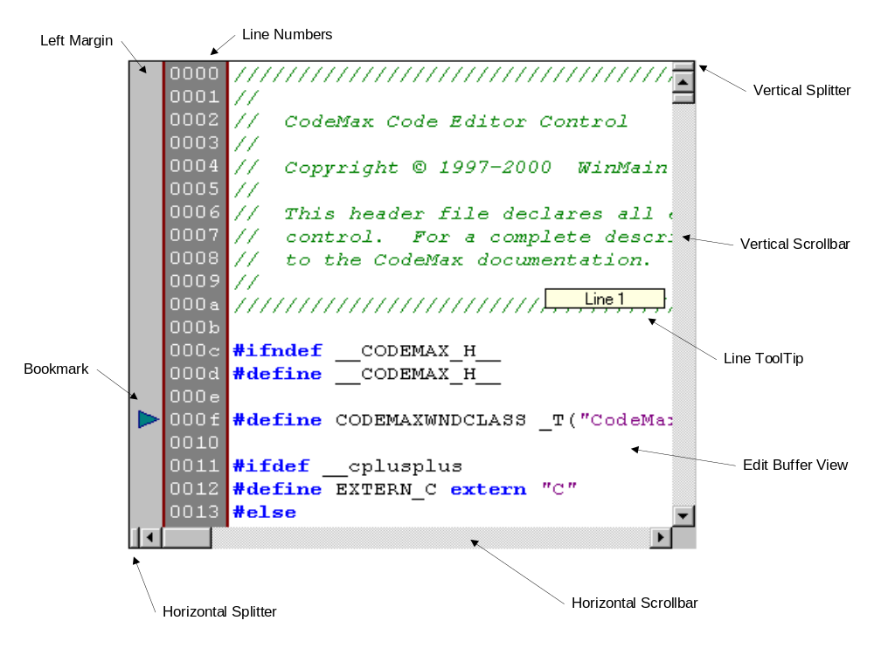CodeMax supports a wide range of features, all of which are available to the user without any extra programming after the control is created (Color Syntax Highlighting, Fully Customizable Keyboard Mappings, Keystroke Macros, Drag and Drop Text Manipulation, Multiple Split Views, Unlimited Undo/Redo, Custom Margin Images, Per-Line Item Data, Regular Expression Searching, Auto Indentation, Built-In File Support, Clipboard Support, Built-In Support for C/C++, Java, SQL, Pascal, and Basic, Support for Custom Languages, Column Selection and Manipulation, Custom Color Settings, Built-In Window Properties Dialog, Built-In Right Click Menu, Microsoft IntelliMouse Support, Over 130 Separate Edit Commands, Line Numbering, Keyword Case Normalization, Built-in Printing Support, Line Highlighting, Horizontal Line Dividers, Custom Line Drawing (DLL version only), Selection Bounding) and much more.
Hierarchy

DFUIWindow
+-DFControl
+-cCodeMax

Source

<HAMMERDIR>\Pkg\cCodeMax.pkg

Programmer’s Level Rank: Intermediate

Class intended to be used by experienced developers.
Sample

Object oCodeMaxEdit Is a cCodeMaxEdit
Set Location To 70 10
Set Size To 20 580
End_Object

Comments

This class is a wrapper of worldwide known CodeMax control used by most of code editors, including Visual Dataflex® IDE and Database Builder utilities.

Since TheHammer 2.0 we have use CodeMax extension named CodeSense control. It is exactly same control as CodeMax, but expands original component with new possibilities like CodeLists and CodeTips. All of these features implemented in this cCodeMaxEdit class.

TheHammer use

This class is a key class of TheHammer and used for editing source files.

Properties, Methods and Events

There are no any reason to repeat CodeMax original User’s manual for describing properties and methods used here. Please refer to official CodeMax/CodeSense manuals to explore appropriate property or method.

The only purpose of additional methods is to simplify CodeMax interface to be more user friendly for using in VDF applications.

cFolderTabs Class

Purpose

A Folder tab panel is created by creating a cFolderTabs object and then by adding Tab objects inside it. Each tab displays a tab with its name on it within the Folder Tabs panel at all times. You may use this panel for switching some options or as some actions selection during runtime.

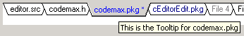

Hierarchy

DFUIWindow
+-DFControl
+-cFolderTabs

Source

<HAMMERDIR>\Pkg\cFolderTabs.pkg

Sample

Object oFolderTabs Is a cFolderTabs
Set Location To 70 10
Set Size To 20 580
Set Color To clWhite
Send Add_Item MSG_None "Apple"
Send Add_Item MSG_None "Orange"
Set ToolTip_Value Item (Item_Count(Self)-1) To "This is an Orange"
Set ItemTextColor Item (Item_Count(Self)-1) To clNavy
Send Add_Item MSG_None "Banana"
End_Object

Comments

This class uses Microsoft common controls library and created using special “#32768” class (USER menus). It is an external class.

TheHammer use

This class used in TheHammer to show the currently opened source files list. It also provided a tooltip to show full file name path and hot tracking feature. Also, it used to eluminated changed and read-only files opened in the editor.

Programmer’s Level Rank: Beginner

May be used by beginners newbie VDF developers.
Public interface properties

piTopState -- Integer -- True / False -- Property
The position of the tabs can be on the top or the bottom of the tab-panel. To display them on the top, set this property to True; to display them on the bottom set this property to False.

piTabsColor -- Integer -- clWhite --Property
This property sets the not-selected tabs color. By default, this value is clWhite.

piSelectedItemColor -- Integer -- clBtnFace -- Property
This property sets the selected tab color. By default, it will be set to clBtnFace system color.

piHotItemTextColor -- Integer -- clBlue -- Property
If you will set this property, the tab text will be highlighted with specified color when mouse moved over the tab.

piItemTextColor -- Integer -- clWindoText – Property
This property allows change the color of the text placed on the tab.

Autosize_Height_State -- Integer – True / False—Property
If this property True, the Tab control will adjust own size to be exact to fit own buttons height.

Border_Style – Mode – (Border_None) – Property
This property cancelled in this class. Always sets and returns Border_None value.

Label – String – Property
This property sets text for the currently selected tab item.

Color – ColorRef – Property
This property sets the background color of cFolderTab panel.

HeightAddedToSelected – Integer – 0 – Property
This property sets the extra gap in pixels for the currently selected tab, making selected tab more contrast.

Item based properties

Current_Item – Integer – 0 – Property
This property sets or returns current item of cFolderTabs control. Tab item number is zero based.

Value -- string -- " " -- item_value
This property allows Get/Set tab text value. Item based. Item number is zero based.

ItemColor – Integer – ColorRef – item_value
This property allows to set color of appropriate Tab by item number (zero based) reference.

ItemTextColor – Integer – ColorRef – item_value
This property allows to set color of the text of appropriate Tab by item number (zero based) reference.

ToolTip_Value – String – ““ – item_value
This property sets tooltip string for the tab by item number reference.

item_shadow_state – Boolean – True / False – item_value
This property allows to shadow the appropriate tab by item number reference (zero based).

aux_value – integer – ObjectRef – item_value
This property allows setting the object reference associated with this tab item (See Add_Item for defaults).

Public interface events

OnPaint – Procedure
The OnPaint message is sent when the system or another application makes a request to paint a portion of an application's window.

OnMouseMove Integer iKeys Integer iXPos Integer iYPos – Procedure
The OnMouseMove message is posted to a window when the cursor moves. If the mouse is not captured, the message is posted to the window that contains the cursor. Otherwise, the message is posted to the window that has captured the mouse.

OnMouseLeave – Procedure
The OnMouseLeave message is posted to a window when the cursor leaves the client area of the window

OnItemChanging Integer iNewItem Integer iOldItem – Procedure
The OnItemChanging message is sent when user pressed mouse button to change current selected item.

OnItemChanged Integer iNewItem Integer iOldItem – Procedure
The OnItemChanged event is sent when tab button actually changed by user action.

OnClick Integer iItem – Procedure
The OnClick event will be sent when user clicked on appropriate tab. Tab item number will be passed as parameter. If you will set item message (see Add_Item method) and Aux_Value property, by default this event will send specified message to the object, specified in Aux_Value property.

Public interface methods

Dstroy_Object – Procedure
Frees all memory allocated for use by the object, and causes any future references to that object to refer to the null object instead. If an object is on the screen at the time it is destroyed, it will be removed first. All properties and key definitions will be removed.

Item_Count – Integer Function
The item_count returns the number of items in the cFolderTab class object. cFolderTabs with no tabs defined (items have never been added or the object has been cleared) will return zero.

ScrollLeft – Procedure
This method scrolls tab items to the left in bounds of control panel. Current item will not be changed on scrolling.

ScrollRight – Procedure
This method scrolls tab items to the right in bounds of control panel. Current item will not be changed on scrolling.

Refresh – Procedure
This method refreshes the control to show all changes made (if case).

Add_Item Integer iMsg String sText -- Procedure
Items are added to the end of the object. If the object is active, and the added item appears in the screen window, the display is automatically updated.

Delete_Item Integer iItem – Procedure
The specified item is deleted from the tab control if it exists. The screen is automatically updated to reflect the change.

Delete_Data – Procedure
Deletes all data from the cFolderTabs class object. All memory is released back to the system.

Private interface methods

Normally, you should never use this methods in the your application.

AutoSizeHeight – Procedure
Size the height of the control to the selected settings and system fonts

ButtonGuiSize Integer iItem – Integer Function
Delivers the GuiSize of a specified Button

ButtonGuiLocation Integer iItem – Integer Function
Delivers the GuiLocation of a specified Button

ItemAtPos Integer iX Integer iY – Integer Function
Delivers the Item-Number if there is a Item under pos iX/iY else -1

SetHotState Integer iItem Integer iState – Procedure
Set's the HotState of a specified item to true/false

HotItem Integer iItem – Procedure Set
Sets the current HotItem (deselects current hot-item if necessary)

GetTrapezoid String sRect – String Function
Create a point array (string of points added together that defines the trapezoid used FOR painting

OffsetTrapezoid Integer iItem Integer iRight Integer iDown – Procedure
Moves a Trapezoid location specified by iRight iDown.

XFromPointArray String sArray Integer iIndex – String Function
Delivers the x-Position of a point in my Point-Array

YFromPointArray String sArray Integer iIndex – Integer Function
Delivers the y-Position of a point in my Point-Array

ScrollDatas Integer iRight Integer iDown – Procedure
Shift the position of all rects, regions and trapezoids by the specified values.

CreateRegions Handle hDc Integer iStartOffset – Integer Function
Creates all Regions needed to paint the visible Buttons

DrawButton Handle hDC Integer iItem – Integer Function
Draws a single Button

PaintBackground Handle hDc – Procedure
Paints the contol’s background

CreateToolTipWindow – Procedure
This method creates tooltip window using special WinApi function call.

ToolTipActive Integer iState – Procedure Set
Activates or deactivates a ToolTip control.
AddWindowToToolTip – Procedure
Registers a tool with a ToolTip control.

HideToolTip – Procedure
Allows to remove tooltip from the screen.

RefreshToolTip – Procedure
Refreshes tooltip window text and location.

cClassBitmap Class

Purpose

This is a special class for the TreeView Bitmaps processing. This class loads bitmaps from external database into internal repository.

Hierarchy

Object
+-Set
+-cClassBitmap

Source

<HAMMERDIR>\Pkg\Bitmaps.pkg

Programmer’s Level Rank: N/A

Internal TheHammer Class.

Sample

Object Bitmaps Is a cClassBitmaps
// Uncomment to load all bitmaps on startup...
// Set Auto_Load_Bitmaps to TRUE
Send Load_Bitmaps 0 0
End_Object
...
Move (ClassBitmaps("dbList",MK_CLASS)) to sBitmap

Comments

This class extracts bitmaps from some data file in following order: 1. From the internal repository, if not found, 2. From the Data Base, and adds it into the internal repository.

It is TheHammer’s helper class, not intended to be used outside of TheHammer.

Public Interface

There is a once DeskTop function defined to accesss this class in TheHammer:

ClassBitmaps String sClass Integer iType – String Function (for desktop)
sClass – TheHammer VDFCLS data file NAME field, iType should be always MK_CLASS. This function used on filling in the Code explorer TreeView control. Function returns name of the bitmap associated with appropriate class. Bitmap to the class may be assigned by using TheHammer Class Explorer utility.

