Introduction

The Hammer is a SourceCode editor based on the CodeMax control which is also used by the Data Access Worldwide Visual Dataflex® Integrated Development Environment.

It is especially designed for the needs of developing Visual DataFlex Applications, but the editor currently also supports other languages such as: C/C++, Basic, Java, Pascal, SQL, Html and Xml.

The complete project is currently open source under the „GPL“-license

The Hammer was originally developed by Michael Kurz and Sergey Naratov. Currently, The Hammer developmet team includes:

- Bernhard Ponemayr
- Sergey V. Natarov
- Wil van Antwerpen
- Peter H. Van Wijk
- Udo Haemel
- Magnus Bergh

And many other developers.

KURANT Project, January 2003‘

CodeTip Abilities

Code tips is a new feature of The Hammer, introduced in the version 2.0. Within 2.0 revision of this editor, we implemented updated CodeMax control, named CodeSense, that adds this feature to the Editor.

To utilise this functionality, CodeMaxEdit.ini file were expanded with a new parameters:

pbCodeTipAutoPopup – FALSE ( = 0 )

Boolean INI property of the Editor. Has false value by default. This property allows to the editor to show code tips automatically, if cursor set into particular position of Editor window and line content recognized as function, defined in the special INI file.

pbTrimComments – FALSE ( =0 )
Boolean INI property. If defined as TRUE, cCodeTip will trim the comments, following after function description. This will save a bit memory on your PC. If defined as FALSE, you will see additional information on function used, defined in the Functions.ini file.

pbHighlightArguments – TRUE ( =1 )
Boolean INI property. If defined as TRUE, cCodeTip will will highlight current function argument.

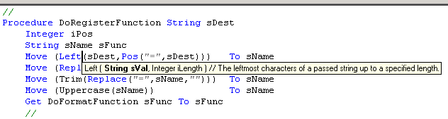
Picture 1 Codetip highlighting

pbUseCodeTips – TRUE ( =1 )

Boolean INI property. Enables CodeTip support in the Editor. If this has FALSE value, CodeTip engine will be disabled.

psCodeTipIniFile – “Functions.ini“

String INI property. Defines the name of INI file with the list of functions, that recognized by CodeTip parser. If this property has <Empty> value, FUNCTIONS.INI file will be used by default. If this file does not exists, CodeTip feature are disabled.

Additionally, you have a new properties in the main editor window properties. Codetip property allows you to assign special Hot Key to be used for calling CodeTip window. Please note, if you have pbCodeTipAutoPopup INI property defined as FALSE and did not set Hot Keys, you will not see ToolTip window.

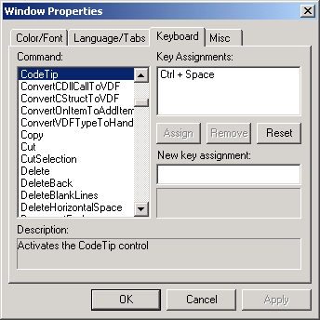
Picture 2 Editor window properties

Structure of Functions.ini file

This is a usual ASCII file and has now any special format. Some features of cCodeTip class:

// - the sequence with double slashes defined as comment. Comments just ignored by cCodeTip class.

CodeTip Function descriptor includes 2 main parts - <HEADER> and <DESCRIPTION>. The format of record as following:

<HEADER> = <DESCRIPTION>

Example:
Cos = Cos ( Real rVal ) // The cosine of a passed value.

Format of the function description

cCodeTip expects, tha all functions defined as following:

<Name> ( <Type1> Argument1, <Type2> <Argument2>, ... ) // Comment

This important if you enabled Argument highlighting feature. To make text more readable in the ToolTip window, you can add a few extra spaces between arguments, function names etc.

Example:

Left(String sVal, Integer iLength ) // The leftmost characters of a passed string up to a specified length.

TheHammer Menu System

File menu

File menu includes all required commands to open, close, save or print sources file.

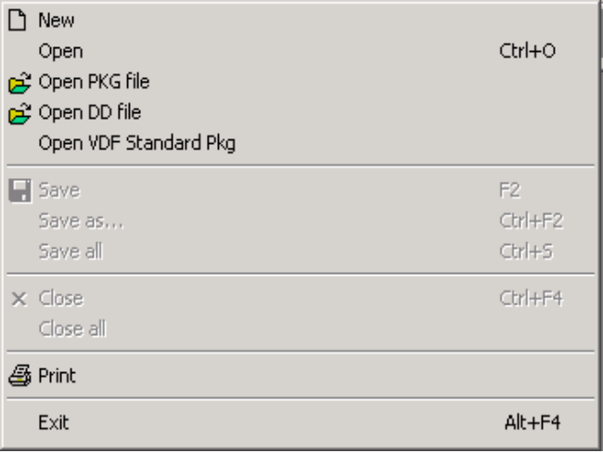

New – Creates new, untitled document (Editor window).
Open – Opens existent source file from selected workspace, AppSrc path.
Open PKG file – Opens existent package file from PKG directory of current workspace if defined, otherwise open AppSrc path.
Open DD file – Opens existent DataDictionary file from DD directory of current workspace DDSrc path.
Open VDF Standard Pkg – Opens global package file from Visual Dataflex PKG directory.
Save – Saves currently opened source file.
Save as – Saves currently opened source file with a new name.
Save all – Saves all currently opened files.
Close – Closes currently opened source file.
Close all – Closes all currently opened source files.
Print – Outputs currently opened source file to printer.
Exit – Closes TheHammer window.

You can assign hot keys to the commands listed in this menu by using standard Editor property dialog.

Edit menu

Edit menu includes all commands, required to edit currently opened source file in the editor window.

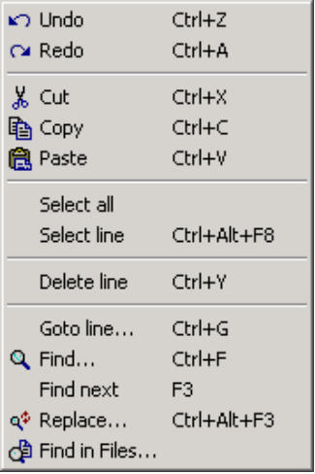
Wefwefw

Options menu

Dfgfdgdf
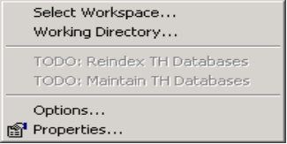
Sdgsdgsd

Build menu

Wedwefwe
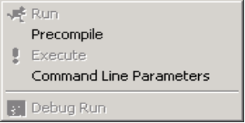
Wefwefwef

Tools menu

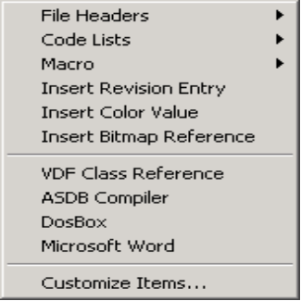

Source menu

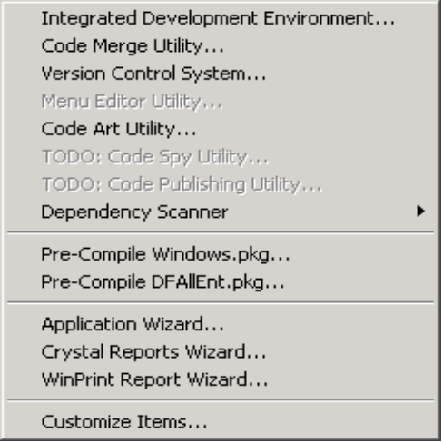

Database menu

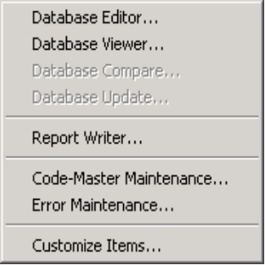

Window menu

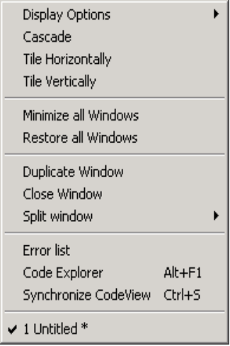

Help menu

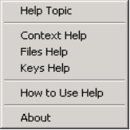

Autosuggestion Abilities

Objects Autosuggestion
A list with all available objects apears whenever you type a piece of code where you need to enter an objectreference.

The Hammer checks the following statements:
set YourProperty of ...
get YourFunction of....
send YourMessage to...

Procedure / Functions Autosuggestion
A list of all available methods apears whenever you are creating a procedure in an object and helps you to override methods in objects.

Procedure...
Function...

Create call statements with the „Creator“
This list is invoked whenever you type one of the following keywords and press [Enter] afterwards.

set [Enter]
get [Enter]
send [Enter]
move [Enter].

Commands

File Commands
FileOpenFile | Opens a file
FileSaveFilem | Saves the file
FileSaveFileAs | Save file as...
FileSaveAll | Saves all opened files
FileCloseFile | Closes the file
FileCloseAllFiles | Closes all files

Build Commands
BuildRun | Compiles And runs the main programfile
BuildRunCurrent | Compiles And runs the current file
BuildCompile | Compiles the current file
BuildPrecompile | PreCompiles the current file
BuildExecute | Starts the main program without compiling
BuildDebugRun | ReCompiles with debug info And starts the main program
BuildDebugRunCurrent | ReCompiles with debug info And starts the current program

Window Commands
WindowSwitchToCodeView | Activates the codeview window
WindowSwitchToErrorView | Activates the error window
WindowSyncCodeView | Synchronizes the CodeView with cursorposition
WindowNextView | Activates the next view
WindowPreviousView | Activates the privious view
List Commands
ListCreator | Activates the Creator list
ListObjects | Activates the Object List
ListVariables | Activates the Variables List
ListKeys | Activates the Keys List
ListProcedures | Activates the Procedures List (Overwriting)
ListFunctions | Activates the Functions List (Overwriting)
Tools Commands
ToolsInsertHeaderGlobal | Inserts a header into the current file (global)
ToolsInsertHeaderUser | Inserts a header into the current file (userspecific)

Mixed Commands
OpenFileUnderCursor | Tries to open the file under the current cursorposition
InsertRevisionMark | Inserts a Revisionmark
ToggleComment | Toggles the current line comment marks

