Energy Efficient Routing Implementation in Matlab

The program is run by running the routing.m(main) file. Here the arrival of flows is scheduled.
flowArrival.m handles the arriving flows. It is called within routing.m file. A flow arrival brings more links to active state when needed. It also schedules flow finish time.
The finishing of a flow is handled in flowFinishTimer.m file. It also changes the active topology by removing links with zero load.
routeOptimization.m is invoked when ever new nodes/or links are active in the topology. It tries to find a better path in the new active topology for flows started before half the flow mean duration(µ/2). If the process of route optimization results in links having zero load, the active topology is changed by removing such links similar to what is done in flowFinishTimer.m.
The ntkPower.m file computes the total power being consumed in the network. It is called from within routing.m file.
lambda(a parameter to the poisson process flow arrival) and mu the mean flow duration can be set in the routing.m and in flowArrival.m files respectively.

Table 1 : Parameter values used in the simulation

Parameter | Average flow duration (µ) | Number of Nodes(N) | Simulation Time | Flow re-routing threshold time | Flow Rate | Packet Size | Idle Power | Prob. of having Link b/n 2 nodes
Value | 20s | 13 | 500s | µ/2 | 2000  pkts | 64bytes | 200W | 0.5

Any pair of nodes have a link with probability of
For each lambda, five runs are made and the average is taken.

Figure 1 shows the variation of per flow power consumption for as a function of flow arrival rate.

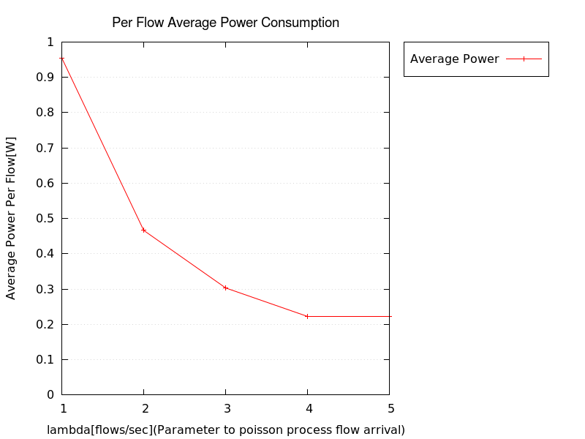
Figure 1: Average Power Consumption Per flow

