Energy Efficient Routing in SDN
Results

Table 1 : Parameter values used in the simulation

Parameter | Average flow duration (µ) | Number of Nodes(N) | Simulation Time | Flow re-routing threshold time | Flow Rate | Packet Size | Idle Power | Prob. of having Link b/n 2 nodes
Value | 20s | 13 | 500s | µ/2 | 2000  pkts | 64bytes | 200W | 0.5

Flow re-routing threshold time is the minimum time that must have passed starting from the activation of a flow for the flow to be considered for re-routing.
For each lambda, five runs are made and the average is taken.

Figure 1 shows the variation of per flow power consumption as a function of flow arrival rate.
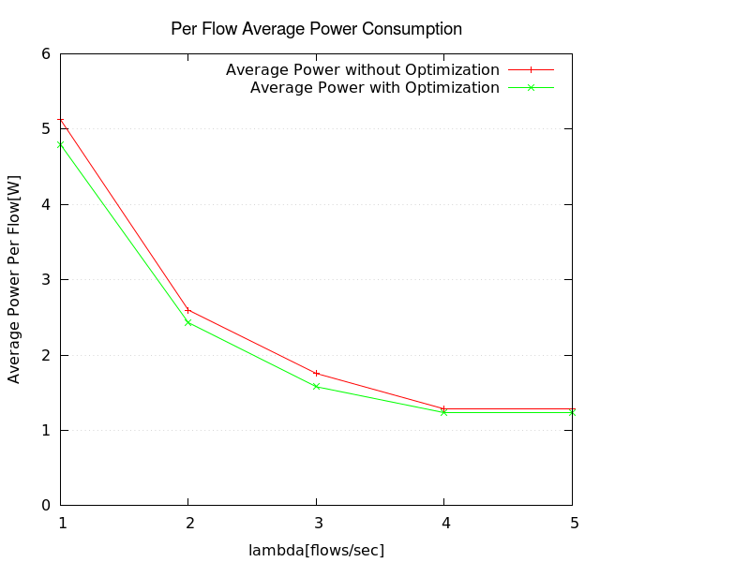
Figure 1: Average power consumption per flow

In the plot, it can be observed that the power consumption with Energy Efficient Routing algorithm is less at smaller flow arrival rate. As the flow arrival rate increases the the power consumption starts to be the same as that of the power consumption of the unoptimized open shortest path first routing algorithm.
Figure 2 shows average power consumption as a function of number of nodes. Simulation parameters are as given in Table 1.
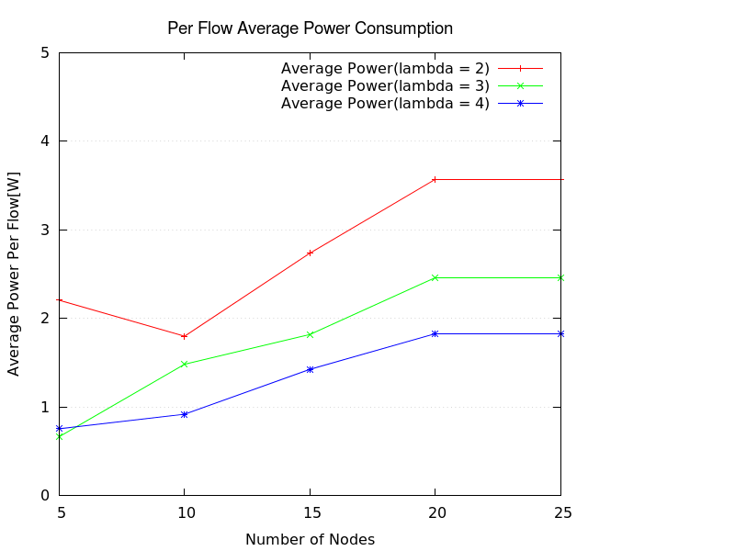
Figure 2: Average power consumption per flow as a function of number of nodes
for the optimized routing algorithm.

Figure 3 shows performance of optimized routing for flow rates of each flow selected randomly between (2 and 10)K packets per second. Number of nodes, N = 25, other simulation parameters are as given in Table 1.

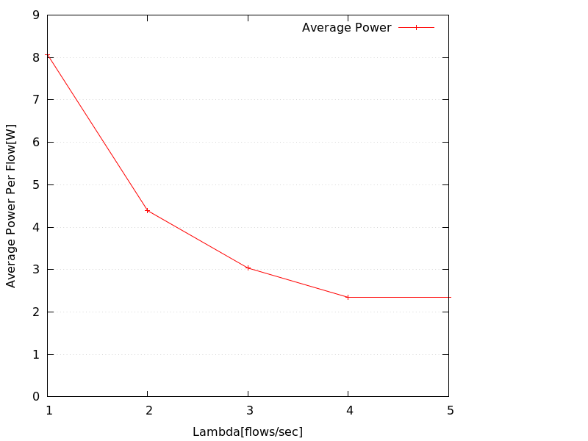
Figure 3: Average power consumption per flow as a function of flow arrival rate and with randomly selected flow rates for the optimized routing algorithm.

Figure 4 shows a comparison of network power consumption as a function of number of nodes for optimized and non optimized routing . Lambda = 3, other simulation parameters are as given in Table 1.
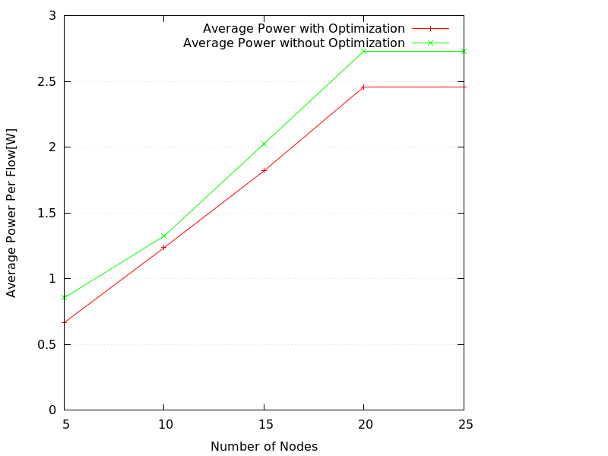
Figure 4: Comparison of average power consumption per flow between optimized and non-optimized routing.

Figure 5 presents a comparison of Network power consumption as a function of flow duration between optimized and non optimized routing. N = 13, lambda = 3, other simulation parameters are as given in Table 1.
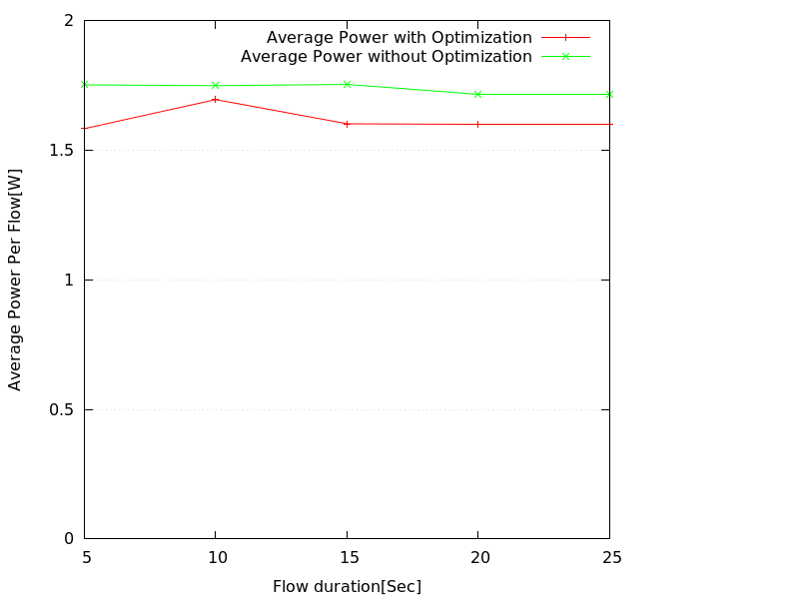
Figure 5: Average power consumption per flow as a function of flow duration.

