Energy Efficient Routing Implementation in Matlab

The program starts by running the routing.m(main) file.
flowArrival.m handles the beginning of flows. It is called within routing.m file. A flow arrival brings more links to active state when needed. It also schedules flow finish time.
The finishing of a flow is handled in flowFinish.m file. It is called from routing.m. It may change the active topology by removing links with zero load.
routeOptimization.m is invoked when ever new nodes/or links are active in the topology. It tries to find a better path in the new active topology for flows started before half the flow mean duration(µ/2). If the process of route optimization results in links having zero load, the active topology is changed by removing such links similar to what is done in flowFinish.m.
The ntkPower.m file computes the total power being consumed in a given instant of time. It is called from within routing.m file every time there is an end of flow or beginning of flow event.

Result

Table 1 : Parameter values used in the simulation

Parameter | Average flow duration (µ) | Number of Nodes(N) | Simulation Time | Flow re-routing threshold time | Flow Rate | Packet Size | Idle Power | Prob. of having Link b/n 2 nodes
Value | 20s | 13 | 500s | µ/2 | 2000  pkts | 64bytes | 200W | 0.5

Flow re-routing threshold time is the minimum time that must have passed starting from the activation of a flow for the flow to be considered for re-routing.
For each lambda, five runs are made and the average is taken.

Figure 1 shows the variation of per flow power consumption as a function of flow arrival rate.
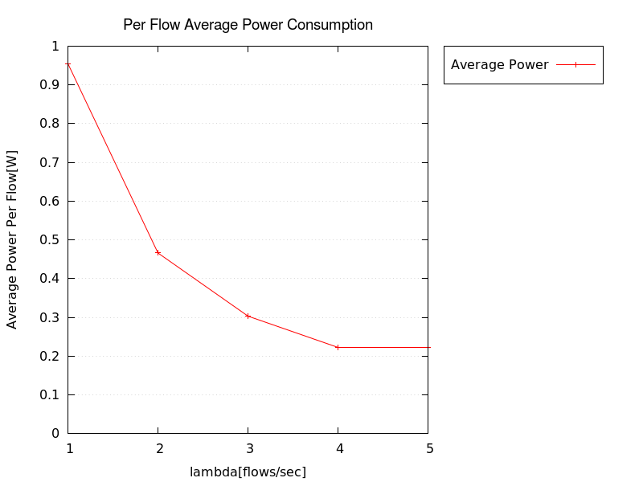
Figure 1: Average power consumption per flow

