Instructions for INM705 Lab 8:

Dataset:

MS COCO, you need to download keypoint detection annotation files from OneDrive (train and val), make sure they are in the working directory. Annotation extraction is similar to masks, but only for ClassID=1 (‘person’). The name of the MS COCO interface that loads the gts objects is coco_interface_kp in lecture8.py script. The list of category Ids (coco_interface_kp.getCatIds()) returns [1].

To get the annotation metadata for person class, use coco_interface_kp.cats or coco_interface_kp.loadCats(coco_interface_kp.getCatIds()) (the former returns a dict with 1 key, ‘1’, and the latter a list, so access the dict by taking the key 1 in the former case and the 0th element in the list in the latter case) returns a dict with ‘skeleton’ and ‘keypoints’.

Each keypoit annotation consists of at 17 keypoints, each encoded in 3 values (x,y, visibility), so a total of 51 values. Skeleton is a collection of 19 tuples in the form [keypoint_1, keypoint_2] indicating connection between two keypoints, e.g. [16,14] stamds for ['right_ankle', 'right_knee'].

There’s a total of 262465 annotated objects (persons) across 64115 images. To acces the list of image ids, simply use coco_interface_kp.getImgIds(catIds=[1]). Be careful: If you don’t use the category ID here, it will load ids of all images from MSCOCO, including those that do not have keypoints!

To get the list of annotations from each image, you need to use the method getAnnIds(imgIds = [id] ), e.g for imgId = 262465.

list_of_anns = coco_interface_kp.getAnnIds(imgIds= [262465])

to get

[467326]

Finally, to load the annotation for this object, use

annotation = coco_interface_kp.loadAnns([467326]) to get the object annotation dict:

Each annotation stores bbox coords, mask (in RLE format), number of keypoints and the coordinates of keypoints + visibility in a vector length 51.

For each image, gt must include bboxes for each object + labels (all 1s for person) – same as for Faster R-CNN and a Tensor or keypoints in the format [#objects, 17, 3], where 17 is the number of all possible keypoints and 3 is the vector of (x,y,visibility) for each keypoint. After extraction of the keypoint vector, you need to convert it to numpy array and append to the list of keypoints:

list_of_keypoints = []

import numy as np

kp = annotation[0][‘keypoint’]
kp = np.reshape(np.array(kp), (17,3))

Once you are done adding keypoints for this image to the list, convert it to Pytorch tensor:

list_of_keypoints = torch.tensor(list_of_keypoints)

Dataset interface will output gt dictionary with bbox coords, labels and keypoints. Keep in mind that the key for the keypoint tensor must be ‘keypoint’, it’s the key that the model script (keypoint_rcnn.py) seeks to create the model.

Model:

To load the keypoint prediction model, simply import it with pretrained weights from torchvision (again, version 0.3.0 is essential):

import torchvision
model = torchvision.models.detection.keypointrcnn_resnet50_fpn(pretrained=True)

Unlike Mask R-CNN, Keypoint R-CNN uses its own RoiAlign module (KeypointRCNNHeads) followed by a fully convolutional feature extractor and a prediction module with 17 heatmaps, one/keypoint.

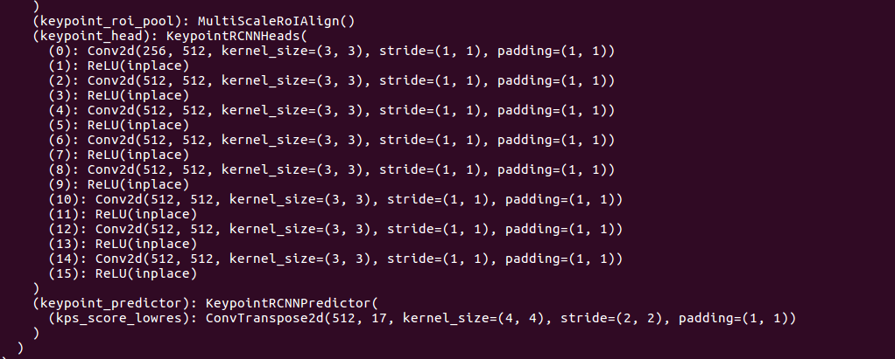

You will have to implement the training script, which is very similar to the Mask R-CNN one, except that you have to call the labels for keypoints instead of masks: y[‘keypoints’].

The model converts keypoint features to heatmaps using Conv2dTranspose upsampling layer (called KeypointRCNNPredictor), from which it extracts predictions, which are compared to the gt keypoints. GT keypoints are transformed into heatmaps, and the cross-entropy loss is computed between prediced and gt heatmaps (if you intend to do model hacking, lookup methods keypointrcnn_loss and keypoints_to_heatmap in roi_heads.py).

At inference time, keypoint model outputs keypoints and keypoint_scores, as well as bbox predictions, scores and predicted labels (all 1s). In the script inference.py keypoints and skeletal connections are plotted for objects with predicted score>0.75 (one false positive).

