Title
Subtitle
Daniel Weiand
Thursday, the 15th of December, 2022
Table of Contents
What is Quarto? 1
YAML setup in Quarto 1
Next… 2
Combining Quarto with Zotero and the {citr} package 3
Cross-referencing functionality in Quarto 6
References 7
Appendix 8

What is Quarto?
Quarto enables you to weave together content and executable code into a finished document. To learn more about Quarto see https://quarto.org.

Where to begin?
Start by:
- choosing the right YAML settings (including format:, execute:, and knitr:); and,
- creating appropriate .docx, .bib, and .csl files (which need to be located in the main project directory)

YAML setup in Quarto
Quarto files start with Yet Another Markup Language (YAML) code.

.csl file
Citation Style Language (CSL) styles are used to format references according to requirements of journal Editors and publishers.
For example, you may wish to render your references in Harvard style, including the title of each manuscript, as required by some Elsevier publications. To do so, simply search the Zotero Style Repository and download the elsevier-harvard.csl file, saving it to your project directory. This file needs to be referred to using the csl YAML metadata field, as shown above.

.css files
These files can be used to, for example, add double spacing to the final, rendered document. To do so, first create a .css file called mystyle.css in your project directory. This file needs to be referred to using the css YAML metadata field, as shown above. To add double spacing, the file should contain only the following text:

.bib files
Quarto supports bibliography files in a wide variety of formats including BibLaTeX and CSL. Add a bibliography to your document using the bibliography YAML metadata field.

Next…
Your .qmd file should outline which packages need to be loaded. For example:
library(here) #For correctly loading files/data
library(knitr) #General-purpose tool for dynamic report generation in R
library(citr) #RStudio Addin to Insert Markdown Citations

Combining Quarto with Zotero and the {citr} package

Zotero
Zotero can be used to put selected references in a plain text file with the extension .bib, in BibTex format.
For example, we may wish to cite the following journal article: Anhøj, J., Olesen, A.V., 2014. Run charts revisited: A simulation study of run chart rules for detection of non-random variation in health care processes. PLoS One 9, e113825
To do so, simply load the reference into Zotero to produce a plain text file in BibTex format (.bib):
@article{anhoj2014run,
title = {Run Charts Revisited: A Simulation Study of Run Chart Rules for Detection of Non-Random Variation in Health Care Processes},
author = {Anhøj, Jacob and Olesen, Anne Vingaard},
date = {2014},
journaltitle = {PLoS One},
volume = {9},
number = {11},
pages = {e113825},
publisher = {{Public Library of Science San Francisco, USA}}
}

Inserting citations in Quarto (conventional method)
Normally, citations go inside square brackets, with each journal article referenced using a single string of characters, defined in Zotero. In the example above, you could cite the paper in question by typing…
Blah blah [@anhoj2014run].
@anhoj2014run says blah.
Blah blah [see @anhoj2014run].
…which turns into:
Blah blah (Anhøj and Olesen, 2014) Anhøj and Olesen (2014) says blah. Blah blah (see Anhøj and Olesen, 2014).

Inserting citations in Quarto (using the {citr} package)
The {citr} RStudio add-in simplifies the process of inserting citations by providing a simple search function that looks for free text of interest (e.g. author or manuscript title) in the .bib file referred to in the bibliography YAML metadata field.
For example, to search for the paper by Anhøj et al:
- Install the {citr} RStudio add-in
- Load the {citr} package using library(citr)
- Click on the Addins button in RStudio

- Click on insert citations
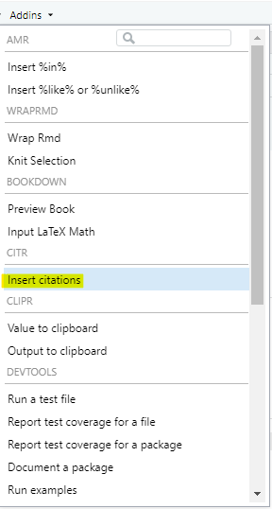
- Use the free-text box to search by author / publication date / title / journal
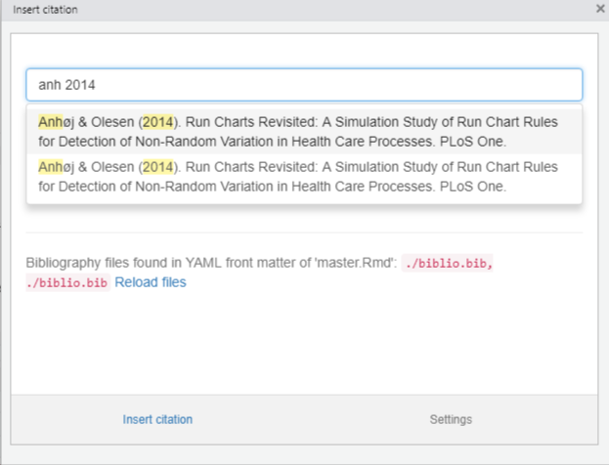
- Click insert citation

Cross-referencing functionality in Quarto
Cross References make it easier for readers to navigate documents by providing numbered references and hyperlinks to various entities like figures, tables, and equations.
For example, the following code…
@fig-airquality further explores the impact of temperature on ozone level.
…will cross-reference to the following figure, using the label tag
library(ggplot2)
ggplot(airquality, aes(Temp, Ozone)) +
geom_point() +
geom_smooth(method = "loess")
This is how it looks in practice:
Figure 1 further explores the impact of temperature on ozone level.
library(ggplot2)
ggplot(airquality, aes(Temp, Ozone)) +
geom_point() +
geom_smooth(method = "loess")
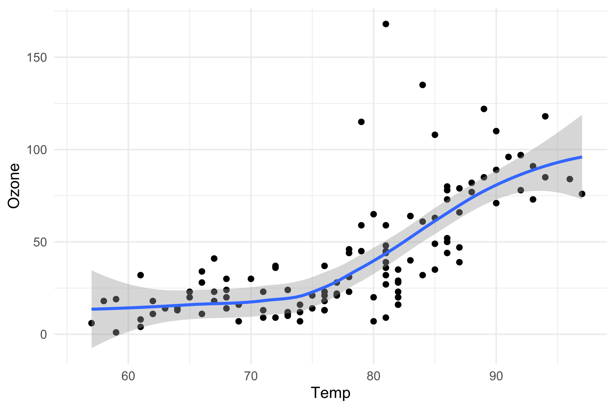
Figure 1: Temperature and ozone level.

References
References can be added to the rendered document by adding a div with the id #refs at the location in your document where you’d like the bibliography to be generated:
# References {.unnumbered}
::: {#refs}
:::
The resulting list of references looks like this:
Anhøj, J., Olesen, A.V., 2014. Run charts revisited: A simulation study of run chart rules for detection of non-random variation in health care processes. PLoS One 9, e113825.

Appendix
Text entered after the div with the id #refs will come after the list of references, which may be useful when adding appendices, for example.

