**Sample File**

**Test**

**Aadfds**

|  |  |  |
| --- | --- | --- |
| Name | Age | Salary |
| Eric | 39 | 7777 |
| Sri | 34 | 8888 |
| Jet | 48 | 9999 |
| Sen | 45 | 5555 |

vertical

A canyon with a sunset in the background

Description generated with very high confidence





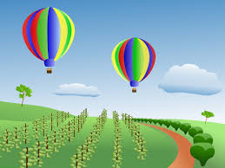

A picture containing food, indoor

Description generated with high confidence

text vertical