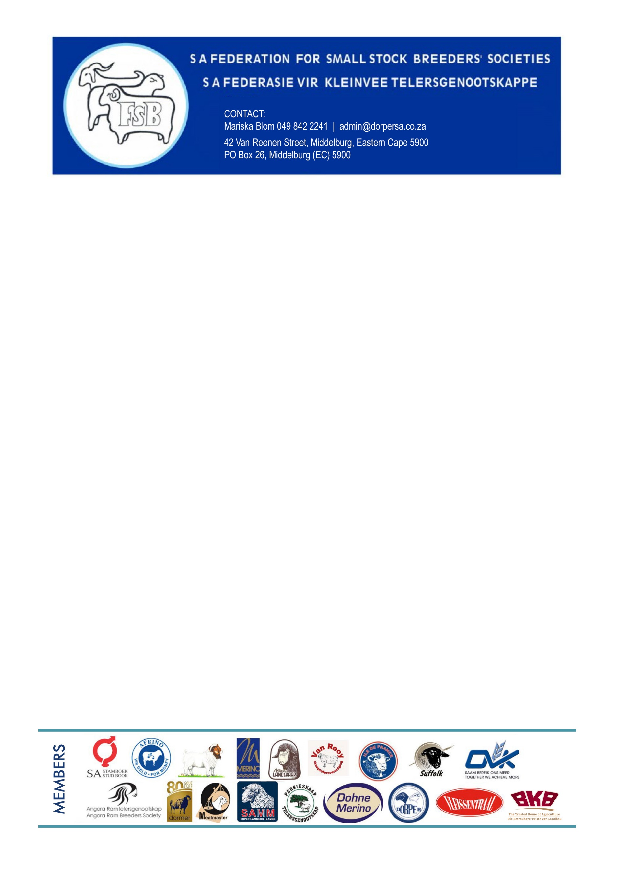
19 MAART 2025

Nationale RPO
Posbus 132
PERSEQUOR PARK
0020
BTW 4910203233
corine@rpo.co.za

SAFKTG Ledegelde / SAFSBS Membership  2024 / 2025 |  | R800.00
 |  | R800.00

BANKBESONDERHEDE:
FNB
530 2002 4237
Reference: RPO
Proof of payment: info@dorpersa.co.za

Baie dankie vir u ondersteuning / Thank you for your support

