**Setting up paths**

1. Clone the Koosha-Interdependency repo into the directory of your choice (path to this directory is referred to as ‘X’ going forward).
2. Download the PSAT toolbox version 2.1.8 into the directory of your choice (path to this directory is referred to as ‘Y’ going forward).
3. Change the current path to ‘X\Koosha-Interdependency\simulations’ at the top of the Matlab window.

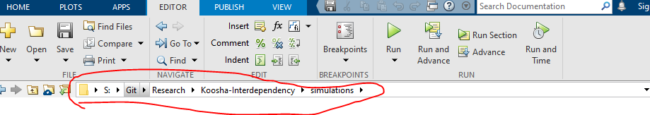

1. Run the command (must be done every time opening up Matlab or can be added to cascade file before psat commands are run)

addpath( “Y\psat\”)



**Fixing Syntax**

1. In X\Koosha-Interdependency\simulations\cascade.m, change line 54 to

copyfile(fullfile(DATA_PATH, append(file_name, '.m')), pwd);



1. In X\Koosha-Interdependency\simulations\cascade.m, change line 69 to

fid = fopen(fullfile(FAILURE_SEQ_PATH, append(file_name, '.txt')), 'w');



1. In X\Koosha-Interdependency\simulations\cascade.m, change line 92 to

load(fullfile(NN_PATH, append(file_name, '.mat')))



1. In X\Koosha-Interdependency\simulations\cascade.m, change line 336 to

save(fullfile(FAILURE_SEQ_PATH,append(file_name,'.mat')),'failure_seq);



1. In X\Koosha-Interdependency\simulations\cascade.m, change line 337 to

delete(append(file_name, '.m'));



1. In Y\psat\fmwindup.m change line 32 to

k = find(x >= xmax & DAE.f(idx) > 0);



1. In Y\psat\fmwindup.m change line 38 to

k = find(x <= xmin & DAE.f(idx) < 0);



1. **In** Y\psat\runpsat change line 241 from

**b = dir([filedata,'.m']); to b = dir(append(filedata,'.m'));**

1. **Line 38 in** X\Koosha-Interdependency\simulations\identify_dep.m adding a comma to fix syntax error

**From load(fullfile(FAILURE_SEQ_PATH, append(file_name '.mat')));**

**To load(fullfile(FAILURE_SEQ_PATH, append(file_name,'.mat')));**

1. **Add filedata = strcat(filedata(1),filedata(2)); at line 222 of runpsat.m between 2 following lines:**

**filedata = strrep(filedata,'@ ','');**

**and**

**if ~isempty(findstr(filedata,'(mdl)')) && clpsat.refreshsim**

1. **NO MATTER WHAT I DO PMU FIELD NEVER GETS UPDATED FROM 3X6 MATRIXES VALUES**

**Attempt no. 1: Line 270 add**

**failure_seq(i).sv.pmu{j} = failure_seq(i).sv.pmu{j}(:,end); between**

**failure_seq(i).sv.pmu{j} = Pmu.store(:, end);**

**failure_seq(i).sv.pmu_ds{j} = ...**

**isempty([failure_seq(i).pmu_ds{1:j}]);**

**Logical Errors**

1. In Y\psat\PMclass\subsref.m add the following case to the index(1).subs switch case statement:

case 'store'

b = a.store;

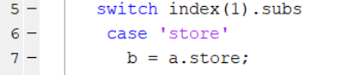

Try case 'store'

if length(index) == 2

b = a.store(index(2).subs{:});

else

b = a.store;

end

instead

**Troubleshooting**

1. If PSAT functions are throwing out-of-index errors, it is likely the input to the initial_failures function does not make sense with the file chosen as input to cascade.m. For example, the file chosen could specify 3 PMUs, but the initial failures function has a maximum of 4 PMUs failing.