
Business Question and Visualization Report

Date | 01 November 2026
Team ID | Add your SkillWallet Team ID
Project Name | Global Olympic Sports Performance Analysis
Maximum Marks | 5 Marks

Visualization development refers to the process of creating graphical representations of data to facilitate understanding, analysis, and decision-making. The goal is to transform complex datasets into visual formats that are easy to interpret, enabling users to gain insights and make informed decisions. Visualization development involves selecting appropriate visual elements, designing layouts, and using interactive features to enhance the user experience. This process is commonly associated with data visualization tools and platforms, and it plays a crucial role in business intelligence, analytics, and reporting
Project owner: Sendhika Vishwakarma
Business Questions and Visualisation
The process involves defining specific business questions to guide the creation of meaningful and actionable visualizations in Tableau. Well-framed questions help in identifying key metrics, selecting relevant data, and building visualisation that provide insights.

Project focus: nine Olympic performance questions grouped into three stakeholder scenarios.

The report below covers nine business questions and their corresponding visualizations.

Scenario 1 - National Olympic Committee Performance Strategist
01. What is the average number of medals per athlete by sport category?
Horizontal bar chart; source: athletes.csv. Biathlon, Shooting and Cycling are the leading categories in the supplied records. Use the measure as a screening signal, not a causal ranking.
02. Which countries have the highest all-time medal totals, and how are medals split by type?
Stacked horizontal bar chart; source: alltime_country_rankings.csv. The United States leads with 735 total medals, China has 696 and Russia has 429.
03. Which sport categories have the highest medalist rate?
Horizontal bar chart; source: athletes.csv. Medalist rate is the share of athlete records with at least one medal; the category view shows only categories with at least 100 athlete records. Cycling is about 77% in the supplied data.
Scenario 2 - International Sports Investment Analyst
04. How does medal output vary across reported investment tiers?
Scatter / bubble chart; source: medal_results.csv. Bubble size represents athlete entries across editions. This is an association view; investment is categorical and the dataset has no currency amounts.
05. What is mean reported medal efficiency by investment tier?
Bar chart; source: medal_results.csv. Source-field averages are Low 39.24%, Medium 34.97% and High 17.21%. Values need interpretation because the efficiency formula is not documented.
06. How does mean reported medal efficiency vary by region?
Horizontal bar chart; source: medal_results.csv. South America averages 49.64% and the source region Europe/Asia averages 45.98%. Compare sample counts and outliers before interpreting region differences.
Scenario 3 - Olympic Broadcast Journalist and Data Storyteller
07. How many medals were awarded in each Olympic edition?
Line chart; source: games_summary.csv. The lowest supplied total is 305 in 2000, the peak is 363 in 2020, and the supplied 2026 row records 334 medals.
08. Which host countries won the most medals at their home Games?
Horizontal bar chart; source: medal_results.csv plus games_summary.csv. China recorded 63 medals at its 2008 home Games in the supplied data. The host-country calculation normalizes the 2012 UK label to Great Britain.
09. What share of all-time medals does each region represent?
Donut chart; source: alltime_country_rankings.csv. Europe accounts for 2,822 medals and Asia for 1,516; together this is about 72.0% of the 6,025 medals in the ranking file.
Dashboard Overview
The image below is the analysis package overview. Replace it with a direct screenshot of the published Tableau dashboard if your instructor requires native Tableau evidence.
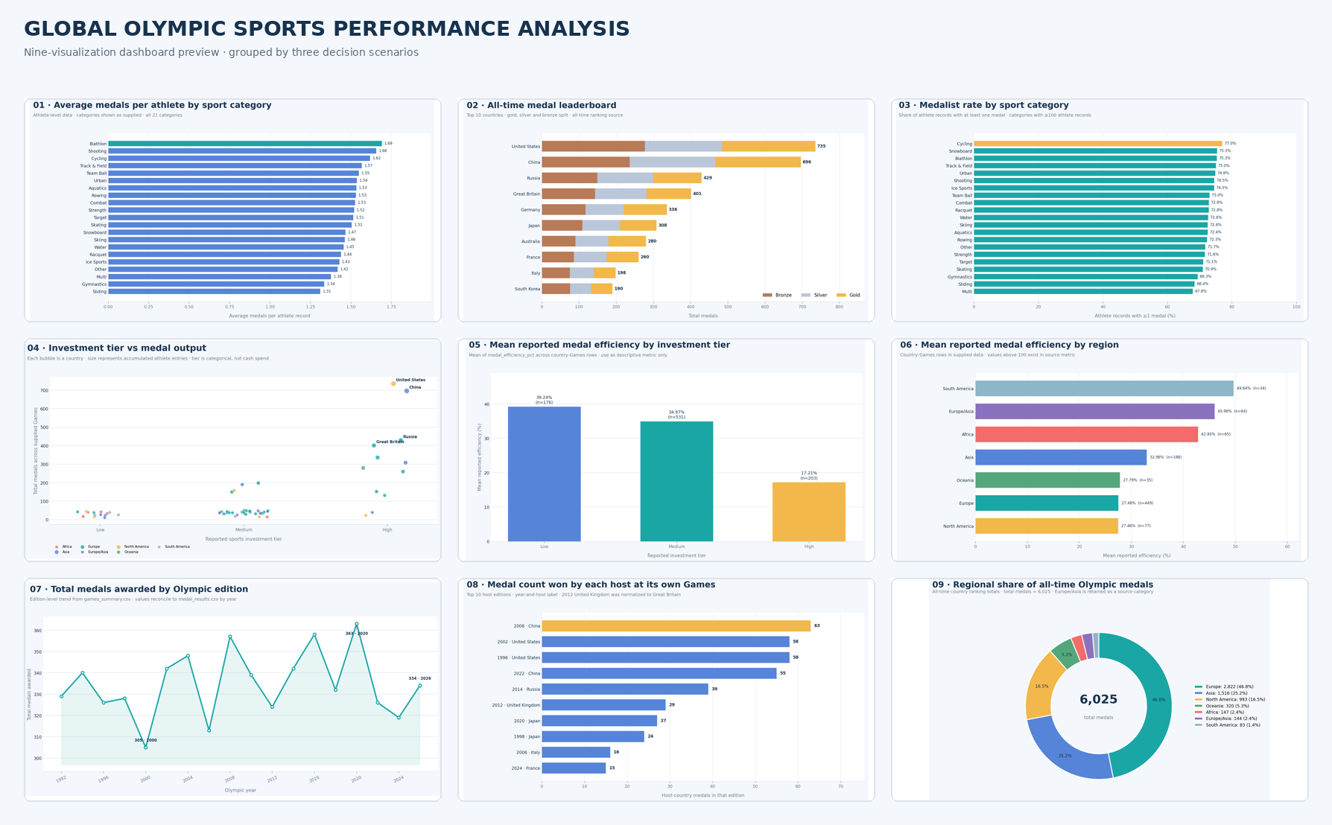
Validation and Limitations
• The four source datasets contain 8,000 athlete rows, 910 country-by-Games rows, 18 edition rows and 60 country-ranking rows.
• All-time country medal totals sum to 6,025; year-level medal totals reconcile across the supplied medal-results and Games-summary files.
• The efficiency field includes 54 values above 100, with a maximum of 600.0; confirm its formula before relying on the metric.
• The sports_investment field contains Low, Medium and High categories rather than spending amounts; do not call this a financial ROI analysis.
• The supplied data should be verified against official records before being presented as verified Olympic history.
Project Links
Tableau Public dashboard: Open published Tableau dashboard
Google Drive demo video: Open Google Drive demo video
GitHub repository: Open GitHub repository

