Project Design Phase-II
Data Flow Diagram & User Stories
Project owner: Sendhika Vishwakarma
Project links: Tableau Public dashboard | Google Drive demo video

Date | 01 November 2026
Team ID | Add your SkillWallet Team ID
Project Name | Global Olympic Sports Performance Analysis
Maximum Marks | 4 Marks

Data Flow Diagrams:
A Data Flow Diagram (DFD) is a traditional visual representation of the information flows within a system. A neat and clear DFD can depict the right amount of the system requirement graphically. It shows how data enters and leaves the system, what changes the information, and where data is stored.
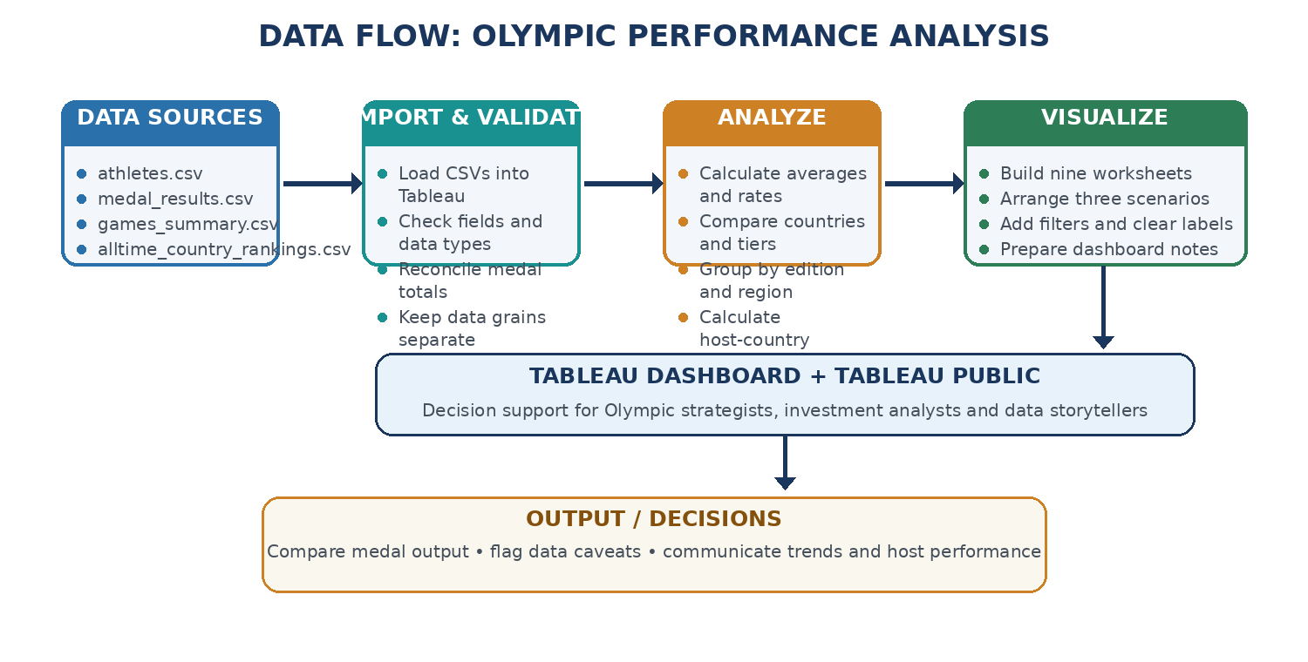
DFD Symbol Legend
Symbol | Name | Description
Oval / Rounded  shape | External Entity | A person, organization, or system outside the project that sends or receives data (e.g., Customer, Payment Gateway).
Rectangle with  numbered header | Process | An activity that transforms incoming data into outgoing data (e.g., Validate Request, Process Order).
Rectangle (solid fill, no number) | Data Store | A place where data is held for later use (e.g., Customer Database, Inventory).
Labeled arrow | Data Flow | The movement of data between entities, processes, and data stores, labeled with what data is being passed.

Example: DFD Level 0 (Industry Standard)



User Stories
Use the below template to list all the user stories for the product.
User Type | Functional Requirement (Epic) | User Story Number | User Story / Task | Acceptance criteria | Priority | Release
Data Analyst | Data Access | USN-1 | As an analyst, I can connect to the four supplied CSV datasets so that I can analyze Olympic performance. | All four files load and expected columns are visible. | High | Sprint-1
Data Analyst | Data Validation | USN-2 | As an analyst, I can check key totals and data types before building charts. | Country medal totals reconcile to 6,025 and year totals match the Games summary. | High | Sprint-1
Performance Strategist | Sport Analysis | USN-3 | As a strategist, I can compare average medals per athlete and medalist rate by sport category. | Charts label the metric and use athlete-level data. | High | Sprint-2
Performance Strategist | Country Comparison | USN-4 | As a strategist, I can compare gold, silver, bronze and total medals by country. | Top-country ranking and medal types are readable. | High | Sprint-2
Investment Analyst | Investment Analysis | USN-5 | As an analyst, I can compare medal output and reported efficiency by investment tier and region. | Dashboard displays supplied categories and includes a caution that correlation is not causation. | High | Sprint-2
Data Storyteller | Edition Trends | USN-6 | As a storyteller, I can see medal totals across Olympic editions and host-country results. | Year trend and host medal chart clearly define the measure. | High | Sprint-2
Dashboard Viewer | Explore Dashboard | USN-7 | As a viewer, I can explore all nine visuals grouped into three scenarios. | Chart titles and labels are clear; dashboard fits the page. | High | Sprint-3
Project Evaluator | Project Review | USN-8 | As an evaluator, I can open the dashboard, source-data files and documentation. | Public repository is provided; missing external links are marked for final update. | Medium | Sprint-3
Project Owner | Publication | USN-9 | As the project owner, I can publish the Tableau dashboard and share a public link. | The published dashboard URL is included in the project proposal and dashboard design template. | High | Sprint-3
Project Owner | Documentation | USN-10 | As the project owner, I can explain every chart and the key limitations. | Report includes all nine business questions and the metric caveats. | High | Sprint-3
Project Owner | Version Control | USN-11 | As the project owner, I can store workbook, CSVs, templates and project documentation in GitHub. | Repository includes deliverables and a readable README. | Medium | Sprint-3
Project Owner | Demo Video | USN-12 | As the project owner, I can record a voice-over walkthrough of the project. | Video covers the problem, three scenarios and nine charts. | Medium | Sprint-3

