Project Design Phase-I
Problem – Solution Fit Template
Project owner: Sendhika Vishwakarma
Project links: Tableau Public dashboard | Google Drive demo video

Date | 01 November 2026
Team ID | Add your SkillWallet Team ID
Project Name | Global Olympic Sports Performance Analysis
Maximum Marks | 2 Marks

Problem – Solution Fit Template:
The Problem-Solution Fit simply means that you have found a problem with your customer and that the solution you have realized for it actually solves the customer’s problem. It helps entrepreneurs, marketers and corporate innovators identify behavioral patterns and recognize what would work and why
Purpose:
- Solve complex problems in a way that fits the state of your customers.
- Succeed faster and increase your solution adoption by tapping into existing mediums and channels of behavior.
- Sharpen your communication and marketing strategy with the right triggers and messaging.
- Increase touch-points with your company by finding the right problem-behavior fit and building trust by solving frequent annoyances, or urgent or costly problems.
- Understand the existing situation in order to improve it for your target group.

Template:
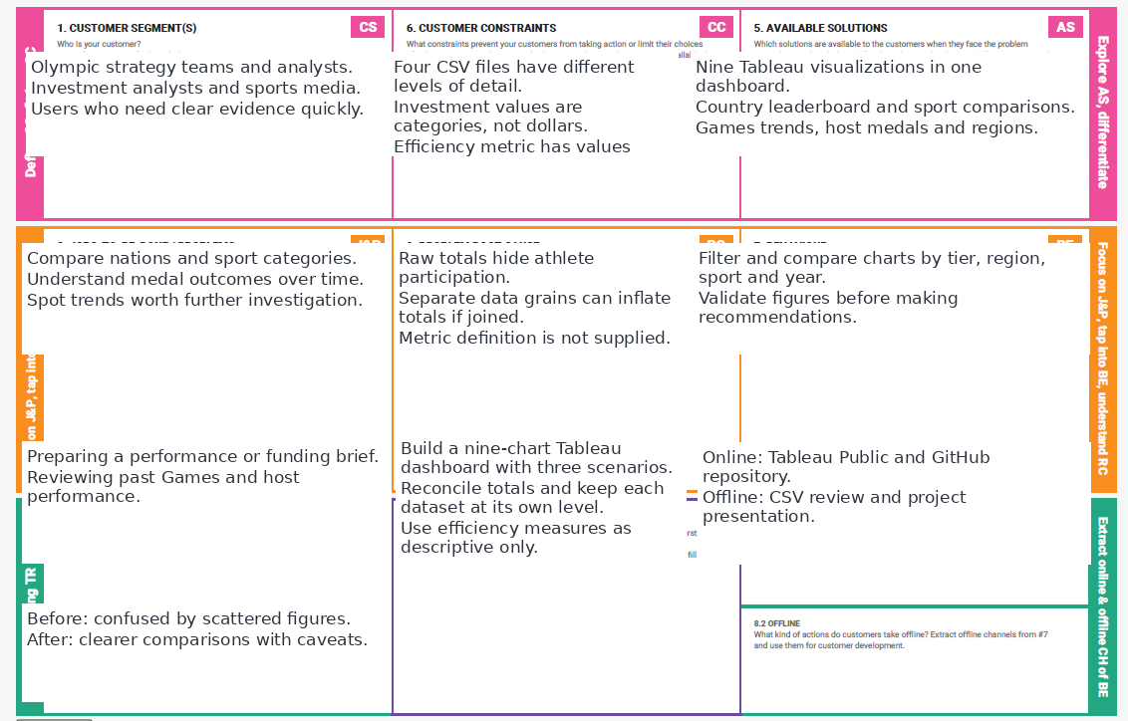
References:
- https://www.ideahackers.network/problem-solution-fit-canvas/
- https://medium.com/@epicantus/problem-solution-fit-canvas-aa3dd59cb4fe
Problem-Solution Fit Summary
Target user: Olympic performance strategist, sports investment analyst, or broadcast/data storyteller. The project addresses a discovery and communication problem: important Olympic records are split across files and raw totals can hide differences between athlete counts, country performance and Games editions.
Proposed solution: one Tableau dashboard with nine visualizations grouped into national performance, investment-tier analysis, and Olympic storytelling. The dashboard improves access to the evidence but does not prove causality or financial return on investment.

