
Dashboard Design

Date | 01 November 2026
Team ID | Add your SkillWallet Team ID
Project Name | Global Olympic Sports Performance Analysis
Maximum Marks | 5 Marks

Creating an effective dashboard involves thoughtful design to ensure that the presented information is clear, relevant, and easily understandable for the intended audience. Here are some key principles and best practices for dashboard design
Project owner: Sendhika Vishwakarma
Activity 1: Interactive and visually appealing dashboards
Creating interactive and visually appealing dashboards involves a combination of thoughtful design, effective use of visual elements, and the incorporation of interactive features. Here are some tips to help you design dashboards that are both visually appealing and engaging for users so take care of below points
- Clear and Intuitive Layout
- Use Appropriate Visualizations
- Colour and Theming
- Interactive Filters and Slicers
- Drill-Down Capabilities
- Responsive Design
- Custom Visuals and Icons
- Use of Infographics


Note: Highlight the major outcomes in form of bullet points

- National Performance: The United States leads the supplied all-time country ranking with 735 medals, followed by China with 696 and Russia with 429.
- Sport Categories: Cycling has an approximately 77% medalist rate among the categories shown with at least 100 athlete records. This is a descriptive comparison, not proof that one sport is easier to medal in.
- Investment Tiers: Mean reported efficiency is 39.24% for Low, 34.97% for Medium, and 17.21% for High. The source does not document the calculation, so interpret these figures cautiously.
- Olympic Editions: The supplied Games summary shows 305 medals in 2000 and a peak of 363 in 2020. The 2026 row is part of the supplied dataset and should be verified before presenting it as official Olympic history.
- Host and Region: China recorded 63 medals at the 2008 home Games in the supplied data. Europe and Asia together account for about 72% of the all-time ranking dataset’s medals.

Activity 2
Tableau Public dashboard link: see the active project link in the Project Links section below.

Demo video and GitHub links are also listed in the Project Links section below.
Dashboard Design for Global Olympic Sports Performance Analysis
Layout: one dashboard with nine views arranged in a 3 by 3 grid. The rows follow three scenarios: national performance, investment analysis, and Olympic storytelling. Use short titles, consistent number formats, legends, and notes where the meaning of a metric needs explanation.
• Use horizontal bars for category and country rankings, so labels remain readable.
• Use stacked bars to distinguish gold, silver and bronze medals by country.
• Use a scatter / bubble view for medal output by investment tier; the bubble size represents athlete entries, not money spent.
• Use line chart for edition-level medal totals, horizontal bar chart for host-country medals, and donut chart for regional medal share.
• Keep colors consistent and readable; label percentage charts as reported efficiency rather than verified return on investment.
• Include relevant filters for year, region, sport category and investment tier where appropriate.
Major Outcomes
• The United States leads the supplied all-time ranking with 735 medals, followed by China with 696 and Russia with 429.
• Cycling has about a 77% medalist rate among the selected sport-category records; categories with fewer than 100 athlete records are excluded from that rate chart.
• Mean reported efficiency is higher in Low (39.24%) and Medium (34.97%) tiers than the High tier (17.21%); treat this as descriptive only.
• The source lists 305 medals in 2000 and a peak of 363 in 2020; the supplied 2026 row records 334.
• China recorded the largest displayed host-edition medal count: 63 at the 2008 Games.
• Europe and Asia account for 4,338 of 6,025 all-time medals (about 72.0%) in the ranking dataset.
Dashboard Overview Image
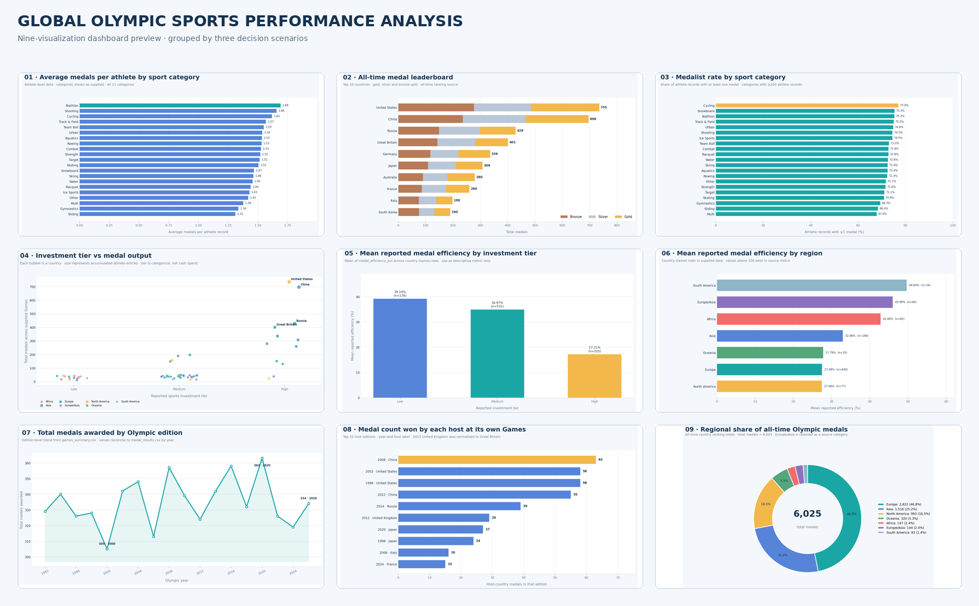
Evidence note: this is the dashboard overview image packaged with the analysis. Attach or replace it with a screenshot from Tableau if SkillWallet specifically requests proof of the native workbook.
Project Links
Tableau Public dashboard: Open published Tableau dashboard
Google Drive demo video: Open Google Drive demo video
GitHub repository: Open GitHub repository

