Ideation Phase
Empathize & Discover
Project owner: Sendhika Vishwakarma
Project links: Tableau Public dashboard | Google Drive demo video

Date | 01 November 2026
Team ID | Add your SkillWallet Team ID
Project Name | Global Olympic Sports Performance Analysis
Maximum Marks | 4 Marks

Empathy Map Canvas:
An empathy map is a simple, easy-to-digest visual that captures knowledge about a user’s behaviours and attitudes.

It is a useful tool to helps teams better understand their users.
Creating an effective solution requires understanding the true problem and the person who is experiencing it. The exercise of creating the map helps participants consider things from the user’s perspective along with his or her goals and challenges.
Example:
Reference: https://www.mural.co/templates/empathy-map-canvas

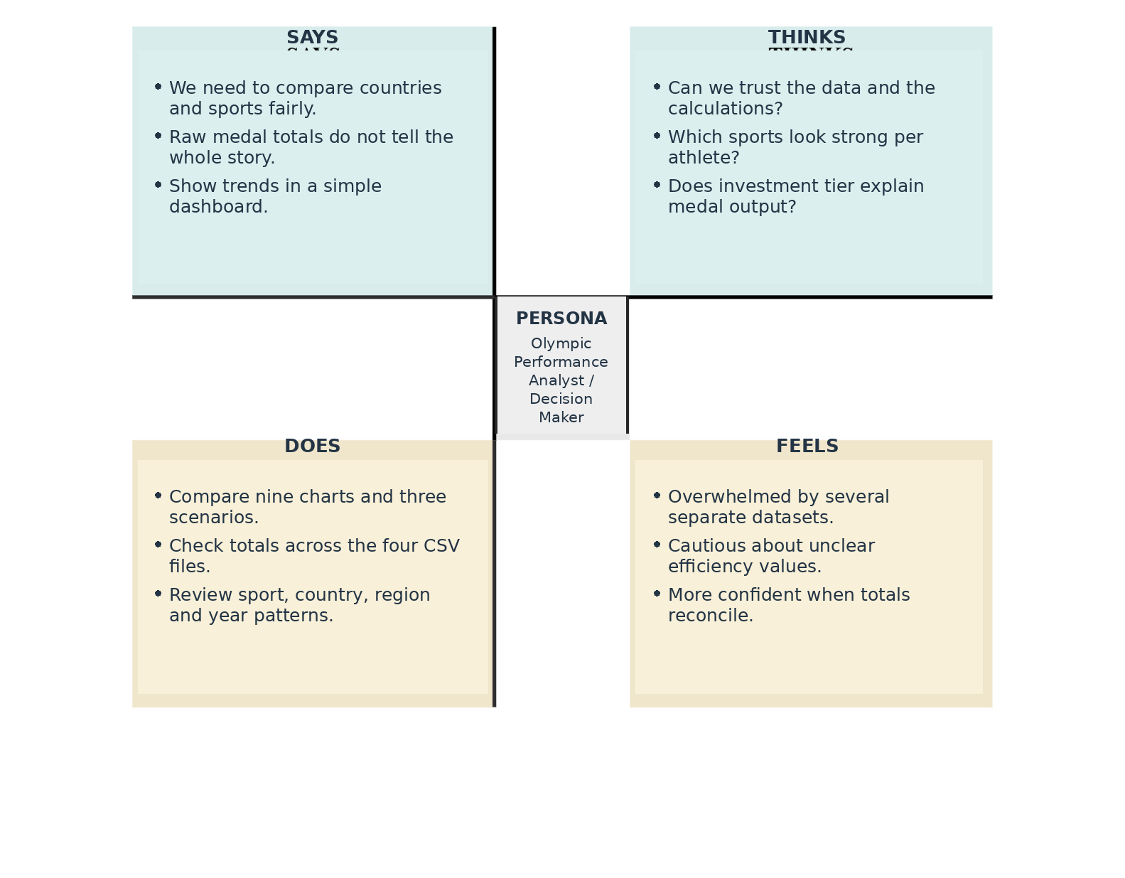

Completed Empathy Map: Olympic Data Dashboard User
Primary user: an Olympic performance analyst, national sports strategist, or sports data storyteller who needs to compare performance across countries, sports and Games.

SAYS
“Which countries and sports stand out?” “Can I compare medal totals fairly?” “What do these efficiency figures actually mean?”

THINKS
Raw medal counts may not tell the whole story. Athlete participation, time period, host status and data quality can affect interpretation.

DOES
Reviews country rankings, compares sport categories, checks Games trends, and prepares summaries for decisions or presentations.

FEELS
Wants confidence in the findings, but may feel uncertain when data is split across files or when a metric is not clearly defined.

PAINS
Different datasets use different levels of detail; totals can be misleading without context; the reported efficiency formula is undocumented and includes values above 100.

GAINS
A single dashboard with nine visuals, clearly labelled measures, concise findings, validation notes and links to supporting documentation.
Design implication: keep athlete-level, country-by-Games and all-time country data at their proper levels of detail; show the denominator for rates; label reported efficiency as an unverified source metric.

